Cincinnati Model Investment Club Minutes
West Chester Mid-Pointe Library Boardroom – Mar 24, 2018

Call to Order: Presiding Partner Richard Alden called the meeting to order at 9:45a. Proxies were noted.
Guests in Person: Rick Gady, Philip Baxman . Guests on webinar: Susan Tanoe, Susan Hargett.

Name | Here | Proxy | Name | Here | Proxy
Jackie Koski | web |  | Harrison Baumbaugh | web
Betsy Eller, Financial Partner | web |  | Mary Thomas | web
Craig Jacobsen | web |  | Gregg Hopkins | web
Marty Eckerle | web |  | Latisha Douglas | --- | ---
Gerry Geverdt | X |  | Frank Bicknell | --- | Michele
Dene Alden, Volunteer Recording | X |  | Michele Grinoch | X
Richard Alden, Presiding Partner | X |  | Kate Lester | --- | Dene
 |  |  | Nelson Page | --- | Dene
Note: Parentheses denote provisional presence or proxies should members not be present for the full meeting

Recording Partner’s Report: Minutes of the Feb 17 meeting were approved as posted.

Financial Partner’s Report:
- Current cash: $1,725.13; There are no limit orders
- Audit was completed, taxes filed; K-1s are available in bivio. Dene/Rich – motion to reimburse Betsy for postage

Announcements:
- The OKI Chapter will have their spring educational event on April 21, 2018 in Dayton (Fairborn) at the Holiday Inn opposite Wright State. Marty showed the flyer and Michele has posted the event on Meetup
- There will be a Money Smart Week presentation at the MidPointe Library on Thu, Apr 26, 2018, 7:00p, Room C
- Classes and webinars: see BetterInvesting Magazine “ONLINE” section opposite CONTENTS or visit the web site under Events.
- “The Roundtable”, “Turn Out Tuesday” and “Investing Topics with Mark and Ken” are sponsored by BI Mid-Michigan. Register for any of them by contacting: nkavula1@comcast.net.
- Check out Stock Up and Ticker Talk on the BI web site
- The Better Investing National Convention (BINC) will be held in May 17-20, 2018 in Orlando. Jackie will attend and Craig may also

Old Business:
- The April Meeting will be on Apr 28 in Room C due to the conflict with the Chapter Spring Event on Apr 21

New Business:
- There is no room available for the next mid-month meeting on Apr 7. The meeting will be held on-line instead

Education: Michele Grinoch - “Preferred Procedure” (PP) (from Anne Cuneaz’ presentation)
- Preferred Procedure is used to estimate forward EPS on the first tab of SSG+ as an alternative to the user’s own estimate or analyst estimates.
- It is a reality check along with Yahoo, Zacks, Morningstar, Reuters, and Value Line. These are all available by subscription or through MidPointe Library membership.
- Earnings growth comes from sales and should generally be no higher than sales growth or over 20%.
- PP is a supplementary reality check and the user is urged to keep notes about this selection if deviating from the PP figures.
- Pre-tax margin, tax rate, preferred dividends, and number of shares historical data are available as pull-downs on the right-hand side of the procedure.
- Percentages and historical data automatically pre-populate but the user can adjust estimates based on other research.

New Stock Presentation: None this month, continuation of the Portfolio Review

Portfolio Analysis The stock covered this month was AAPL, the last in our portfolio, by Jackie
- Only the most recent six years of sales and earnings data was used as the AAPL business model is changing from product sales to a subscription model.
- AAPL has taken on substantial debt in recent years but interest is more than covered by substantial cash flow.
- AAPL is paying a dividend, an additional benefit from a company still experiencing high growth.
- AAPL is in the lower end of the HOLD zone.

Stock Study: Marty and Craig have done a great job applying the club’s stock screening criteria to selecting stocks that would enhance our portfolio. Marty now includes this data as a separate tab on his monthly Close of Bell report and members can choose from the list when scheduled to present a stock, or suggest new entries using the club criteria. Gerry is scheduled to do the Apr stock presentation and will likely select from the list. Gregg mentioned that he was looking at Fleetcor and Argan for another club. Craig suggested looking at BI magazine, undervalued lists, ten most active stocks, other club holdings, IAS, and the portfolios of small cap mutual fund holdings for ideas.

Close of the Bell: Marty’s report: Six companies are in the BUY zone. APOG, CERN, CVS, LKQ, SLB, and TSCO. This fact is based on the watcher SSG’s. Three of these companies, CVS, TSCO, and APOG are in the Manifest Sweet Spot and are Nicholson Triple Plays.

Portfolio Review:

Stock | Symbol | Watcher | Watcher: Buy/Hold/Sell | SSG: Buy/Hold/Sell | Report posted: | # of Shares | % of Portfolio | Year End | Next Earnings Report:
Apogee | APOG | Nelson | BUY | BUY |  | 165 | 5.0 | Dec | 4/12/18
Apple | AAPL | Jackie | HOLD | HOLD |  | 95 | 11.1 | Sep. | 4/30-5/4/18
C. H. Robinson | CHRW | Dene | HOLD | HOLD |  | 150 | 9.6 | Dec | 4/23-4/27/18
Cerner | CERN | Gregory | HOLD | BUY |  | 60 | 2.4 | Dec | 4/25-4/30/18
Cognizant | CTSH | Michele | HOLD | HOLD |  | 200 | 11.2 | Dec | 5/3-5/7/18
CVS Health | CVS | Latisha |  |  |  | 130 | 5.6 | Dec | 4/30-5/4/18
Danaher | DHR | Harrison | HOLD | HOLD |  | 110 | 7.5 | Dec | 4/19/18
Fastenal | FAST | Rich | HOLD | HOLD |  | 200 | 7.6 | Dec | 4/10-4/16/18
Gilead | GILD | Dene | HOLD | HOLD/SELL? |  | 30 | 1.5 | Dec | 4/30-5/4/18
LKQ Corp | LKQ | Frank | HOLD | BUY |  | 375 | 9.8 | Dec | 4/25-4/30/18
Schlumberger | SLB | Mary | HOLD | BUY |  | 140 | 6.3 | Dec | 4/20/18
Signature Bank | SBNY | Craig | HOLD | HOLD |  | 110 | 10.9 | Dec | 4/17-4/23/18
Starbucks | SBUX | Gerry | HOLD | HOLD |  | 130 | 5.2 | Sep | 4/26/18
Tractor Supply | TSCO | Kate | HOLD | HOLD |  | 120 | 5.0 | Dec | 4/24-4/30/18
 | Stocks on “Pounce / Watch List”
ULTA | ULTA | IAS | Buy Range: 130.4 to 238 |  |  | 0 | 0 | Jan | N/A

Buy/Sell Decisions: (motion/second: action, type, yes/no/abstain)
- Craig/Dene: sell all 30sh of GILD @window; 14/0/0, passed
- Nelson(Dene)/Marty: buy 10sh of APOG @window; 13/1/0, passed
- Craig/Marty: buy 20sh of CERN @window; 7/7/0, failed
- Craig/Marty: buy 10sh of CERN @window, 11/2/1, passed
- Dene/Craig: buy 10sh of TSCO @window; 12/1/1, passed

Next Meeting:
- Mid-month Study Group: Sat, Apr 7, on-line; Regular meeting: Sat, Apr 28, 9:45-11:45AM; Room C

Education and Stock Presentation Schedule for 2018/2019:
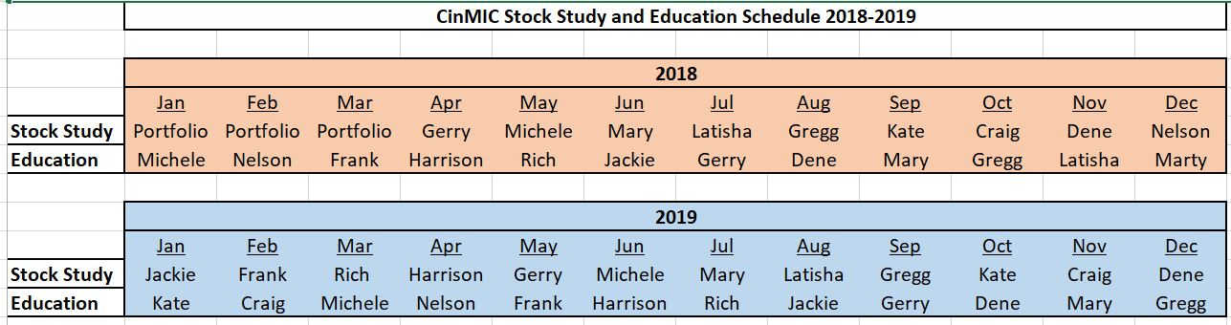

Adjourned: by Rich at 11:48AM

Submitted by Rich Alden, acting recording partner

