MicNOVA Feb 2024 Meeting Agenda
Meeting Location | Online via Go-To Meeting
Meeting Date & Time | Feb 13 2024 07:00 PM - 09:00 PM
Online Meeting | https://global.gotomeeting.com/join/251997157  You can also dial in using your phone.  United States: +1 (312) 757-3121  Access Code: 251-997-157

MODEL INVESTMENT CLUB DISCLAIMER
• The information presented and discussed in this model club meeting is for demonstration and educational purposes only. The securities of companies referenced or featured in the meeting materials, presentation and discussion are for illustrative purposes only and are not to be considered endorsed or recommended for purchase or sale by BetterInvesting™ / National Association of Investors™. The views, opinions expressed and decisions made by club partners regarding the purchase and sale of stocks or other assets are those of the partner(s), and do not necessarily reflect the views and opinions of BetterInvesting. No recommendation to purchase or sell any stock, mutual fund, or other security referenced is being made on behalf of BetterInvesting.
• Securities discussed may be held by the club partners and presenters in their own personal portfolios or in those of their clients. BetterInvesting presenters and volunteers are held to a strict code of conduct that precludes benefiting financially from educational presentations or public activities via any BetterInvesting programs, events and/or educational sessions in which they participate. Any violation is strictly prohibited and should be reported to the CEO of BetterInvesting or the Director of Chapter Relations.
• This meeting may contain images of websites and products or services not endorsed by BetterInvesting. The presenter is not endorsing or promoting the use of these websites, products or services.
• We may record this session for our future use.

Agenda
07:00 - 07:05 PM | Welcome Partners, Regular Guests and First Time Visitors  Disclosure: Better Investing | Pat
07:05 - 07:07 PM | Secretary’s Minutes | Arvind/Maskey
07:07 - 07:15 PM | Treasurer’s report  - Thank you for the Audit Support, Tax-Forms  - Cash + ETF is available to invest | Gladys
07:15 - 07:35 PM | Education: Ken Kavula’s Jan Session: Beginner’s Investment | Maskey
07:35 - 07:55 PM | New Stock Presentation: Allient (Ticker: ALNT) | Sheryl
07:55 - 08:25 PM | Stock Watchers ( Please share the Online SSG with all MicNOVA members)  Portfolio:  - Gentex (GNTX) - Maskey  - Microsoft (MSFT) - Janet  - Visa (V) - Patrick  - Western Alliance (WAL) - Sheryl  - Alphabet (GOOG) - Jo  - Apple (APPL) - Gladys | Maskey  Janet  Patrick  Sheryl  Jo  Gladys
08:25 - 08:30 PM | Portfolio Review (report will be sent to all partners in advance) | Ty
08:30 - 08:45 PM | Decision: Buys and Sells | Partners
08:45 - 08:55 PM | Upcoming Events and Announcements | Pat
09:00 | Adjourn | Pat

2024 BI and Community Events & Announcements
Feb 15 2024 08:00 - 09:15 PM | Stock Up: The ABCs of Google  Registration required
Tue Feb 20 2024 07:30 - 09:00 PM  (Third Tuesdays of Month) | Money Matters Book Discussion. Book: Talks at Google: Quantum Supremacy by Michio Kaku  Online via GTM: You can also dial in using your phone.  United States: +1(646) 749-3122  One-touch: tel:+16467493122,,804623085#  Access Code: 804-623-085
Wed Feb 21 07:00 - 09:00 PM  Wed Mar 20 07:00 - 09:00 PM  (3nd Wednesdays of Month) | MCMC Monthly Meeting  https://global.gotomeeting.com/join/745127301  You can also dial in using your phone.  (For supported devices, tap a one-touch number below to join instantly.)  United States: +1 (872) 240-3311  - One-touch: tel:+18722403311,,745127301#  Access Code: 745-127-301
Thu Feb 22 2024 08:00-09:15 PM | Ticker Talk: Overview of Ratios Tab in SSGPlus  Registration Required
Fri Mar 1 2024 08:00 - 09:00 PM | DC Chapter Director Meeting
Mon Mar 4 2024 07:00 - 08:15 PM | Digging into BI Magazine  Registration URL: https://register.gotowebinar.com/rt/6574788583850753036  Webinar ID:729-893-259
Tue Mar 12 07:00 - 09:00 PM  (2nd Tuesdays of Month) | MicNOVA Monthly Meeting Online  https://global.gotomeeting.com/join/251997157  You can also dial in using your phone.  United States: +1 (312) 757-3121  Access Code: 251-997-157

Schedule: New Stock Presentation, Planning and Monthly Meeting Chair
 | Name | Education | New Stock Presentation | Conduct MicNOVA Monthly Meeting | Conduct MicNOVA Planning Meeting
1 | Patterson, Sheryl | 5/14/24 | 2/13/24 | 12/12/23 | 12/5/23
2 | Hughes, James (Ty)* | 1/9/24 | 04/9/24 | 10/8/24 | 10/1/24
3 | Krishnarao, Maskey | 2/13/24 | 12/12/23 | 5/14/24 | 5/7/24
4 | Krishna, Arvind | 7/9/29 | 11/14/23 | 8/13/24 | 8/6/24
5 | Arumugam, Baskar | 9/10/24 | 1/9/24 | 6/11/24 | 6/4/24
6 | Henrikson, Gladys | 3/12/24 | 7/9/24 | 1/9/24 | 1/2/24
7 | Murphy, Josephine(Jo)* | 8/13/24 | 6/11/24 | 7/9/24 | 7/2/24
8 | Emmons, Elinor(Kathy) | 11/12/24 | TBD | 9/10/24 | 9/3/24
9 | Smith, Patrick | 12/12/23 | 10/8/24 | 3/12/24 | 3/5/24
10 | Onufrak, Patricia | 6/11/24 | 8/13/24 | 2/13/24 | 2/6/24
11 | O’Mara, W. Paul | 4/9/24 | 5/14/24 | 11/5/24 | 11/12/24
12 | Lewis, Janet | 10/8/24 | 09/10/24 | 4/9/24 | 4/2/24
13 | Ober, Andrew | 10/8/24 | 3/12/24 | 2/11/25 | 2/4/25

Stock Watcher Reports
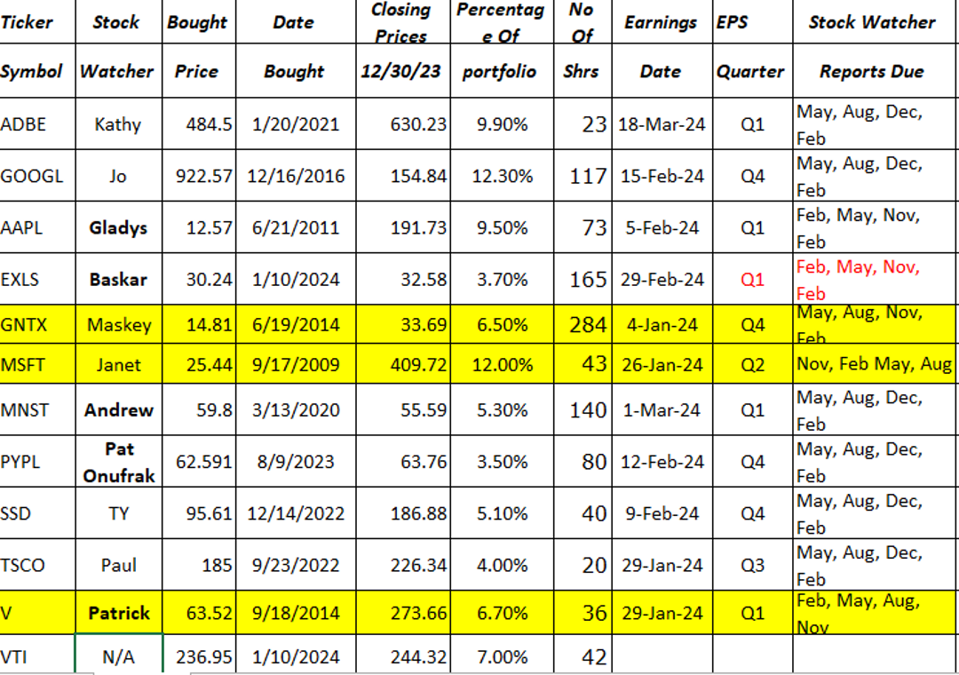

Next 3 Months - Reminders
Mar 2024 | Education | Investment Ratios | Gladys
Mar 2024 | New Stock | Addus Homecare Corporation (Ticker: ADUS) | Andrew
Apr 2024 | Education |  | Paul
Apr 2024 | New Stock |  | Ty
May 2024 | Education |  | Sheryl
May 2024 | New Stock |  | Paul

