Better Investing Guidelines for Stock Buying Decisions
MicNova Meeting, July 10, 2019
Acid Test Worksheet Exercise (1) - Example
Company/ Stock Name:__ABBV____________________________________________________
Acid Test 1: Sales | Y/N/ %/? | Notes | SSG Location
- Growing/Up? |  | Page 1 SSG and Quarterly Data Tab | Sales:  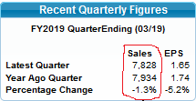  Examine 10 Yr history – SSG Pg 1  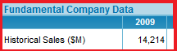  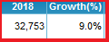  Examine Quarterly Data  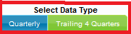  Select SSG Quarterly Data Tab  Select Data Type: Quarterly & Sales Radio  Examine line graph to see trend  Company Size:  Hover over ticker to see co. size  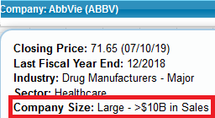
- % from yr ago (up/growing?)
- Target per size
Large Co (>$10B/yr) = 5-7%
Med Co ($1B-10B/) = 7-10%
Small Co (<$1B) = 12%
Acid Test 2: Pre-tax Profit (PTP) | Y/N/ %/? | Notes | SSG Location
- Growing up/even with sales? |  |  | Select SSG Quarterly Data Tab (see steps above)  Select Data Type: Quarterly, Sales & PTP  Examine line graph to see trend  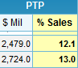  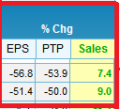  Examine PTP % Sales (up, down, even)  Examine % Chg for PTP/Sales for each Qtr
b. Profit Margin (Down, even, up)  Are operating expenses increasing (bigger gap between Sales and PTP) |  |  | Examine 10 Yr PTP trend under Evaluate Management  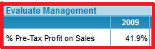  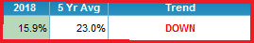
c. Last 4 Qtrs% (Down, even, up) |  |  | Examine line graph for trend for last 4 Qtr  Find the last 4 Qtr in Growth Trend Data Table  Examine PTP % Sales (up, down, even)  Examine % Chg PTP/Sales for each Qtr
Acid Test 3: Earnings per Share (EPS) | Y/N/ %/? | Notes | SSG Location
- Growing up/even w sales & profits?  Are earning consistently growing |  |  | Select SSG Quarterly Data Tab (see steps above)  Select Data Type: Earnings Radio  Examine line graph for trend  Add Sales and PTP for comparison
- Latest Qtr vs Yr ago? |  |  | 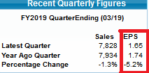
- Recent 4 Qtr (Up, even, down) |  |  | Examine line graph for trend  Find the last 4 Qtr in Growth Trend Data Table  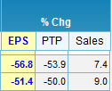
- Debt to Capital (&, up, even, down) |  |  | Bottom Pg 1 SSG

