Model Investment Club of Northern Virginia (MicNOVA)
DC Chapter of Better Investing
Minutes for the September 13, 2022 (Online Meeting)

Members Present: Jo Murphy, Sheryl Patterson, Gladys Henrikson, Maskey Krishnarao, Baskar Arumugam, Arvind Krishna, Pat Onufrak, Ty Hughes, Amy Laing, Kathy Emmons, Paul O Mara, Janet Lewis.
Members Absent:
Proxies for Members: None
Visitors Present: Lee Outlaw, Fred Beckman, Robert Kellog, Paul, Bridgett, Caller 01, Caller 02, Caller 03

Kathy Emmons was meeting lead. She welcomed everyone including new visitors; explained the club’s purpose & objectives; reviewed announcements of upcoming events; displayed the BI Disclaimer; and conducted the meeting.

Treasurer’s Report – Gladys – From Aug meeting, we sold 50 shares of TROW, at $119.08/share, and 5 shares of MSFT, at $256.02/share. Broker’s monthly statements are filed in Bivio under Files/Members Only/2022 Monthly TDA Statements. TDA monthly statements match Bivio Valuation Reports. Motion by Maskey and Sheryl to accept the Treasurer’s report was accepted. No objections. Gladys reported the following accounts status:
Cash on hand as of meeting date: $18,823.60
Total Securities plus Cash Account as of meeting date: $63,764.06

- Secretary’s Report – Arvind & Maskey
August 23, 2022 Meeting Minutes report was presented by Maskey. No additional corrections were addressed. Sheryl made the motion to accept minutes. Minutes were approved. Gladys has posted the Minutes in the Bivio folder.

- Officer Slate of MicNOVA for 2022-23 - Jo Murphy
Jo presented a slate of officers for the year 2022 – 2023 after confirming with each partner. They are: President-Baskar Arumagam; Vice President - Paul O’Mara; Secretaries –Arvind Krishna for Minutes and Maskey Krishnarao for Assignment and Stock Watching tables; Treasurers – principal – Gladys Henrikson, Assistant Treasurer- Pat Onufrak, 2nd Assistant Treasurer - Janet Lewis. Sheryl moved the slate be approved and Paul seconded. No objections were raised. This slate was approved by acclamation.

- Finalize Sign-ups for Education and New Stock Presentations for 2022-23: Sheryl
Each member must sign-up for an educational presentation (2022 – 2023 for a month and topic). See the possible topic list or pick an idea from a Ticker Talk or the Website.

- New Stock Presentation (Tractor Supply Co. TSCO) – by Paul
Paul presented a detailed assessment of TSCO (NASDAQ) stock – representing the largest rural lifestyle retailer in USA. They sell products for home, land, pets, animals, etc. Headquartered outside of Nashville, TN. SSG shows that on Sept 9, TSCO was at $200.92 in the “Hold” Range. The Buy range was at $162 - $194.7. Club initially decided to put this stock on the “Watch List”.

- Education – CHART A COURSE TO BETTER SALES GROWTH FORECASTS (Adding Judgment Series 1 of 5) - by Baskar
Baskar presented an excellent education on how to chart a course to better sales forecasts while performing an individual stock research. The session was obtained from the Video Learning Library of BI. Future Sales forecasting consists of a five step process, including determining Growth Strategy, Analyst’s estimates and judgements based on the Analyst Commentary.

- Stock Watcher Quarterly Reports Presented:
Amy – Monster Bev: SSG analysis showed “Hold”.
Sheryl – NVEE: SSG showed “Hold”.
Arvind – VRTX: SSG shows “Hold” or challenge.
Maskey – CBOE: SSG shows “Hold”
Baskar – EPAM: SSG shows “Sell” but recommended “Hold”
Janet – GNRC: SSG shows “Buy” Recommend to buy at $214 or below

Stock Watchers (Please share the Online SSG with all MICNOVA members going forward)

- Overview of I-CLUB Accounting Program - by Janet
Kathy indicated to add discussion about the I-Club by Janet to the Agenda for the next month in October. No time available for I-Club presentation during the current meeting.

- Watch List Stocks Review – by Sheryl
Sheryl updated SSGs of some stocks, given a high potential return by Manifest, on the MicNova Portfolio Watch List:
- Floor & Décor (FND)
- URI
- Lithia Motors
- CoPart
Sheryl suggested the club consider buying shares of FND @ market order: $81.00 per share.

- Decision Buys/Sells: Partners
Partners voted to approve Motions to buy the following shares of stocks. The trades were executed as follows:

Purchased 12 more shares of Generac Holdings (GNRC) at 213.95/share, Sept 14
Purchased 100 shares Floor & Decor Holdings (FND) at 81.35 per share, Sept 14
Paul and Ty, by emails after the meeting, proposed buying newly presented stock, Tractor Supply Company (TSCO). Through email discussions, Sheryl moved, and Ty seconded, that the club buy 20 shares on a limit order ($185/share). This motion was approved by a majority of members after the meeting through online emails. On Sept 23, the price dropped to $185/share and TDA filled the club’s limit order for 20 shares.

- Member Questions and other Matters - Partners
- No Questions.

- Next Month Meeting Reminders - October 11, 2022:
Education | New Tools in SSG: Audit Function | Gladys
New Stock Presentation | Inmode Ltd (Ticker: INMD) | Sheryl
Stock Watcher Reports Due | Adobe | Kathy
Portfolio Reports
Watchlist Reports

2022 BI and Community Events & Announcements

Tue Sep 20 2022 07:30 - 09:00 PM | Money Matters Book Discussion.  Online via GTM: <See Website for Registration Link>  Book Title: “How Finance Works”
Wed Sep 21 07:00 - 09:00 PM | MCMC Monthly Meeting  https://global.gotomeeting.com/join/745127301  You can also dial in using your phone.  (For supported devices, tap a one-touch number below to join instantly.)  United States: +1 (872) 240-3311  - One-touch: tel:+18722403311,,745127301#  Access Code: 745-127-301
Mon Oct 3 2022 07:00 - 08:15 PM | Digging into BI Magazine  Registration URL: https://register.gotowebinar.com/rt/6574788583850753036  Webinar ID:729-893-259
Fri Oct 7 2022 08:00 - 09:00 PM | DC Chapter Monthly Meeting
Tue Oct 11 07:00 - 09:00 PM | MicNOVA Monthly Meeting Online
Mon Oct 17 07:00 - 08:15 PM | “DC Series Education Series: Case for growing dividends” by Craig Braemer (See Website link for registration)
Tue Oct 18 07:30 - 09:00 PM | Money Matters Book Discussion.  Online via GTM:  Book Title: The Contrarian
Wed Oct 19 07:00 - 09:00 PM | MCMC Monthly Meeting  https://global.gotomeeting.com/join/745127301  You can also dial in using your phone.  (For supported devices, tap a one-touch number below to join instantly.)  United States: +1 (872) 240-3311  - One-touch: tel:+18722403311,,745127301#  Access Code: 745-127-301
Sat Sep 24 09:30 AM - 03:30 PM | Fall SSG Part 1 Class Online (See Website for Registration Link)
Sat Oct 1 09:30 AM - 03:30 PM | Fall SSG Part 2 Class Online (See Website for Registration Link)

Schedule: New Stock Presentation, Planning and Monthly Meeting Chair

 | Name | Education | New Stock Presentation | Conduct MicNOVA Monthly Meeting | Conduct MicNOVA Planning Meeting
1 | Patterson, Sheryl | 5/9/23 | 10/11/2022 | 12/13/2022 | 12/6/2022
2 | Hughes, James (Ty)* | 1/10/23 | 04/12/2022 | 10/11/2022 | 10/4/2022
3 | Krishnarao, Maskey | 2/14/23 | 12/13/2022 | 5/9/23 | 5/2/2023
4 | Krishna, Arvind | 7/11/23 | 11/8/2022 | 8/8/2023 | 8/1/2023
5 | Arumugam, Baskar | 9/13/22 | 1/10/2023 | 6/13/2023 | 6/3/2023
6 | Henrikson, Gladys | 10/11/22 | 8/8/23 | 1/10/2023 | 1/3/2023
7 | Murphy, Josephine(Jo)* | 8/8/23 | 6/13/2023 | 7/11/2023 | 7/4/2023
8 | Emmons, Elinor(Kathy) | 4/11/23 | 3/14/2023 | 9/13/2022 | 9/6/2022
9 | Laing, Amy | 12/31/22 | 2/14/2023 | 3/14/23 | 3/7/23
10 | Onufrak, Patricia | 6/13/23 | 7/11/2023 | 2/14/2023 | 2/7/2023
11 | O’Mara, W. Paul | 11/8/22 | 09/13/2022 | 11/8/2022 | 11/1/2022
12 | Lewis, Janet | 3/14/23 | 5/9/23 | 4/11/2023 | 4/4/2023

Education Topics
See BI Ticker Talk, Stock-Up, and Learning Modules for ideas

MicNOVA Portfolio Updated with closing prices as of 9/29/2022
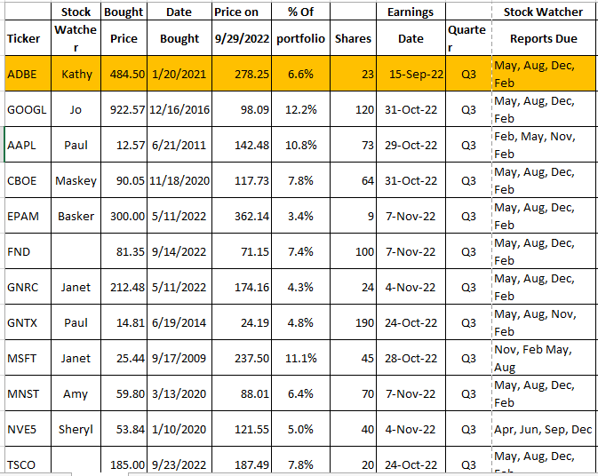
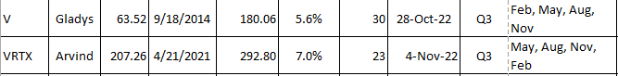

Meeting Adjourned: Kathy Emmons
Minutes Submitted by Arvind Krishna; Portfolio Stocks’ Earnings Calendar updated by Maskey Krishnarao

