Model Investment Club of Northern Virginia (MicNOVA)
DC Chapter of Better Investing
Minutes for the August 08, 2023 (Online Meeting)

Members Present: Sheryl Patterson, Arvind Krishna, Ty Hughes, Janet Lewis, Pat Onufrak, Jo Murphy, Maskey Krishnarao, Patrick Smith, Baskar Arumugam, Kathy Emmons
Members Absent: Gladys Henrikson, Paul O Mara
Proxies for Members: Sheryl for Gladys
Visitors/New Attendees Present: Fred Beckman, Carol Cuddihy, Cathy Duthie, Carmen Dudley, Ray Woods, Atul Manocha, Hien Nguyen, Helen Albanese, Paul Doku, Robert Beatly, Lisa Faustin, Janet Fitzhugh, Raj Satyanarayan

Arvind acted as the meeting lead. He welcomed guests including newcomers and led the meeting. He then started the meeting by explaining the club’s purpose & objectives, displayed the BI Disclaimer and explained all the clauses and stipulations.

- Secretary’s Report – Arvind
July 11-2023 Meeting Minutes report was presented by Arvind. No corrections were addressed in the draft minutes. Jo made the motion to accept minutes, which was seconded by Janet. The final Minutes as accepted are now posted in the Bivio folder.

- Treasurer’s Report – by Sheryl and Ty
Sheryl presented the Treasurer’s Report, which was accepted. The report indicated availability of $3,535 cash. Current IRR of the MicNova Portfolio is 27.32%.
A Motion was made to accept Treasurer’s Report, which passed. Final Treasurer’s report is filed in Bivio.
The new brokerage account for MicNova just opened and its registration completed with Fidelity has been successfully established by Gladys.
Gladys (on vacation during August meeting) has emailed to all the Partners that MicNova’s Fidelity brokerage account has transferred of its portfolio assets from Schwab. Partners can resume monthly contributions to MicNova Portfolio – instructions have already been provided by Gladys.

- Education & New Stock Presentation Timetable for 2023 – Sheryl
Partners are requested to identify their 2023 Education and Stock Presentation titles for the next 3 months in advance, so that Carol Cuddihy can submit them onto our BI webpage.

- Education: (Value Line Beyond the 1-Page PDF) - by Jo Murphy
Jo presented education on “Value Line (VL) Beyond the SSG”. She explained how the VL has much to offer to the Stock Investor in assessing the worth of a company and its stock. VL universe follows 1700 stocks representing 93 industries (refer to Page 24 in VL. Jo discussed the VL Dashboard – a weekly 3-part survey; VL Investment survey supplemental reports; and small/midcap weekly survey.

- New Stock Presentation: Toro Company (TTC) – by Pat
Pat presented a detailed analysis of new stock – TTC (NASDAQ). It is a Midcap Stock. Toro, a lawnmowers and irrigation equipment company, operates in two segments – Professional Segment and Residential Segment. SSG analysis shows “Buy” from $93.3 - $133.3. Current price is at $101.82. Current PE is too high. It was decided to put this stock under Stock Watch List for the next month.

- Stock Watcher Quarterly Reports Presented:
There were 5 stock watchers’ reports:
VISA (V) – Patrick – Recommend “Hold”
Generac (GNRC) - Ty – Currently at $116 but recommend “Hold”;
WAL - Sheryl – Good position to come back but “Hold” for Another Quarter then re-evaluate
GOOG – Jo – Current price at $132.97; Stock is finally turning around. Recommend “Hold”
MSFT – Janet – Recommend “Hold”
Stock Watchers (Please share the Online SSG with all MICNOVA members going forward)

- Watch List Stocks Review – by Sheryl
Sheryl mentioned that Malibu Boats is running “Loss”. She mentioned that we take out Superior Group”, “Malibu Boats” and “LCI industries” from the list. She likes AVNET, PAYPAL, and Taiwan Semiconductor as they have excellent quality rating and PAR and are in sweet spot of Manifest Dashboard.

- Current MICNOVA Portfolio Review: by Ty
Ty presented performance of our Portfolio – MicNova Dashboard – CBOE, EPAM and Clearfield are our major down stocks. Rest of the stocks are doing good. Overall, MicNova’s portfolio is in a better shape.

- Decision Buys/Sells: Partners
Ty made the motion to buy shares of PAYPAL at market (Buy range is from $59 - $106) for the balance of cash account in MicNova’s treasury. The motion passed with no objections.

- Member Questions and other Decisions: None

- Next Month Meeting Reminders – September 12, 2023:
Education | Topic: Stock Selection by Industry Study | Baskar
New Stock Presentation | STOCK: HEICO (Ticker: HEI) | Paul
Stock Watcher Reports Due | Stock Watchers ( Please share the Online SSG with all MicNOVA members):  - EPAM (Baskar)  - SSD (Ty)  - TSCO (Paul)  - VRTX (Arvind)  - WAL (Sheryl) | Baskar  Ty  Paul  Arvind  Sheryl
Portfolio Reports |  | Ty
Watch List Reports |  | Sheryl

2023 BI and Community Events & Announcements

Tue Sep 19 2023 07:30 - 09:00 PM  (Third Tuesdays of Month) | Money Matters Book Discussion. Book: Against the Gods: The Remarkable Story of Risk by Peter Bernstein  Online via GTM: You can also dial in using your phone.  United States: +1(646) 749-3122  One-touch: tel:+16467493122,,804623085#  Access Code: 804-623-085
Wed Sep 20 07:00 - 09:00 PM  Wed Oct 18 07:00 - 09:00 PM  (3nd Wednesdays of Month) | MCMC Monthly Meeting  https://global.gotomeeting.com/join/745127301  You can also dial in using your phone.  (For supported devices, tap a one-touch number below to join instantly.)  United States: +1 (872) 240-3311  - One-touch: tel:+18722403311,,745127301#  Access Code: 745-127-301
Fri Oct 6 2023 08:00 - 09:00 PM | DC Chapter Director Meeting
Mon Oct 2 2023 07:00 - 08:15 PM | Digging into BI Magazine  Registration URL: https://register.gotowebinar.com/rt/6574788583850753036  Webinar ID:729-893-259
Tue Oct 10 07:00 - 09:00 PM  (2nd Tuesdays of Month) | MicNOVA Monthly Meeting Online  https://global.gotomeeting.com/join/251997157  You can also dial in using your phone.  United States: +1 (312) 757-3121  Access Code: 251-997-157

Schedule: New Stock Presentation, Planning and Monthly Meeting Chair

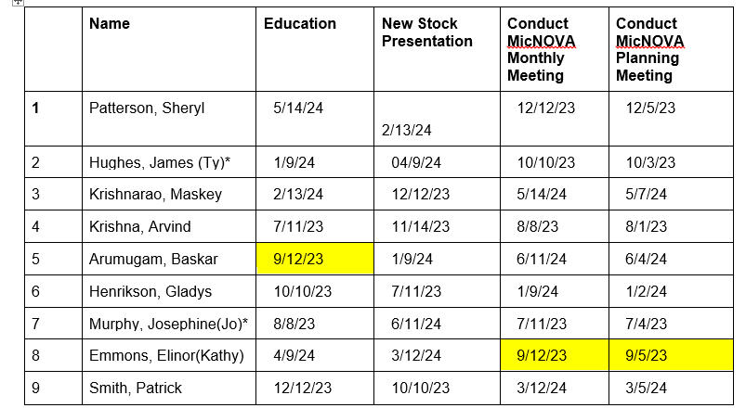
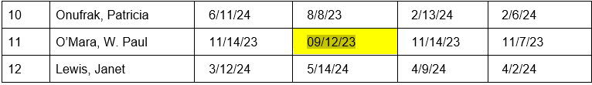

Stock Watcher Reports
MicNOVA Portfolio Updated with closing prices as of 09/01/23
Ticker | Stock Watcher | Bought Price | Date Bought | Closing Prices As of 9/1/23 | % of portfolio | Shares | Earnings Date | Quarter | Stock Watcher Reports Due
ADBE | Kathy | 484.5 | 1/20/21 | 436.57 | 15.40% | 23 | 18-Sep-23 | Q3 | May, Aug, Dec, Feb
GOOGL | Jo | 922.57 | 12/16/16 | 46.29 | 8.30% | 117 | 27-Oct-23 | Q3 | May, Aug, Dec, Feb
AAPL | Paul | 12.57 | 6/21/11 | 12.77 | 1.40% | 73 | 3-Aug-23 | Q3 | Feb, May, Nov, Feb
CLFD | TY | 62.92 | 2/15/23 | 50.27 | 4.00% | 52 | 3-Aug-23 | Q3 | Apr, Jun,Sep,Dec
EPAM | Baskar | 300 | 5/11/22 | 291.95 | 5.80% | 13 | 5-Jun-23 | Q2 | May, Aug, Dec, Feb
FND | Pat | 81.35 | 9/14/22 | 81.35 | 12.40% | 100 | 7-Aug-23 | Q1 | May, Aug, Dec, Feb
GNRC | Janet | 212.48 | 5/11/22 | 187.7 | 9.20% | 32 | 7-Aug-23 | Q2 | May, Aug, Dec, Feb
GNTX | TY | 14.81 | 6/19/14 | 14.81 | 4.30% | 190 | 20-Oct-23 | Q3 | May, Aug, Nov, Feb
MSFT | Janet | 25.44 | 9/17/09 | 25.44 | 1.70% | 43 | 27-Oct-23 | Q1 | Nov, Feb May, Aug
MNST | Amy | 59.8 | 3/13/20 | 33.14 | 7.10% | 140 | 7-Aug-23 | Q2 | May, Aug, Dec, Feb
NVE5 | Maskey | 53.84 | 1/10/20 | 53.84 | 3.30% | 40 | 9-Aug-23 | Q2 | Apr, Jun, Sep, Dec
PYPL | ????? | 62.591 | 8/9/23 | 62.6 | 5.40% | 56 | 6-Nov-23 | Q3 | May, Aug, Dec, Feb
SSD | TY | 95.61 | 12/14/22 | 96.41 | 5.90% | 40 | 28-Jul-23 | Q2 | May, Aug, Dec, Feb
TSCO | Paul | 185 | 9/23/22 | 185 | 5.70% | 20 | 24-Jul-23 | Q1 | May, Aug, Dec, Feb
V | Gladys | 63.52 | 9/18/14 | 63.52 | 2.90% | 30 | 27-Oct-23 | Q4 | Feb, May, Aug, Nov
VRTX | Arvind | 207.26 | 4/21/21 | 207.26 | 7.30% | 23 | 7-Jul-23 | Q2 | May, Aug, Nov, Feb
WAL | Sheryl | 59.225 | 12/15/22 | 39.16 | 7.30% | 159 | 24-Jul-23 | Q2 | May, Aug, Dec, Feb

For Future Education Topics:
See BI Ticker Talk, Stock-Up, and Learning Modules for ideas
Next 3 Months - Reminders
Oct 2023 | Education | Using the BI Stock Screener to find Great Stocks in Targeted Industries | Gladys
Oct 2023 | New Stock |  | Patrick
Nov 2023 | Education |  | Paul
Nov 2023 | New Stock |  | Arvind
Dec 2023 | Education |  | Patrick
Dec 2023 | New Stock |  | Maskey

Schedule: Education Topics For 2023
Title | Presenter
Please go to BI Website Ticker Talk to find the best topics for your Education Schedule. Come up with ideas and provide your schedule and topic next month

Meeting Adjourned: At 9 PM by Arvind
Minutes Submitted by Arvind Krishna; Portfolio Stocks’ Earnings Calendar updated by Maskey Krishnarao

