Model Investment Club of Northern Virginia (MicNOVA)
DC Chapter of Better Investing
Minutes for the December 12, 2023 (Online Meeting)

Members Present: Sheryl Patterson, Arvind Krishna, Ty Hughes, Pat Onufrak, Jo Murphy, Patrick Smith, , Maskey Krishnarao, Baskar Arumugam, Paul O’Mara, Gladys Henrickson, Andrew
Members Absent: Janet Lewis, Kathy Emmons
Proxies for Members: None
Visitors/New Attendees Present: Fred Beckmann, Paul Doku, Atul Manocha, Carol Cuddihy, Lisa Faustin, Lee Outlaw, Ray Woods, Vancii, Janel, Caller 01

Sheryl led the meeting. She welcomed guests including newcomers, stated the club’s purpose & objectives, displayed the BI Disclaimer and followed the meeting agenda.

- Secretary’s Report – Arvind
Nov 14, 2023 Meeting Minutes report was presented by Arvind. No corrections were addressed in the draft minutes. Sheryl made the motion to accept minutes as-presented. The final Minutes were accepted and now posted in the Bivio folder.

- Treasurer’s Report – Gladys
Gladys presented the Treasurer’s Report, which was accepted. The report indicated Cash Account basis: $19,380 and Total Securities & Cash Account basis: $77,978. Micnova accounts overall gains are $4,000 and losses are $1,000. Sheryl made the Motion to accept the report and the motion passed without objections. The Treasurer’s report is filed in Bivio

- Education & New Stock Presentation Timetable for 2024 – Sheryl
Partners are requested to identify their 2024 Education and Stock Presentation titles for the next 3 months in advance, so that Carol Cuddihy can submit them onto our BI webpage.

- Education: “First Cuts in Investment Research” - by Paul O’Mara
Paul presented an educational Session on First Cuts in Investment Research, based on first cut stock reports by BI. Paul provided an example of TSCO as an application of this concept since it is a high quality and growth stock.

- New Stock Presentation: “Catalyst Pharmaceutical, Inc.” (NasdaqCM: CPRX) - by Maskey
Maskey presented an analysis of new stock CPRX, in Healthcare sector (Biotechnology Industry) small CAP and a fast growth company – a commercial-stage biopharmaceutical company, focuses on developing and commercializing therapies for people with rare debilitating, chronic neuromuscular, and neurological diseases in the United States. It offers Firdapse, an amifampridine phosphate tablets for the treatment - an emerging leader in treatment of rare diseases. CPRX was founded in 2002 and is based in Coral Gables, Florida. SSG analysis shows “Buy” up to $16.4. Upside/downside of 5.0 to 1. Return at high PE is 20.2%. Recently Oppenheimer has initiated coverage of Catalyst Pharmaceuticals with an "Outperform" rating and $30 price target.

- Stock Watcher Quarterly Reports Presented:
There were 5 stock watchers’ reports scheduled:
Microsoft (Janet) – SSG shows “Sell” (at current $372.52). (But, viewed as a core, growth, stock in MicNova portfolio)
SSD (Ty) – SSG shows “Hold”
TSCO (Paul) – SSG shows “Buy”
Gentex (Maskey) – SSG shows “Buy”; Buy Range ($25.3 - $33.4); Current Price at $31.11
VRTX (Arvind) – SSG shows “Hold”. FDA approved VRTX new treatment “exa-cel” (on Dec 08) developed with CRISPER Therapeutics for treatment of severe sickle cell disease – expected to be launched by VRTX by year end. Recommend watch VRTX stock as we go forward.
Stock Watchers (Please share the Online SSG with all MICNOVA members going forward)

- Watch List Stocks Review – by Ty
Ty recommended to consider the Average P/E value for the SSG Rate of Return projections for each stock.

- Current MICNOVA Portfolio Review: by Ty
Ty made a comprehensive presentation of club’s Portfolio review as of 12/12/2023, which included data from resources – BIVIO Net Asset Value Report; Performance Report (Investment Account Manager); Better-Investing Reports, Portfolio Evaluation Review Technique (PERT) Report and Summary; and Manifest Investing Dashboard. Overall portfolio Annualized IRR – 34.78%, doing well this year. Unrealized Gain is $62,419 representing 86.5% of total portfolio. Manifest-Investing high PAR is for Gentex, Google, Visa, GNRC, TSCO, Monster Bev and PYPL. Manifest-Investing low PAR is for MS, Apple, VRTX and Adobe. Current Micnova Portfolio distribution is – 65% in Large CAP and 35% in Mid CAP and 31.7% of portfolio is in Tech. stocks. Ty recommended for the portfolio to add more-small CAP and mid-CAP stocks (Goal for the portfolio is to consist of 25% large, 50% mid and 25% Small stocks). Add more companies with PAR> 15%. Continue to watch Generac (GNRC) closely, look for positive revenue trends over the next two quarters, if positive, consider adding to the position, if negative, challenge.

- Decision Buys/Sells: Partners
Gladys made the MOTION to sell all 52 shares of GNRC. Motion passed by all Partners. Gladys executed the sale of 52 shares of Generac on Dec 13. Fidelity's confirmation information below: Dec-13-2023, Sold 32 Shares of GNRC at Market at $120.52
(Total proceeds: +$3,856.64).

- Member Questions and other Decisions: Partners
Patrick presented two ETF's as a suggestion for a benchmark that Micnova can use to park available cash funds while looking for and approve long term investments. Andrew liked the idea of having a goal to be fully invested, so we could leverage an index fund, per Patrick’s proposal. Pat questioned the wisdom of investing money (available cash) in one investment with the intent of using that money at a moment's notice to purchase another investment. Pat indicated that our cash holdings are incredibly short term. Why would Micnova invest it in what may essentially be a core holding with the inherent market risk. There is nothing wrong with parking money at 5% (money market fund) while we catch up. No specific decisions resulted from the discussion.

- Next Month Meeting Reminders – January 09, 2024:

Education | Topic: | Ty
New Stock Presentation | STOCK: | Baskar
Stock Watcher Reports Due | Stock Watchers ( Please share the Online SSG with all MicNOVA members):  - ADBE  - AAPL  - PYPL  - MNST | Kathy  Paul  Baskar  Gladys
Portfolio Reports |  | Ty
Watch List Reports |  | Sheryl

2024 BI and Community Events & Announcements:
Dec 20, 2023 7-9p | MCMC Monthly Meeting Online  https://global.gotomeeting.com/join/745127301  You can also dial in using your phone.  (For supported devices, tap a one-touch number below to join instantly.)  United States: +1 (872) 240-3311  - One-touch: tel:+18722403311,,745127301#  Access Code: 745-127-301
Dec 31, 2023 | Deadline for BINC (May 16-19) discount. Register online ($550/members; $675/non-members; Spouses= $400; Student 30 = $299; Chapter director =$450)
Fri Jan 5, 2024, 08:00 - 09:00 PM | DC Chapter Director Meeting
Mon Jan 8, 2024, 07:00 - 08:15 PM | Digging into BI Magazine  Registration URL: https://register.gotowebinar.com/rt/6574788583850753036  Webinar ID:729-893-259
Tue Jan 9 07:00 - 09:00 PM  (2nd Tuesdays of Month) | MicNOVA Monthly Meeting Online  https://global.gotomeeting.com/join/251997157  You can also dial in using your phone.  United States: +1 (312) 757-3121  Access Code: 251-997-157
Tue Jan 16 2024 07:30 - 09:00 PM  (Third Tuesdays of Month) | Money Matters Book Discussion. Book: One Up On Wall Street by Peter Lynch  Online via GTM: You can also dial in using your phone.  United States: +1(646) 749-3122  One-touch: tel:+16467493122,,804623085#  Access Code: 804-623-085
Wed Jan 17 07:00 - 09:00 PM  Wed Feb 21 07:00 - 09:00 PM  (3nd Wednesdays of Month) | MCMC Monthly Meeting  https://global.gotomeeting.com/join/745127301  You can also dial in using your phone.  (For supported devices, tap a one-touch number below to join instantly.)  United States: +1 (872) 240-3311  - One-touch: tel:+18722403311,,745127301#  Access Code: 745-127-301

Schedule: New Stock Presentation, Planning and Monthly Meeting Chair
 | Name | Education | New Stock Presentation | Conduct MicNOVA Monthly Meeting | Conduct MicNOVA Planning Meeting
1 | Patterson, Sheryl | 5/14/24 | 2/13/24 | 12/12/23 | 12/5/23
2 | Hughes, James (Ty)* | 1/9/24 | 04/9/24 | 10/8/24 | 10/1/24
3 | Krishnarao, Maskey | 2/13/24 | 12/12/24 | 5/14/24 | 5/7/24
4 | Krishna, Arvind | 7/9/24 | 11/14/24 | 8/13/24 | 8/6/24
5 | Arumugam, Baskar | 9/10/24 | 1/9/24 | 6/11/24 | 6/4/24
6 | Henrikson, Gladys | 10/8/24 | TBD | TBD | TBD
7 | Murphy, Josephine (Jo) | 8/13/24 | 6/11/24 | 7/9/24 | 7/2/24
8 | Emmons, Elinor(Kathy) | 4/9/24 | 3/12/24 | 9/10/24 | 9/3/24
9 | Smith, Patrick | 12/12/23 | 10/8/24 | 3/12/24 | 3/5/24
10 | Onufrak, Patricia | 6/11/24 | 8/13/24 | 2/13/24 | 2/6/24
11 | O’Mara, W. Paul | 11/14/23 | 09/10/24 | 11/14/24 | 11/7/24
12 | Lewis, Janet | 3/12/24 | 5/14/24 | 4/9/24 | 4/2/24
13 | Ober, Andrew |  | 7/9/24 * | 1/9/24* | 1/2/24*

For Future Education Topics:
See BI Ticker Talk, Stock-Up, and Learning Modules for ideas
Next 3 Months - Reminders
Feb 2024 | New Stock |  | Sheryl
Feb 2024 | Education |  | Maskey
Mar 2024 | New Stock |  | Kathy
Mar 2024 | Education |  | Janet
Apr 2024 | New Stock |  | Ty
Apr 2024 | Education |  | Kathy

Schedule: Education Topics For 2024
Please go to BI Website’s Ticker Talk, Stock-Up, and Volunteer 4-Bits to find good topics for your Education Schedule. Provide your schedule and topic 3 months in advance.

MicNOVA Portfolio & Stock Watchers: Updated closing prices as of December 08-2023

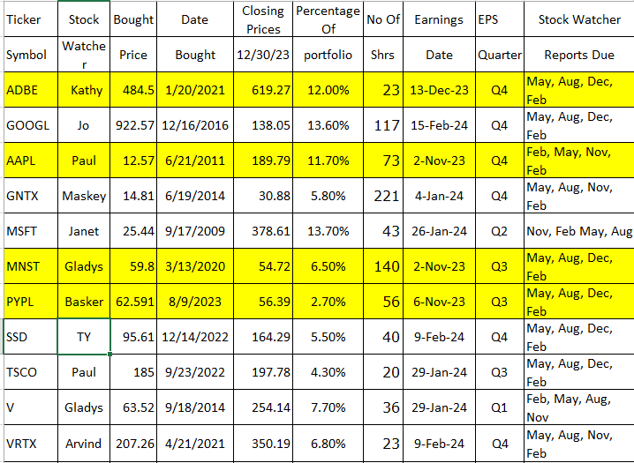

Meeting Adjourned: At 9 PM by Sheryl
Minutes Submitted by Arvind Krishna; Portfolio Stocks’ Earnings Calendar updated by Maskey Krishnarao

