Model Investment Club of Northern Virginia (MicNOVA)
DC Chapter of Better Investing
Minutes for the April 11, 2023 (Online Meeting)

Members Present: Sheryl Patterson, Arvind Krishna, Ty Hughes, Gladys Henrikson, Paul O Mara, Kathy Emmons, Janet Lewis, Jo Murphy, Baskar Arumugam, Pat Onufrak
Members Absent: Maskey Krishnarao
Proxies for Members: None
Visitors/New Attendees Present: Thomas Brooks, Allen Foster, Carol Cuddihy, Patrick Smith, Carol, Joe Farrell, Andrew, Lee Outlaw, Ray Woods, Catherine Duthie, T. Yuval, Jigar Parikh, Atul Mariocha

Janet Lewis acted as the meeting lead. She welcomed guests including newcomers and led the meeting. She then started the meeting by explaining the club’s purpose & objectives, displayed the BI Disclaimer and explained all the clauses and stipulations.

- Secretary’s Report – Arvind
March 14, 2023 Meeting Minutes report was presented by Arvind. No corrections were addressed in the draft minutes. Gladys made the motion to accept minutes, which was seconded. The Secretary’s minutes were approved without any further editing. Final Minutes are now posted in the Bivio folder.

- Treasurer’s Report – Gladys
Gladys presented the Treasurer’s Report indicating the availability of $3615 available to buy stocks. Total securities and cash are now at approximately $107,854. Motion was made to accept Treasurer’s report and seconded. Motion to accept the Treasurer’s report to date was passed by the Partners.
Gladys has sent emails to all the Partners with some recent notes regarding upcoming transition and expected address change of MICNOVA accounts to SCHWAB from the current brokerage TD Ameritrade.

- Amy Laing Resignation Final Payoff – Jo
Jo Murphy, Ty Hughes, and Maskey met online and proposed that to pay Amy's Withdrawal, valued at ($960.3) as of March 31, 2023, the club give her 2 shares of Microsoft, 3 shares of Google, and the balance in cash ($71.76). The stock transfers would trim an overbalance in MicNova’s portfolio. Janet moved that the club accept the committee’s proposal and it passed.

- Education & New Stock Presentation Timetable for 2023 – Baskar/Sheryl/Gladys
Partners are requested to identify their 2023 Education and Stock Presentation titles for the next 3 months in advance, so that Carol Cuddihy can submit them onto our BI webpage.

- Education: “The PEG Ratio – What Does it Mean” - by Kathy
Kathy Emmons presented a well-illustrated session on how to use the PEG (Price to Expected Earnings Growth) ratio to determine whether a stock is overvalued or on sale. Her presentation covered explanation of what PEG means and how it is measured. She also explained the differences between PE and PEG Ratios. A stock with PEG ratio closer to 1.5 is better, while a PEG of 1 is optimum. Her presentation is filed in Bivio under Public – Education, March 2023.

- New Stock Presentation: Installed Building Products (IBP) – by Ty
Ty presented new stock - IBP, which is in the residential construction industry in the Consumer Cyclical Group (75% in new construction and 6% in remodeling business). He projected a 9% growth for this firm and the company has had excellent revenue growth including lot of acquisitions. Does not offer a dividend. At current price $107, Value Line and Ty’s SSG place this stock in the Buy range. The Club voted to place this stock on our Portfolio Watch list. Ty's presentation is also filed in Bivio.

- Stock Watcher Quarterly Reports Presented:
- Adobe (Kathy) – SSG recommends “BUY”. Kathy Recommended - buy more Adobe. Current Price - $380.60. Buy Range from SSG is $264 - $436
- SSD (Ty) – SSG recommends “Buy”. MICNOVA bought this stock at $96.41/share and price as of April Meeting was $106.36. Morningstar’s Fair Value is $135/share; and Manifest Investing indicated its growth rate at about 10%. Ty recommended against buying more of SSD since 3.8% of our portfolio is already in this stock.
- MNST (Maskey) – Postponed, since stock watcher was not present in the meeting

Stock Watchers (Please share the Online SSG with all MICNOVA members going forward)

- Watch List Stocks Review – by Gladys
Gladys made the motion for new stock IBP presented by Ty to be added to the Watch list. The motion passed.

- Portfolio Review: Closer Look at the Current MICNOVA Portfolio – by Ty
Ty presented a review of the MICNOVA portfolio Performance Report, year-to-date ending 04/11/23. The annualized IRR for the period from 01/01/2023 - 04/11/2023 is 38.07. There are currently 17 stocks in the Portfolio. The stocks with negative IRR are: CLFD, EPAM, GNRC, NVEE, and WAL.
Ty reviewed the SSG for CLFD – everything looked good – no negatives were seen – at the current price of $61.41, it is in the Buy Range.

YTD, MICNOVA portfolio had a return of 13.2% vs. 8.34% for the total US market.
Our big winners so far this year are Simpson Manufacturing (+42%), Apple (+30.6%), Microsoft (+28.2%), and Google (+22%).
MICNOVA laggards are Western Alliance (-29.2%), NV5 Global (-28.4%), Clearfield (-18.5%), and EPAM (-11%). We need to have a good discussion on these laggards at the next meeting, May 9, after all the quarterly earnings reports are in. We have also lost money on Generac (-$2,735) and Adobe (-$1,357). Apple and Microsoft, as indicated above, are our big winners.

- Decision Buys/Sells: Partners
After much discussion, the Club voted to defer sell/buy any stocks until the next meeting in May, when the first quarter earnings are expected to be announced. Kathy made the motion to buy 5 shares of Adobe but the motion did not pass.
NOTE: Gladys picked up MNST as the stock watcher, which was previously being watched by Amy who has now resigned from MICNOVA.

- Member Questions and other Matters - Partners
Patrick (Guest) had a question regarding his desire to join MICNOVA. Gladys explained him the process to join MICNOVA as a partner and make monthly contributions to the Portfolio. Gladys indicated that she would follow up with him with the required documents that he has to submit.
Jigar Parikh (Guest) also expressed his desire to join MICNOVA. He also wanted to learn the process for “How to start a new BI Club in his community – Ashburn, VA.

- Next Month Meeting Reminders – May 09, 2023:
Education | - What other clubs are doing  - How to do First Cut | Sheryl
New Stock Presentation | STOCK: Avnet Inc (Ticker: AVT) | Janet
Stock Watcher Reports Due | Stock Watchers ( Please share the Online SSG with all MicNOVA members):  - MSFT  - TSCO  - V  - WAL  - MNST  - CLFD | Janet  Paul  Gladys  Maskey  Gladys  Ty
Portfolio Reports |  | Ty
Watch List Reports |  | Sheryl

2023 BI and Community Events & Announcements

Tue Apr 18 2023 07:30 - 09:00 PM  (Third Tuesdays of Month) | Money Matters Book Discussion. Book: The Most Important Thing: Uncommon Sense for the Thoughtful Investor by Howard Marks  Online via GTM: You can also dial in using your phone.  United States: +1(646) 749-3122  One-touch: tel:+16467493122,,804623085#  Access Code: 804-623-085
Wed Apr 19 07:00 - 09:00 PM  Wed May 17 07:00 - 09:00 PM  (3nd Wednesdays of Month) | MCMC Monthly Meeting  https://global.gotomeeting.com/join/745127301  You can also dial in using your phone.  (For supported devices, tap a one-touch number below to join instantly.)  United States: +1 (872) 240-3311  - One-touch: tel:+18722403311,,745127301#  Access Code: 745-127-301
Fri May 5 2023 08:00 - 09:00 PM | DC Chapter Monthly Meeting
Sat May 6th 2023 | Club Anniversary Recognition – Sheryl stressed that everyone should attend this planned Anniversary Meeting
Tue May 9 07:00 - 09:00 PM  (2nd Tuesdays of Month) | MicNOVA Monthly Meeting Online  https://global.gotomeeting.com/join/251997157  You can also dial in using your phone.  United States: +1 (312) 757-3121  Access Code: 251-997-157
Tue May 16 2023 07:30 - 09:00 PM  (Third Tuesdays of Month) | Money Matters Book Discussion. Book: The Intelligent Investor by Benjamin Graham, 1947  Online via GTM: You can also dial in using your phone.  United States: +1(646) 749-3122  One-touch: tel:+16467493122,,804623085#  Access Code: 804-623-085
Thursday, May 18 8:00 – 9:30 PM EDT | Bite of BINC Register on the BetterInvesting site. Janet stressed that ever one should participate in this event
June 3 10:00 AM EDT  June 10 3:00 PM EDT | Virtual BINC $125.00 (Includes recordings for all of BINC and Bite of BINC through Dec 31 2023)  Virtual BINC Second sessions
Bogleheads Conference 2023 - an incredible lineup of investment & personal finance experts who will be appearing at the conference for the first time along with regulars – Highly recommended by Ty Hughes. | Conference Dates: October 13-15, 2023, at the Bethesda North Marriott Hotel & Conference Center - Rockville, MD. Early-bird registration is $495 until May 31. The banquet is additional $100 /person. Starting June 1, the registration fee will be $595 + banquet at additional $100 per person. For more information, refer to Ty’s email sent to all the members & guests.

Schedule: New Stock Presentation, Planning and Monthly Meeting Chair
Name | Education | New Stock Presentation | Conduct MicNOVA Monthly Meeting | Conduct MicNOVA Planning Meeting
Patterson, Sheryl | 5/9/23 | 2/13/24 | 12/12/23 | 12/5/23
Hughes, James (Ty)* | 1/9/24 | 04/11/23 | 10/10/23 | 10/3/23
Krishnarao, Maskey | 2/13/24 | 12/12/23 | 5/9/23 | 5/2/23
Krishna, Arvind | 7/11/23 | 11/14/23 | 8/8/23 | 8/1/23
Arumugam, Baskar | 9/12/23 | 1/9/24 | 6/13/23 | 6/3/23
Henrikson, Gladys | 10/10/23 | 8/8/23 | 1/9/24 | 1/2/24
Murphy, Josephine(Jo)* | 8/8/23 | 6/13/23 | 7/11/23 | 7/4/23
Emmons, Elinor(Kathy) | 4/11/23 | 3/14/23 | 9/12/23 | 9/5/23
Henrikson, Gladys | 12/12/23 | 10/10/23 | 3/14/23 | 3/7/23
Onufrak, Patricia | 6/13/23 | 7/11/23 | 2/13/24 | 2/6/24
O’Mara, W. Paul | 11/14/23 | 09/12/23 | 11/14/23 | 11/7/23
Lewis, Janet | 3/14/23 | 5/9/23 | 4/11/23 | 4/4/23

For Future Education Topics:
See BI Ticker Talk, Stock-Up, and Learning Modules for ideas

Next 3 Months - Reminders
May 2023 | Education | - What other clubs are doing  - How to do First Cut | Sheryl
May 2023 | New Stock | Avnet Inc (Ticker: AVT) | Janet
Jun 2023 | Education |  | ???? not Pat
Jun 2023 | New Stock |  | Jo
Jul 2023 | Education |  | Arvind
Jul 2023 | New Stock |  | Pat

Schedule: Education Topics For 2023
Title | Presenter
How to do a First Cut | Sheryl
Please go to BI Website Ticker Talk to find the best topics for your Education Schedule. Come up with ideas and provide your schedule and topic next month

MicNOVA Portfolio and Stock Watchers: Updated with closing prices as of 03/31/2023

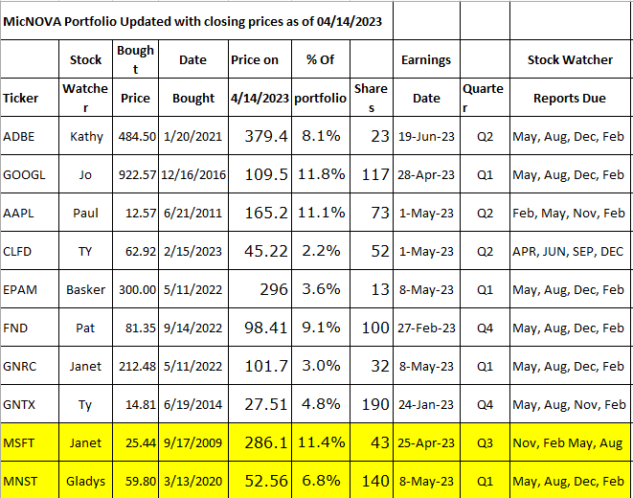
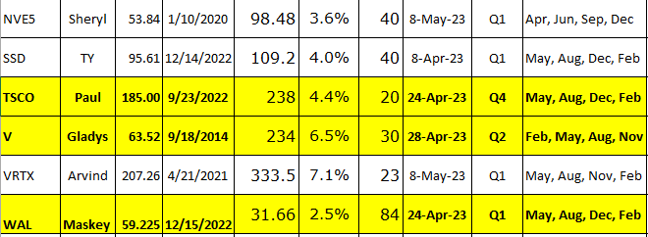

Meeting Adjourned: At 9 PM by Janet
Minutes Submitted by Arvind Krishna; Portfolio Stocks’ Earnings Calendar updated by Maskey Krishnarao

