Model Investment Club of Northern Virginia (MicNOVA)
DC Chapter of Better Investing
Minutes for the November 14, 2023 (Online Meeting)

Members Present: Sheryl Patterson, Arvind Krishna, Ty Hughes, Janet Lewis, Pat Onufrak, Jo Murphy, Patrick Smith, Kathy Emmons
Members Absent: Paul O’Mara, Gladys Henrikson, Maskey Krishnarao, Baskar Arumugam
Proxies for Members: None
Visitors/New Attendees Present: Andrew, Fred Beckmann, Paul Doku, Atul Manocha, Carol Cuddihy, Lisa Faustin, Carmen Dudley, Allan Foster, Lee Outlaw, Ray Woods, Cathy Duthie, Caller 01

Ty led the meeting. He welcomed guests including newcomers, stated the club’s purpose & objectives, displayed the BI Disclaimer and followed the meeting agenda.

- Secretary’s Report – Arvind
Oct 10, 2023 Meeting Minutes report was presented by Arvind. No corrections were addressed in the draft minutes. Ty made the motion to accept minutes, which was seconded by Sheryl. The final Minutes as accepted are now posted in the Bivio folder.

- Treasurer’s Report – Ty
Ty presented the Treasurer’s Report, which was accepted. The report indicated Cash Account basis: $16,493 and Total Securities & Cash Account basis: $77,905. A motion was made to accept the report and the motion passed without objections. The report is filed in Bivio

- Education & New Stock Presentation Timetable for 2023 - 2024 – Sheryl
Partners are requested to identify their 2023 - 2024 Education and Stock Presentation titles for the next 3 months in advance, so that Carol Cuddihy can submit them onto our BI webpage.

- Education: SSG Plus Pre-defined Screens - by Patrick
Patrick presented a detailed educational Session on Stock Screening based upon SSG Plus, Pre-defined screens.

- New Stock Presentation: ASML Holding N. V. ADR (ASML) - by Ty
Ty presented an analysis of new stock ASML, which is a N.V. Headquartered company (traded on NASDQ) - a highly specialized company in the Semiconductor & Semiconductor Equipment market, renowned for its advanced photolithography systems. ASML develops, produces, markets, sells, and services advanced semiconductor equipment systems consisting of lithography, metrology, and inspection systems for memory and logic chipmakers. ASML is a large cap (Market Cap $232B) stock. Current price of the stock is $654.60 (52 week range: $437.12 - $771.98). SSG analysis showed “Buy”.

- New Stock Presentation: ACM Research (ACMR) – by Arvind
Arvind presented a new stock - ACMR (a small Cap NASDQ Stock). ACMR develops, manufactures, and sells single-wafer wet cleaning equipment for enhancing the manufacturing process and yield for Integrated Chips (IC) Worldwide. Founded in 1998 in Silicon Valley (HQ in Freemont - CA), ACMR produces most advanced wet processing cleaning technology products including electroplating processes & the ultimate in thermal deposition for the semiconductor industry. Conducts its R&D and Manuf. & Service Support Operations in Shanghai, China. SSG showed a Buy range from 12.6 to 21.2 and it is a “BUY” at today’s price of $17.6.

- Stock Watcher Quarterly Reports Presented:
There were 5 stock watchers’ reports scheduled:
Google (Jo) - Google is a HOLD (10% of our holdings). Not recommending the club to buy any more shares of this stock.
Adobe (Kathy) – SSG shows “Buy”. Adobe has made a rebound earlier this year.
Clearfield (Ty) – Ty recommended to “Sell” this stock which represents 1% of the portfolio
Gentex (Not presented since Maskey was absent)
WAL (Sheryl) – SSG shows “Buy” but recommend “Hold”
Stock Watchers (Please share the Online SSG with all MICNOVA members going forward)

- Watch List Stocks Review – by Ty
Ty recommended to consider the Average P/E value for the SSG Rate of Return projections for each stock.

- Current MICNOVA Portfolio Review: by Ty
Ty made a comprehensive presentation of club’s Portfolio review as of 11/14/2023, which included data from resources – BIVIO Net Asset Value Report; Performance Report (Investment Account Manager); Better-Investing Reports, Portfolio Evaluation Review Technique (PERT) Report and Summary; and Manifest Investing Dashboard. Apple & Microsoft have produced good returns. GNRC has been a loser. Overall portfolio Annualized IRR - 32.28%, doing well this year. GNRC, PYPL, WAL, GNTX & CLFD are in the “Buy” range. Manifest-Investing high PAR is for CLFD and PYPL. Ty recommended - Sell Clearfield (CLFD), Watch Generac (GNRC) closely, look for positive revenue trends over the next two quarters, if positive, consider adding to the position, If negative, challenge.
Ty mentioned that Micnova Portfolio is heavily invested in large CAP stocks – recommended to move more towards mid/small CAP stocks.

- Decision Buys/Sells: Partners
Sheryl made the MOTION to sell all 52 shares of Clearfield - CLFD. The motion passed – all voted in favor except Kathy voted against it.
- Member Questions and other Decisions: None

- Next Month Meeting Reminders – December 12, 2023:

Education | Topic: | Maskey
New Stock Presentation | STOCK: | Maskey
Stock Watcher Reports Due | Stock Watchers ( Please share the Online SSG with all MicNOVA members):  - GNTX  - MSFT  - SSD  - TSCO  - V  - VRTX
Portfolio Reports |  | Ty
Watch List Reports |  | Sheryl

2023 BI and Community Events & Announcements:

Tue Nov 21 2023 07:30 - 09:00 PM
(Third Tuesdays of Month)
Money Matters Book Discussion. Book: Where the Money is:
Value Investing in the Digital Age by Adam Seessel
Online via GTM: You can also dial in using your phone.
United States: +1(646) 749-3122
One-touch: tel:+16467493122,,804623085#
Access Code: 804-623-085

Wed Nov 15 07:00 - 09:00 PM
Wed Dec 20 07:00 - 09:00 PM
(3nd Wednesdays of Month)
MCMC Monthly Meeting
https://global.gotomeeting.com/join/745127301
You can also dial in using your phone.
(For supported devices, tap a one-touch number below to join instantly.)
United States: +1 (872) 240-3311
One-touch: tel:+18722403311,,745127301#
Access Code: 745-127-301

Fri Dec 1 2023 08:00 - 09:00 PM DC Chapter Director Meeting
Mon Dec 4 2023 07:00 - 08:15 PM
Digging into BI Magazine
Registration URL:
https://register.gotowebinar.com/rt/6574788583850753036
Webinar ID: 729-893-259

Tue Dec 12 07:00 - 09:00 PM
(2nd Tuesdays of Month)
MicNOVA Monthly Meeting Online
https://global.gotomeeting.com/join/251997157
You can also dial in using your phone.
United States: +1 (312) 757-3121
Access Code: 251-997-157

Schedule: New Stock Presentation, Planning and Monthly Meeting Chair
 | Name | Education | New Stock Presentation | Conduct MicNOVA Monthly Meeting | Conduct MicNOVA Planning Meeting
1 | Patterson, Sheryl | 5/9/23 | 2/13/24 | 12/12/23 | 12/5/23
2 | Hughes, James (Ty)* | 1/9/24 | 04/11/23 | 10/10/23 | 10/3/23
3 | Krishnarao, Maskey | 2/13/24 | 12/12/23 | 5/9/23/  Baskar | 5/2/23  Jo
4 | Krishna, Arvind | 7/11/23 | 11/14/23 | 8/8/23 | 8/1/23
5 | Arumugam, Baskar | 9/12/23 | 1/9/24 | 6/13/23 | 6/3/23
6 | Henrikson, Gladys | 10/10/23 | 7/11/23 | 1/9/24 | 1/2/24
7 | Murphy, Josephine(Jo)* | 8/8/23 | 6/13/23 | 7/11/23 | 7/4/23
8 | Emmons, Elinor(Kathy) | 4/11/23 | 3/12/24 | 9/12/23 | 9/5/23
9 | Smith, Patrick | 11/14/23 | 10/10/23 | 3/12/24 | 3/5/24
10 | Onufrak, Patricia | 6/13/23 | 8/08/23 | 2/13/24 | 2/6/24
11 | O’Mara, W. Paul | 11/14/23 | 09/12/23 | 11/14/23 | 11/7/23
12 | Lewis, Janet | 3/12/24 | 5/9/23 | 4/11/23 | 4/4/23
13 | Ober, Andrew

For Future Education Topics:
See BI Ticker Talk, Stock-Up, and Learning Modules for ideas
Next 3 Months - Reminders
Jan 2024 | New Stock |  | Baskar
Jan 2024 | Education |  | Ty
Feb 2024 | New Stock |  | Sheryl
Feb 2024 | Education |  | Maskey
Mar 2024 | New Stock |  | Kathy
Mar 2024 | Education |  | Janet

Schedule: Education Topics For 2024
Please go to BI Website’s Ticker Talk, Stock-Up, and Volunteer 4-Bits to find good topics for your Education Schedule. Provide your schedule and topic 3 months in advance.
MicNOVA Portfolio and Stock Watchers: Updated with closing prices as of November 2023
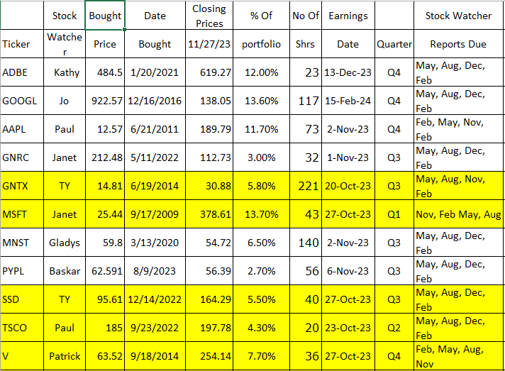
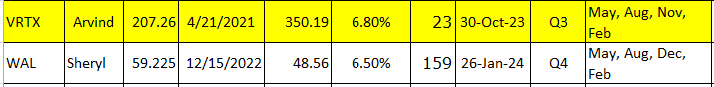

Meeting Adjourned: At 9 PM by Ty
Minutes Submitted by Arvind Krishna; Portfolio Stocks’ Earnings Calendar updated by Maskey Krishnarao

