Model Investment Club of Northern Virginia (MicNOVA)
DC Chapter of Better Investing
Minutes for the February 13, 2024 (Online Meeting)

Members Present: Sheryl Patterson, Arvind Krishna, Pat Onufrak, Jo Murphy, Patrick Smith, , Maskey Krishnarao, Baskar Arumugam, Gladys Henrikson, Andrew Ober, Kathy Emmons, Paul O’Mara
Members Absent: Ty Hughes, Janet Lewis
Proxies for Members: None
Visitors/New Attendees Present: Fred Beckmann, Atul Manocha, Carol Cuddihy, Lisa Faustin, Janel, Lee Outlaw, Gary Chan, Keyur Sharma, Carol 01

Pat Onufrak led the meeting. She welcomed guests including newcomers, stated the club’s purpose & objectives, displayed the BI Disclaimer and followed the meeting agenda.

- Secretary’s Report – Arvind
Jan 09, 2024 Meeting Minutes report was presented by Arvind. No corrections were addressed in the draft minutes. Sheryl made the motion to accept minutes as-presented. Maskey seconded. The final Minutes are now posted in the Bivio folder.

- Treasurer’s Report – Gladys
Gladys presented the Treasurer’s Report, which was accepted. The report indicated Cash Account basis: $6,603 and Total Securities & Cash Account basis: $77,613. Sheryl made the Motion to accept the report, which passed without objections. The Treasurer’s report is filed in Bivio.
Gladys, informed that MicNova IRS 2023 taxes are due on March 15 as she is now working out the details of data extracted from the statements received from three different brokerages.

- Education & New Stock Presentation Timetable for 2024 – Sheryl
Partners are requested to identify their 2024 Education and Stock Presentation titles for the next 3 months in advance, so that Carol Cuddihy can submit them onto our BI webpage.

- Education: “BI Presentation – Getting a Start in Investment (Why, What and How)” - by Maskey
Maskey presented an educational Session reviewing the presentation given by Ken Kavula and Mark Robertson at the BI – Mid Michigan Chapter, Jan 3 – 4, 2024. The presentation was a refresher for many concepts that we are supposed to use during a stock analysis by using the BI tool SSG. It reviewed the fundamental attributes of a company that determine its growth and success including - forecasting sales & earnings, income analysis, debt ratios, calculating earnings per share, forecasting 5 Year average P/E and earnings, etc.. It emphasized that EARNINGS FOLLOW SALES AND STOCK PRICE FOLLOWS EARNINGS

- New Stock Presentation: “Allient” (Nasdaq - ALNT) - by Sheryl
Sheryl presented an analysis of new stock ALNT, a small CAP manufacturer of precision equipment. A technology industry stock picked from the Small Cap Informer. Target markets for ALNT are Industrial, Vehicle, Medical devices & equipment and Aerospace & Defense. ALNT is also in Mega Technology Trends – Electrification, Energy Efficiency and Industrial Automation. ALNT drives long term global growth both organically and through complementary M&A. ALNT is currently undervalued (Current P/E 19.7, trading below its 5 year average PE 23.3). SSG shows that at current price of $27.30 is Buy price to satisfy 3:1 US/DS & 15% return. ALNT could be a worthy candidate for purchase.

- Stock Watcher Quarterly Reports Presented:
There were 6 stock watchers’ reports due this month:

- GNTX - Maskey – SSG shows BUY, current $35.32; Recommend HOLD
- Microsoft - Janet - absent from the meeting
- Western Alliance - Sheryl – SSG shows “HOLD”. Current Price $61.57. Recommend “HOLD”
- VISA - Patrick – SSG shows BUY. Current Price $273.36. Recommend “HOLD”
- Alphabet - Jo – Recommend “HOLD”
- Apple - Gladys presented for Paul. Currently overvalued. Recommend “HOLD”
Stock Watchers (Please share the Online SSG with all MICNOVA members going forward)

- Watch List Stocks Review – Sheryl
Sheryl recommended to put ALNT (new stock presented during this meeting) on a Watchlist.

- Current MICNOVA Portfolio Review: by Ty
Ty was absent to conduct the Portfolio review – postponed until next month in March

- Decision Buys/Sells: Partners
Sheryl made the motion to buy ALNT (at market) shares worth $3,500 from the Treasury. Kathy seconded. Motion passed w/o any objections. (Follow-up: Gladys bought 129 shares at $29.8521/share, for a total investment of $ 3,850.92. She reported that she did not use a Limit Order of $27.xx/share, because the price, when she placed the order, appeared slightly below the limit. Unfortunately, the market price was volatile and the settle price was higher than the $27.xx/share. In fact, it never fell below $28/share subsequent to the Feb 13 meeting.)

- Member Questions and other Decisions: Partners
Gladys: Regarding Lisa Faustin’s application to join MICNOVA - Given our current 13 members, I received positive votes from 11, by email, and nothing from the other 2. Since 11 is a majority and there were no objections, I recommend her admission into the club.
Other matters to be addressed at the Planning Meeting (March 5) are:
1) Straightening out the assignments schedule. We made some adjustments (mainly to Paul O'Mara's schedule, which he can't fulfil) as we tried to accommodate Kathy Emmons surgery this month and Janet's illness.
2) Deciding how and when to change stock watchers and when to plan for nominations and elections of next year's officers. (Officers usually take over their duties in the fall, coinciding with BI's calendar year)

- Next Month Meeting Reminders – March 12, 2024:
Education | Topic: Investment Ratios | Gladys
New Stock Presentation | STOCK: Addus Homecare Corporation (Ticker: ADUS) | Andrew
Stock Watcher Reports Due | Stock Watchers ( Please share the Online SSG with all MicNOVA members):  - MSFT  - EXLS  - SSD  - TSCO  - VRTX  - PYPL | Janet  Baskar  Ty  Paul  Arvind  Pat
Portfolio Reports |  | Ty
Watch List Reports |  | Sheryl

2024 BI and Community Events & Announcements:
Feb 15 2024 08:00 - 09:15 PM | Stock Up: The ABCs of Google  Registration required
Tue Feb 20 2024 07:30 - 09:00 PM  (Third Tuesdays of Month) | Money Matters Book Discussion. Book: Talks at Google: Quantum Supremacy by Michio Kaku  Online via GTM: You can also dial in using your phone.  United States: +1(646) 749-3122  One-touch: tel:+16467493122,,804623085#  Access Code: 804-623-085
Wed Feb 21 07:00 - 09:00 PM  Wed Mar 20 07:00 - 09:00 PM  (3nd Wednesdays of Month) | MCMC Monthly Meeting  https://global.gotomeeting.com/join/745127301  You can also dial in using your phone.  (For supported devices, tap a one-touch number below to join instantly.)  United States: +1 (872) 240-3311  - One-touch: tel:+18722403311,,745127301#  Access Code: 745-127-301
Thu Feb 22 2024 08:00-09:15 PM | Ticker Talk: Overview of Ratios Tab in SSGPlus  Registration Required
Fri Mar 1 2024 08:00 - 09:00 PM | DC Chapter Director Meeting
Mon Mar 4 2024 07:00 - 08:15 PM | Digging into BI Magazine  Registration URL: https://register.gotowebinar.com/rt/6574788583850753036  Webinar ID:729-893-259
Tue Mar 12 07:00 - 09:00 PM  (2nd Tuesdays of Month) | MicNOVA Monthly Meeting Online  https://global.gotomeeting.com/join/251997157  You can also dial in using your phone.  United States: +1 (312) 757-3121  Access Code: 251-997-157

Schedule: New Stock Presentation, Planning and Monthly Meeting Chair
 | Name | Education | New Stock Presentation | Conduct MicNOVA Monthly Meeting | Conduct MicNOVA Planning Meeting
1 | Patterson, Sheryl | 5/14/24 | 3/11/24 | 12/12/23 | 12/5/23
2 | Hughes, James (Ty)* | 1/9/24 | 04/9/24 | 10/8/24 | 10/1/24
3 | Krishnarao, Maskey | 2/13/24 | 01/14/25 | 5/14/24 | 5/7/24
4 | Krishna, Arvind | 7/9/29 | 12/10/24 | 8/13/24 | 8/6/24
5 | Arumugam, Baskar | 9/10/24 | 2/11/25 | 6/11/24 | 6/4/24
6 | Henrikson, Gladys | 10/8/24 | 7/9/24 | 1/9/24 | 1/2/24
7 | Murphy, Josephine(Jo)* | 8/13/24 | 6/11/24 | 7/9/24 | 7/2/24
8 | Emmons, Elinor(Kathy) | 4/9/24 | 11/12/24 | 9/10/24 | 9/3/24
9 | Smith, Patrick | 12/12/23 | 10/8/24 | 3/12/24 | 3/5/24
10 | Onufrak, Patricia | 6/11/24 | 8/13/24 | 2/13/24 | 2/6/24
11 | O’Mara, W. Paul | 11/12/24 | 09/10/24 | 11/5/24 | 11/12/24
12 | Lewis, Janet | 3/12/24 | 5/14/24 | 4/9/24 | 4/2/24
13 | Ober, Andrew | 10/8/24 | 3/12/24 | 1/9/24 | 1/2/24

For Future Education Topics:
See BI Ticker Talk, Stock-Up, and Learning Modules for ideas
Next 3 Months - Reminders
Apr 2024 | New Stock |  | Ty
Apr 2024 | Education |  | Paul O’Mara
May 2024 | New Stock |  | Paul O’Mara
May 2024 | Education |  | Sheryl
June 2024 | New Stock |  | Jo Murphy
June 2024 | Education |  | Pat Onufrak

Schedule: Education Topics For 2024
Please go to BI Website’s Ticker Talk, Stock-Up, and Volunteer 4-Bits to find good topics for your Education Schedule. Provide your schedule and topic 3 months in advance.

MicNOVA Portfolio & Stock Watchers: Updated closing prices as of March 2-2024

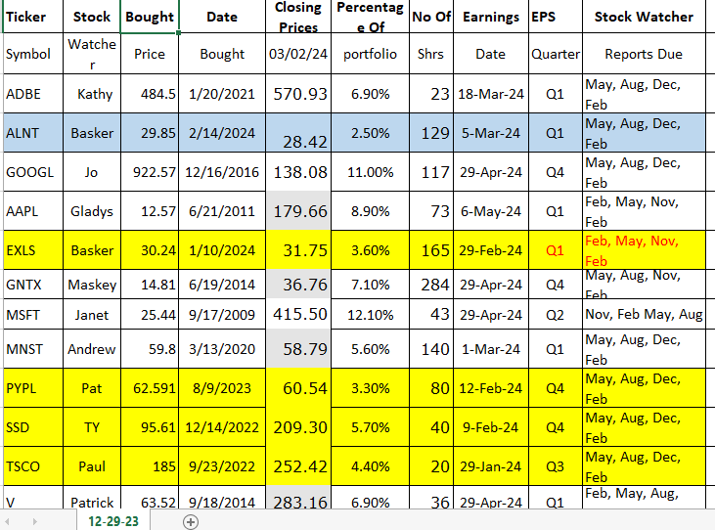
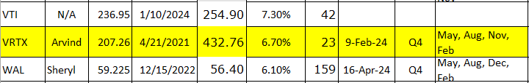

Meeting Adjourned: At 9 PM by Pat
Minutes Submitted by Arvind Krishna; Portfolio Stocks’ Earnings Calendar updated by Maskey Krishnarao

