Model Investment Club of Northern Virginia (MicNOVA)
DC Chapter of Better Investing
Minutes for the March 12, 2024 (Online Meeting)

Members Present: Sheryl Patterson, Arvind Krishna, Ty Hughes, Pat Onufrak, Patrick Smith, , Maskey Krishnarao, Gladys Henrickson, Andrew Ober, Paul O’Mara, Lisa Faustin
Members Absent: Kathy Emmons, Janet Lewis, Baskar Arumugam, Jo Murphy
Proxies for Members: Gladys for Baskar
Visitors/New Attendees Present: Fred Beckmann, Lee Outlaw, Carol Cuddihy, Gene Close, Raj Sathyanarayana, Evelyn, Paul Doku.

Patrick led the meeting. He welcomed guests including newcomers, stated the club’s purpose & objectives, displayed the BI Disclaimer and followed the meeting agenda.

Lisa Faustin’s application for becoming Micnova Partner was voted in the affirmative and she was welcomed into the club.

- Secretary’s Report – Arvind
Meeting Minutes Report (2/13/2024) was presented by Arvind. No corrections were addressed in the draft minutes. Ty made the motion to accept minutes as-presented. Sheryl seconded. The final Minutes are now posted in the Bivio folder.

- Treasurer’s Report – Gladys and Ty
Gladys presented the Treasurer’s Report, which was accepted. The report indicated Cash Account basis: $3,616 and Total Securities & Cash Account basis: $78,477. Sheryl made the Motion to accept the report, which passed without objections. The Treasurer’s report is filed in Bivio.
Gladys, informed that Micnova Federal taxes (2023) have been filed and acknowledged by IRS. Individual member K-1s for Micnova partners to file 2023 taxes are available on the Bivio website under ‘member contributions’.

- Education & New Stock Presentation Timetable for 2024 – Sheryl
Partners are requested to identify their 2024 Education and Stock Presentation titles for the next 3 months in advance, so that Carol Cuddihy can submit them onto our BI webpage.

- Education: “Financial Ratios Checklist” – by Gladys
Gladys presented an excellent educational session on Financial Ratios (adapted from Bakul Lalla,
Virtual BINC 2023, Session 305). Financial Ratios Checklist is a great tool for keeping an investor sane, and for helping to stay within a circle of competence. The presentation consisted of definitions, characteristics and example applications of 10 Financial Ratios - Basic Ratios above Barbed Wire & Intermediate Ratios below as shown in the presentation slides. Recommendations Made: Use the Financial Ratios to compare non-financial stocks to purchase; Use some of these Financial Ratios for stocks in our portfolio to detect signs of improvement or deterioration.

- New Stock Presentation: “ADDUS Home Care” (Nasdaq - ADUS) – by Andrew Ober
Andrew presented an analysis of new stock ADUS – a home care services provider primarily focused in personal care, health care services, and hospice services. It operates at 217 locations in 72 states with over 30K employees. It is one of the fastest home care public health organizations in USA. A small to midcap stock with market capitalization – 1.5b. ADUS long term growth is driven by increasing services and through acquisitions. Current PE is 26.7 and is trading below its 5-year average PE (34.9). SSG analysis shows ADUS at $97.90 is a “Buy” with 6.1 to 1 US/DS ratio (BUY up to $114).

- Stock Watcher Quarterly Reports Presented:
There were 5 stock watchers’ reports:
- PYPL - Pat – SSG says “Buy”; No decision made
- EXLS - Gladys - SSG Says “Buy” (Baskar absent)
- SSD - Ty – SSG says “Hold” – not expected to see much gain
- TSCO - Paul- SSG says “Hold”
- VRTX - Arvind – SSG says “Hold”; Stock gained 45% in one year at current $414.47
Stock Watchers (Please share the Online SSG with all MICNOVA members going forward)

- Current MICNOVA Portfolio Review: by Ty
Ty made a comprehensive presentation of club’s Portfolio review as of Mar 11-2024, which included data from resources – BIVIO Net Asset Value Report; Performance Report (Investment Account Manager); Better-Investing Reports, Portfolio Evaluation Review Technique (PERT) Report and Summary; and Manifest Investing Dashboard. Small Cap & Mid Cap are coming up.
Overall Micnova portfolio performance:
YTD — 1.6% vs. 7.3% for S&P 500 • 1 year — 35.9% vs. 34.9% for S&P 500 • 3 years — 9.2% vs. 11.1% for S&P 500 • Since Sep 11, 2008 — 11.3% vs. 13.5% for S&P 500
Recommendations: We still have no small-cap stocks. Small cap is likely to outperform in the coming year. • Add quality small-cap companies with PAR > 15% • Challenge or Sell SSD • Add to position in PYPL.

- Decision Buys/Sells: Partners voted for the following transactions in the affirmative.
03/13/2024 | Sold 20 shares of Simpson Manufacturing (SSD) at 203.408 per share. Capital Gain: $2,156.06
03/13/2024 | Purchased 37 shares of Addus HomeCare Corp (ADUS) at 99.12 per share | $3,667.44
03/14/2024 | Purchased 23 shares of Addus HomeCare Corp (ADUS) at 98.09 per share | $2,256.07

- Member Questions and other Decisions: Partners
None

- Next Month Meeting Reminders – April 09, 2024:
Education | Topic: Complete an SSG for a Company with Negative Earnings | Baskar (for Maskey)
New Stock Presentation | STOCK: | Ty
Stock Watcher Reports Due | Stock Watchers ( Please share the Online SSG with all MicNOVA members):  - Adobe (ADBE)  - ALNT  - MNST | Kathy  Baskar  Andrew
Portfolio Reports |  | Ty
Watch List Reports |  | Sheryl

2024 BI and Community Events & Announcements:
Thur Mar 14 2024 08:00 – 09:15 PM | Stock-up: Stock Watcher Checklist
Tue Mar 19 2024 07:30 - 09:00 PM  (Third Tuesdays of Month) | Money Matters Book Discussion. Book: Nudge by Richard Thaler and Stan Sunstein  Online via GTM: You can also dial in using your phone.  United States: +1(646) 749-3122  One-touch: tel:+16467493122,,804623085#  Access Code: 804-623-085
Wed Mar 20 07:00 - 09:00 PM  Wed Apr 17 07:00 - 09:00 PM  (3nd Wednesdays of Month) | MCMC Monthly Meeting  https://global.gotomeeting.com/join/745127301  You can also dial in using your phone.  (For supported devices, tap a one-touch number below to join instantly.)  United States: +1 (872) 240-3311  - One-touch: tel:+18722403311,,745127301#  Access Code: 745-127-301
Sat Mar 23 2024 01:00 - 04:00 PM | SSG Intermediate Class – Adding Judgements (Must RSVP)
Tue Mar 26 2024 08:30 – 09:45 PM | Manifest Investing Roundtable
Mon Apr 1 2024 07:00 - 08:15 PM | Digging into BI Magazine  Registration URL: https://register.gotowebinar.com/rt/6574788583850753036  Webinar ID:729-893-259
Fri April 5 2024 08:00 – 09:00 PM | DC Chapter Director Meeting  Please join my meeting from your computer, tablet, or smartphone.  https://attendee.gotowebinar.com/rt/6574788583850753036  You can also dial in using your phone.  (For supported devices, tap a one touch number below to join instantly)  United States: +1 (224) 501-3412  One touch: tel: +12245013412, 654059957#  Access Code: 936-281-979
Tue Apr 09 07:00 - 09:00 PM  (2nd Tuesdays of Month) | MicNOVA Monthly Meeting Online  https://global.gotomeeting.com/join/251997157  You can also dial in using your phone.  United States: +1 (312) 757-3121  Access Code: 251-997-157
Wed & Thur Apr 10 & 11 | Mid-Michigan Investment Conference (Manifest Investing)  Stay Tuned for more information

Schedule: New Stock Presentation, Planning and Monthly Meeting Chair
 | Name | Education | New Stock Presentation | Conduct MicNOVA Monthly Meeting | Conduct MicNOVA Planning Meeting
1 | Patterson, Sheryl | 7/9/24 | 03/11/24 | 12/12/23 | 12/5/23
2 | Hughes, James (Ty) | 1/9/24 | 04/09/24 | 10/8/24 | 10/1/24
3 | Krishnarao, Maskey | 2/13/24 | 01/14/25 | 5/14/24 | 5/7/24
4 | Krishna, Arvind | 5/14/24 | 12/10/24 | 8/13/24 | 8/6/24
5 | Arumugam, Baskar | 4/09/24 | 2/11/25 | 6/11/24 | 6/4/24
6 | Henrikson, Gladys | 3/12/24 | 7/09/24 | 1/9/24 | 1/2/24
7 | Murphy, Josephine (Jo) | 8/13/24 | 6/11/24 | 7/9/24 | 7/2/24
8 | Emmons, Elinor (Kathy) | 9/10/24 | 11/12/24 | 9/10/24 | 9/3/24
9 | Smith, Patrick | 12/12/23 | 10/08/24 | 3/12/24 | 3/5/24
10 | Onufrak, Patricia | 6/11/24 | 8/13/24 | 2/13/24 | 2/6/24
11 | O’Mara, W. Paul | 11/12/24 | 09/10/24 | 11/5/24 | 11/12/24
12 | Lewis, Janet | 10/8/24 | 5/14/24 | 4/9/24 | 4/2/24
13 | Ober, Andrew | 12/10/24 | 3/12/24 | 1/9/24 | 1/2/24

For Future Education Topics:
See BI Ticker Talk, Stock-Up, and Learning Modules for ideas
Next 3 Months - Reminders
Apr 2024 | New Stock |  | Ty
Apr 2024 | Education | Complete an SSG for a Company with Negative Earnings | Baskar (for Maskey for Kathy)
May 2024 | New Stock |  | Janet
May 2024 | Education |  | Arvind
June 2024 | New Stock |  | Jo Murphy
June 2024 | Education |  | Pat

Schedule: Education Topics For 2024
Please go to BI Website’s Ticker Talk, Stock-Up, and Volunteer 4-Bits to find good topics for your Education Schedule. Provide your schedule and topic 3 months in advance.

MicNOVA Portfolio & Stock Watchers: Updated closing prices as of March 31-2024

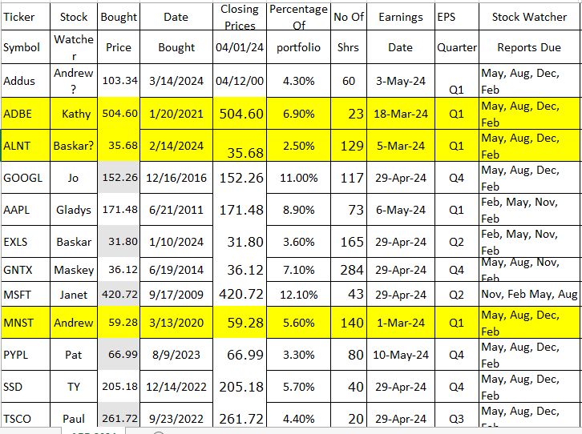
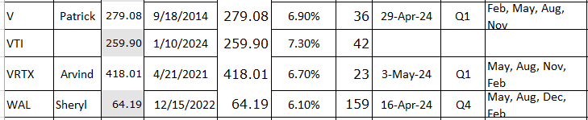

Meeting Adjourned: At 9 PM by Patrick
Minutes Submitted by Arvind Krishna; Portfolio Stocks’ Earnings Calendar updated by Maskey Krishnarao

