UnitedHealth Group Incorporated (UNH)
UnitedHealth Group Center
900 Bren Road East
Minnetonka, MN 55343
Phone: (952 ) 936-1300
Fax: (952 ) 936-1949
BHGP purchase date: 9 October 2002 @ $92/share
Market cap: $176 billion
Performance: ROE 30.6% (ttm).
UnitedHealth Group provides both comprehensive managed care services, such as HMO and carrier replacement products, and unbundled healthcare management and cost containment products and services.
Background: In the Fall of 2000 Steve Perillo (former BHGP secretary) invited Henry Crepeau (investment advisor to MidContinent Management Company) to discuss stock picking with our group. The basis of his strategy was to check IBD (Investors Business Daily) for the lists of “Where The Big Money Is Going,” essentially top 10 lists of recent fund purchases on the New York Stock Exchange and NASDAQ. He suggested using those lists as narrow universes from which to pick stocks.
At that time he pulled out the chart for UNH, a local company, and commented “Look at that chart!” Since then UNH has held up well:
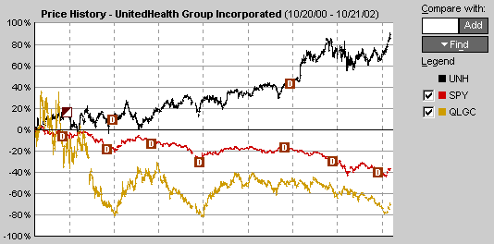
Description: BHGP has watched (painfully) UNH’s performance since Crepeau said “Look at that chart!” (Especially difficult is the comparison to QLGC, our alternative choice to UNH two years ago.) UNH’s fundamentals have remained sound the whole time, and we finally relented and bought in.
Respectfully -- Mike

