Portfolio Management Workshop

Session: | #2, Portfolio Management
Date: | Tuesday, February 9, 1999
Leader: | Ellis Traub
Subject: | The PERT: First Line of Defense
Session #2 Overview:
- Fundamental Performance
- Update SSGs
- Review Assumptions
- PERT: Defensive Elements
- Comparisons
  - Sales
  - Pre-Tax Profits
  - Earnings
  - Benchmark: Growth Rate in EPS
- E-Mail Participation

Portfolio Management Workshop
Session #1 | Session #2 | Session #3 | Session #4 | Session #5 | Step-by-Step

FUNDAMENTAL PERFORMANCE
As with the ball game metaphor, defense involves vigilance -- protecting ourselves from harm.
Fundamental performance is the first and the most critical concern in a defensive plan. Unlike technical analysts who watch for telltale price movement to make buy or sell decisions, NAIC investors monitor the operations of the companies whose stocks they own.
You purchase stocks for the same reason that stock was first issued centuries ago -- to participate in the earnings of the enterprise for the long term, not simply to buy and sell for profit. For that reason, you're interested in watching just how well those companies operate and generate their earnings.

UPDATE SSGs
First, update the data and prices for all of the Stock Selection Guides (SSG) in a portfolio. Toolkit Pro 3.1.1 takes you from each company screen to Web site sources for both the price updates and the Edgar SEC filings.

REVIEW ASSUMPTIONS
Second, quickly review each SSG to make sure that the initial assumptions are correct and that you still agree with your original judgment. Be sure to modify the previous judgments if conditions have changed to warrant it. Use your current judgments in your portfolio review.

PERT: DEFENSIVE ELEMENTS
Most of what needs to be done may be accomplished with the Stock Selection Guide if it is all that you have. Most of the information that we will discuss comes from the SSG. It's certainly the first place that a problem will show up and can be a defensive scout. However, the ideal place to look for trouble is in the PERT (Portfolio Evaluation Review Technique) form after you have updated the SSGs and saved them.
The PERT is a collection of the relevant data from all of the SSGs in a portfolio and it is the best place to spot problem companies. It's your first line of defense. In the Toolkit, activate the PERT to display the NAIC PERT form on the screen.
The most important elements of defense are found on the left side of the form starting with the fifth column. These are the four columns labeled EPS, Sales, Pre-tax Profit, and Trailing 12-month EPS.
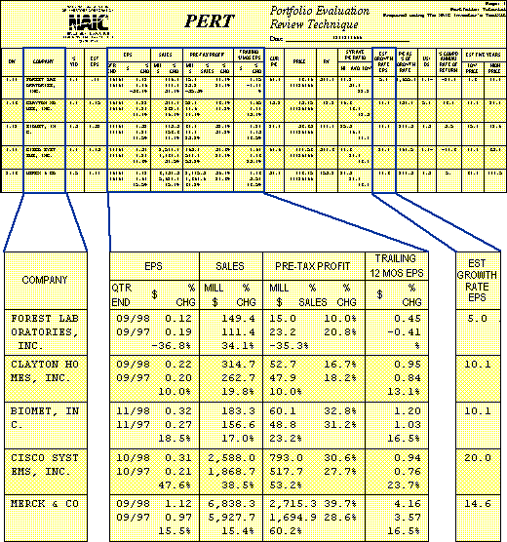
Here's where you find the actual quarterly data for the current quarter and the same quarter a year ago, the percent change (growth rate), and, in the case of Pre-Tax Profit, the Profit Margin (%Pre-tax Profit on Sales).
With Toolkit, click on the label at the top of the form to rank the stocks from the worst to the best performers. (The illustration is ranked by Pre-Tax Profit.)

COMPARISONS
Compare each of these growth rates with your expectation of the company's growth when you first bought it. Estimated earnings growth serves as the best measure of expected company growth and is found in the 13th column from the left.

Sales
Look first at sales growth because it is the most stable statistic and, should there be any serious decline in the growth from the previous year, its cause would likely not be trivial.
Even if growth rates aren't negative, you still want to see growth close to what you anticipated the company's growth would be.

Pre-Tax Profit
Next in importance is probably Pre-Tax Profit -- but only if you have access to the actual figures. If you subscribe to the electronic data sources, you will have them. If not, you can quickly obtain them by clicking on the Toolkit's Web access button at the top of the screen as you update and review each SSG. A pull-down menu takes you directly to FreeEdgar for the company you are working with.
Again, compare the percent change with your earnings growth estimate. Disappointments in PTP growth are critical because you can see them before they show up on the bottom line. It's not easy for a company to hide changes in Pre-Tax Profit, but they can tinker with the tax rate or the number of shares outstanding and keep disappointing numbers from reaching the earnings line until the end of the fiscal year.
Catching problems at this point, especially if they're serious problems, can save you lots of money because you can divest yourself of the poor performers before the rest of the world reacts to a bad earnings report. A significant disappointment in PTP is important to explore and make sure that you know what caused it. Usually a call to the Investor Relations person will provide you with a reason and you'll have to decide on its gravity.

Earnings
Finally, look at the earnings -- preferably the 12-month trailing earnings -- because this will dampen out the occasional poor quarter and smooth out the volatility of simple quarterly data. If earnings growth is lagging, then it may already be too late to do anything except to cut your losses and get out.

Benchmark: Growth Rate in EPS
The PERT "Est Growth Rate EPS" is the growth rate that is necessary to meet the expectations for the return on the investment. In a perfect world with constant profit margins, taxes, and shares outstanding, the sales, pre-tax profit, and earnings will all grow at the same rate and as fast as expected. If earnings growth slows appreciably below expectations, the rate of the return on the investment will fall short of the goal. Investors need to look for the signs that this might happen.
Since the world isn't perfect, look at each of the fundamental values independently in order to learn something from each one. Sales lags are not trivial because it takes somewhat of a catastrophe to turn that type of growth downwards. If sales growth is normal, but we find pre-tax profit flagging, we are looking at declining profit margins and can see that the problem is the way that management is handling expenses. If sales and PTP are doing fine, but earnings per share is slowing, look at tax rates and/or an increase in shares outstanding as the cause of the problem. However, that is less worrisome because they are probably not long-term problems. And so on.
Look out, though! You shouldn't simply sell when there is a single bad quarter. You will want to look a little further. We'll talk about when and why to sell in the next session.
Ellis Traub

E-Mail Participation from I-Club-List:
Editor's note:
There were a number of responses related to Session #2. Edited versions of some are given below. Some of Ellis's responses and clarifications were integrated into the workshop text.

A question on profit margins versus pre-tax profit led to this additional explanation from Ellis:
When we look at profit margins, we certainly hope to find a steady or up trend and not a down trend, quarter to quarter. We never make an effort to quantify a trend. If there's no growth in profit margins, that's just fine. It may well mean that the company is operating at near-peak efficiency and can't do very much to cut costs without it becoming counter- productive. For example, downsizing a company produces a short term increase in profit margin but costs a company dearly in the long run.
If there's an up-trend, that's okay too. It probably means that there was a need for efficiency and management is doing something about it.
Downtrends are bad news, though, because they mean that management's ability to contain costs is diminishing. Management may be becoming extravagant. However, when profit margins don't grow or they decrease, we don't seek to quantify a trend.
Sales, pre-tax profit, and EPS are quite different. Here we are looking for growth and we do quantify that growth.

Nancy Isaacs asked:
When I see that Value Line EPS vary a fair amount from the raw data in the S&P data files or in the company's 10Q, I change the annual data and quarterly EPS and sales to match VL. But, I'm left with the raw data for pre-tax profit. How do you deal with this? It sounds as if you just stick to the raw data.
Ellis replied:
Value Line makes adjustments for non-recurring items only to the EPS. They footnote these. Sales and Net Profit are not adjusted for non-recurring items (or should not be.) They certainly are not removed from that data to the best of my knowledge.
Perhaps my view of these issues is broader than it should be. I don't really care if the data has been "normalized" when I work with the PERT. I am happy to have the reported data there and will look for the discrepancy.
If I find a significant departure from my anticipated growth rate (EPS), I will explore to determine what the issue is. The odds are that I will find out what it was that made the difference. If it is something that falls into the category of a non-recurring event, it will meet my definition of transient and I will simply ignore it. I prefer this to allowing some analyst make the decision for me.
Historical data is a different story because it's not as easy to find the cause in the news and company reports. However, we were dealing with a current situation.

Portfolio Management Workshop
Session #1 | Session #2 | Session #3 | Session #4 | Session #5 | Step-by-Step

Learn to Invest | Workshops
Home | Site Map | Search | Contact Us
Copyright © 1995 - 2002 National Association of Investors Corporation
Where Wall Street and Main Street Meet
Last updated Monday, 22-Mar-1999 16:41:37 EST

