Portfolio Management Workshop

Session: | #3, Portfolio Management
Date: | Wednesday, February 10, 1999
Leader: | Ellis Traub
Subject: | The Trend Report (Investor's Toolkit): A Call to Action
Session #3 Overview:
- When to Sell
- Trouble Signs
- Portfolio Trend Report

Portfolio Management Workshop
Session #1 | Session #2 | Session #3 | Session #4 | Session #5 | Step-by-Step

WHEN TO SELL
Portfolio Management, because you already own the stocks and purchased them to hold for the long term, implies that there is either a time or a cause for selling them (other than when you want or need the money). Therefore, let's talk about selling stocks.
The rules that cover this, cited in the NAIC Official Guide: Starting and Running a Profitable Investment Club, instruct you:
NEVER SELL . . . unless the company:
- Has had an adverse management change.
- Has declining profit margins.
- Has had a deteriorating corporate financial condition.
- Has been beset by effective competition.
- Has relied on a single product that is becoming obsolete.
- Has changed for the worse due to economic conditions.
- Has proven to be cyclical.
- Has upset the balance by company size in your portfolio.
All but the last of these items represent conditions that deal with the fundamentals of the company over the long term. And the list isn't restricted only to those specific items. There are many reasons why a company may falter.
(The last deals with diversification and falls into another defensive category that we'll discuss later.)

TROUBLE SIGNS
Look for signs of these kinds of problems in the PERT report. However, you should realize that the PERT does not display more than a single quarter. Like security guards viewing a bank of TV monitors in a large building, you should look at a portfolio for anything suspicious. If you find something, it's a call to investigate, not necessarily to sell. You have additional tools for your investigation.
The PERT Report excerpt shown in Session #2 is ranked by Pre-Tax Profit. Forest Labs, the worst performer, shows that sales are doing just fine as might be expected. As we said, it is difficult to make a radical change in that statistic in a single quarter. However, the Pre-Tax Profits declined 35.3% over the year before; and earnings have declined 36.8%. There is no data for Trailing 12-month earnings since earnings last year was negative and percent change can't be calculated!
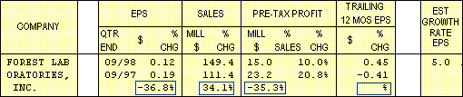
This is certainly a warning sign. Had you been doing PERT on a regular basis, you would probably have seen more reason to be alarmed - and much sooner.
The next step is to see if this decline in fundamentals has only just begun or is it something that has gone on for more than just this quarter. I believe that one bad quarter may be just a quirk. Two or more quarters are significant and require action.

PORTFOLIO TREND REPORT
If you had retained the PERT from the previous quarter, you would be able to compare it with the current edition and see if there are two disappointing quarters. If you have the Toolkit Pro 3.1.1 (previously referred to as the Complete Toolkit), the next step is to click on the button at the top of the PERT to bring up the Trend Report, so called because it reveals the "trend of the trends."
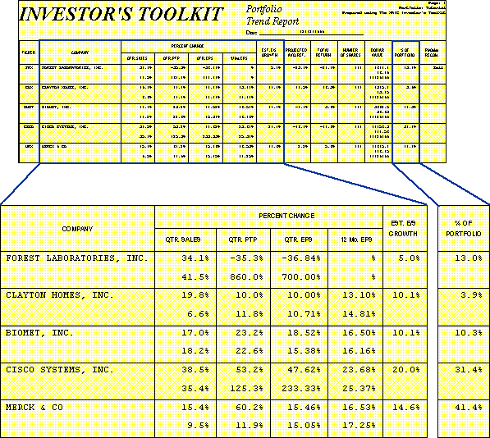
Look at the percent change in the same four columns, Sales, Pre-tax Profit, EPS, and Trailing 12-month EPS. However, the data has been removed and there are two similar lines of data for each company. The top line represents the same information that you just looked at in the PERT. The line beneath represents the percent change between the previous quarter and its counterpart in the year before. In other words, you are looking at the result of last quarter's PERT. Now you can see two quarters in a row and the growth for each.
Again, you wish to compare these growth rates with your expectation (estimated earnings growth). In the Trend report, it is placed in the column adjacent to the four fundamentals columns for convenience, labeled "Est.E/S Growth."
If you see two quarters that are satisfactory, you are happy with that company for the moment. That is true with all of the companies save Forest Laboratories (NYSE: FRX).
If you see that the previous quarter was disappointing but the most recent quarter is satisfactory, you can say that the company had a transient problem but appears to be coming back on track. If the current quarter was disappointing but the previous quarter was good, you might want to explore to find out what caused the slump; but you'll probably go another quarter to see what the company will do.
However, if both last quarter and the current quarter are down, then you need to act - and act right away. Do you sell? Not yet. A call to action merely means that, when you see two quarters in a row that are substantially beneath your expectations, you should find out why. You need to determine if the problem is long term or transient.
In the case of Forest, it appears that last quarter was anomalous, what with earnings growth exceeding 700%. This has to make us curious. For earnings to increase that much, it must mean that the data on which that growth was based must be extraordinarily poor. That demands our attention.
The next step is to look at this quarterly data in more detail. We'll talk about that in the next session.
Ellis Traub

Portfolio Management Workshop
Session #1 | Session #2 | Session #3 | Session #4 | Session #5 | Step-by-Step

Learn to Invest | Workshops
Home | Site Map | Search | Contact Us
Copyright © 1995 - 2002 National Association of Investors Corporation
Where Wall Street and Main Street Meet
Last updated Monday, 22-Mar-1999 16:41:40 EST

