Portfolio Management Workshop

Session: | #4, Portfolio Management
Date: | Thursday, February 11, 1999
Leader: | Ellis Traub
Subject: | PERT-A and the PMG -- Looking at the Details
Session #4 Overview:
- PERT Worksheet-A
- PERT-A Graphs
- Internet Sleuthing
- Portfolio Management Guide

Portfolio Management Workshop
Session #1 | Session #2 | Session #3 | Session #4 | Session #5 | Step-by-Step

A look at the PERT aroused our suspicions about Forest Labs. The company had a disappointing quarter compared with the same quarter the year before. On the Trend Report, suspicions were further aroused by a 700% growth in earnings for the previous quarter over its counterpart the year before. Therefore, you will want to look at what is going on with Forest in greater detail. The PERT Worksheet-A lets you do this.

PERT WORKSHEET A
If you use the Toolkit Pro, you will find that the data is automatically recorded each time you update the quarterly data for the SSG.
Within the Trend Report (or the PERT, for that matter), double-click on the line corresponding to the company which interests you to drill down to the details behind that data and view its PERT-A Report. Here you can see the quarterly progress of this company along with the percent changes.
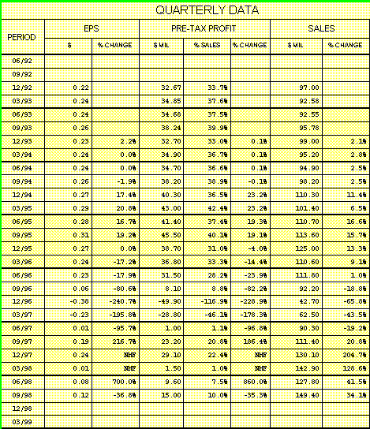
On the left side of the form, the percent changes are recorded for each quarter as compared with the same quarter the year before. As you can see, the numbers are all over the lot on the left (quarterly) section.
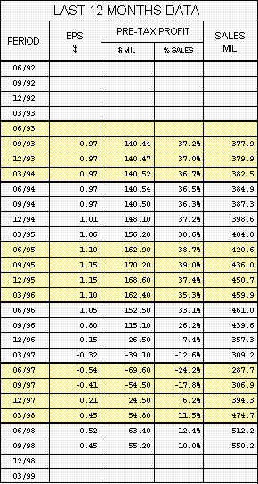

On the right side of the form, you will find the sum of the trailing four quarters for each quarter, and the percent change between that and the same period the year before.
The value of looking at the trailing 12 months (on the right) is that the trends are easier to identify because the data is smoothed by using the moving sum of the trailing data.
Look at Forest and you can readily see, at best, that the company has been through some really bad times. Sales started declining in the first quarter of 1996. Only within the past five quarters have they picked up again. You'll be able to see this clearly on the graph we discuss next.

PERT-A GRAPHS
Using the Toolkit Pro 3.1.1, click on the button at the top of the PERT-A labeled Graphs to learn still more. This gives you the opportunity to view a graphic representation of the percent changes for each quarter. Click on the appropriate check boxes to display Sales, Pre-Tax profit, and/or EPS growth. You may also display the profit margins (Pre-Tax Profit/Sales), quarter to quarter.
Because these parameters have been so volatile -- ranging from (in the case of earnings) plus 700% to minus 240%, the line will seem flat. However, you may restrict the growth or decline to 50% and the variations are more pronounced.
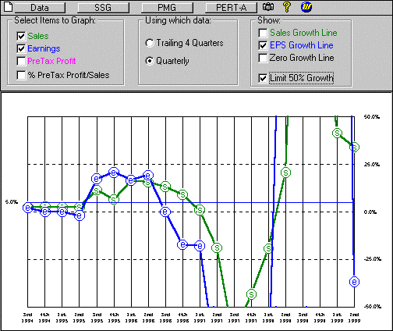
The final, and perhaps most telling view of the data, is when it is plotted as trailing four quarters. This will reveal a distinct and steady trend downwards commencing in the 3rd quarter of 1996. It is unbroken until the 700% spike in the 3rd quarter of 1998 followed by continued negative growth (which you have to shift back to the quarterly calculation to see).
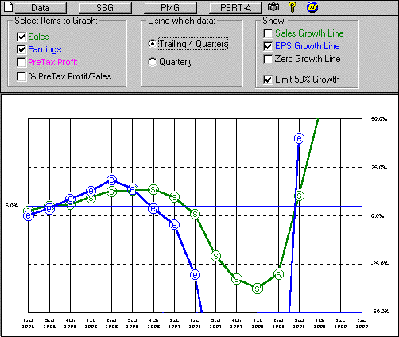

INTERNET SLEUTHING
If the numbers scare you, as they should, then the next place to go is out to the Internet to find out why this kind of performance took place. Is it long or short term? Or will the company's management be able to see it through the crisis?
Access the Web by clicking on the little blue W (web access) button at the top of the company screen. Perhaps the first place to go is the company's own Web site. You should be able to find at least the company's spin on why they are where they are and what they're doing about it. Unfortunately, Forest Labs does not have a Web site. (That might say something in itself.)
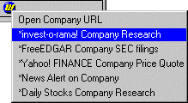
Investorama provides about 75 different sources of information on Forest Labs. When a company does have a Web site, it is easy to access it from there. Cut and paste the company's URL in Toolkit's Web access dialog box for future reference.

PORTFOLIO MANAGEMENT GUIDE
A word about the Portfolio Management Guide is in order here. When the PMG was originally conceived, it was a means to determine if a company met the basic requirements to be either a sell or a buy each month when a new price was obtained.
This purpose has been made obsolete by the computer which can instantaneously perform those calculations and display the result just as soon as the price is updated.
So, unless you're a technical analyst, the graph on the back of the PMG has little value except for its historical perspective. (Gee! If you'd paid attention to the PERT way back there, you'd not be here now! <g>)
It does have a useful purpose, however, when viewed in conjunction with the graph on the PERT Worksheet-A form. By comparing the movements of the fundamentals shown in the PERT-A to the movement of the price and P/E on the PMG graph, you can get a good picture of the reaction of the investing public to changes in those fundamentals. You may also see how prices moved up and down when the fundamentals did not provide the reason. This comparison gives a good lesson in how the public tends to react to issues. It may help you to get an idea of how much time you have to make a decision when a reason for selling seems at hand.
Getting back to Forest Labs, however, the moral of this story is that, had you been minding the store as you are now, you would have been out of it long ago. If you're still in it, you probably shouldn't be!
Next session: On the offensive!
Ellis Traub

Portfolio Management Workshop
Session #1 | Session #2 | Session #3 | Session #4 | Session #5 | Step-by-Step

Learn to Invest | Workshops
Home | Site Map | Search | Contact Us
Copyright © 1995 - 2002 National Association of Investors Corporation
Where Wall Street and Main Street Meet
Last updated Friday, 27-Jul-2001 18:12:08 EDT

