Portfolio Management Workshop

Session: | #5, Portfolio Management
Date: | Friday, February 12, 1999
Leader: | Ellis Traub
Subject: | On the Offensive
Session #5 Overview:
- Challenge Tree
- PERT Report
- PERT Report -- Selected Value Items
- Cost of Trading
- The Challenger
- Percentage of Portfolio
- E-Mail Participation: Robert Half Int'l (NYSE: RHI)

Portfolio Management Workshop
Session #1 | Session #2 | Session #3 | Session #4 | Session #5 | Step-by-Step

The defensive part of the game involves a certain amount of urgency. If you don't take appropriate action, you can get hurt. The sooner that you take such action, the less hurt you're liable to be.
The offensive part of the game can be more deliberate and is less likely to involve pain from failure to act quickly. However, it is fully as important a part of portfolio management strategy if you are to be a winner.

CHALLENGE TREE
The authority for the offensive strategy is in the Challenge Tree chapter of the NAIC Official Guide: Starting and Running a Profitable Investment Club. It has specific guidelines for taking the offensive. Here's the thrust of what it says. When you find that a stock has passed the point where it has greater risk than reward, replace it with one of equal or better quality and a better potential for return.
The Official Guide, p. 150, goes on further to say (believe it or not) that, if you can't find a company that meets those criteria -- at least a 3 to 1 Upside/Downside Ratio -- consider putting 20% of the most speculative part of the portfolio into good quality bonds. Then wait until the market makes stocks attractive once again!

PERT REPORT
The PERT Report serves a dual purpose, as does its companion, the Trend Report. In a sense, the PERT is a mini version of the SSG. PERT first deals with the trends in the quality issues (SSG Sections 1 - 2) with items such as EPS, Sales, and Pre-Tax Profits. PERT also deals with the value issues in SSG Sections 3 - 5. They are P/E Ratio, Relative Value, and Upside/Downside Ratio.
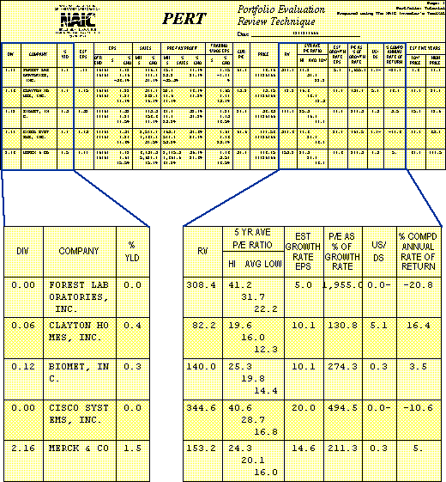
As with the SSG, be cautious about passing judgment on the value side of the PERT without first being certain that the quality issues are not overstated or overestimated. Remember that the worse a company performs, the better a value it will appear to be.
Why? Because investors pay a lower price for the stock and you'll see a higher U/D ratio, a lower P/E, a lower Relative Value, and a much higher Total Return. That is simply because of the low current price when compared with the company's earlier history. So beware!
This is why it is so important to update the company data and prices and review SSG's before attempting to pass judgment on the value side of the PERT. That, however, is where you will go for your offensive game.
With these things in mind, lets take another look at the workshop portfolio.

PERT REPORT - SELECTED VALUE ITEMS
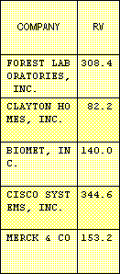
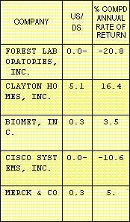
Aside from Forest Labs, the PERT shows a pretty good looking portfolio. Sorted in order of the quality issues, it appears that you are looking at a great bunch of performers. However, shift your attention to the right. The first telltale item that you come to is the RV column (Relative Value). Only Clayton Homes is within a safe and reasonable range. According to the PMG criteria, a Relative Value of more than 150% would suggest that you consider selling at least a portion of your holdings. Biomet approaches the line and the other stocks are well over the line.

Moreover, look a couple of columns further to the right. Clayton Homes is the only remaining holding with reward greater than the risk. Remember that, with an Upside/Downside ratio of 1:1, the risk is equal to the potential reward. Even Merck and Biomet have a 0.4 and 0.3 U/D ratio, respectively. That translates roughly into a potential to gain only another 25-30% should the price go all the way to your 5-year projected high, versus a potential loss of 70-75% should it go down to your potential low price. This reverses the desired risk to reward ratio, giving you three times as much risk as reward!
You know that Forest Labs should go. What should you do with the rest? According to NAIC, you should replace any stocks with risk greater than the potential reward with stocks of equal or better quality and a better potential for return.
Of the remainder, Clayton Homes, with an Upside/Downside ratio of 5.1 to 1 reflects a holding with plenty of upside potential. It's growth rate, while only 10%, is consistent with your expectations when you bought the stock. And it has a potential total return of 16.4% -- enough to more than double in five years.
The remaining holdings are excellent companies with a great capacity to grow their earnings. However, the numbers tell you that, at best, based upon what they are now worth, you would grow your investments (even after dividends) at no more than 5% for Merck and 3.5% for Biomet over the next five years. Moreover, if Cisco were priced at your projected high price five years from now, you would LOSE money!

COST OF TRADING
Our next step, then, will depend upon the cost of trading. If this were a tax deferred portfolio -- an IRA or 401K -- and we traded online with Waterhouse, where it costs $12 for a trade, there would be little question but that we should replace Biomet and Merck with companies of equal or better quality and a better potential for return.
We should sell Cisco outright because we could make a greater return in the money market with virtually no risk.
However, most of you aren't so fortunate. The cost of replacing your companies may be prohibitive. You must weigh the cost of paying taxes on your gains, plus the commissions on the round trip for your trades, and be able to see your way clear to covering that loss with the improvement in your potential within a year or, at most, two.

THE CHALLENGER
The Challenger in the Toolkit Pro 3.1.1 is a good way to compare the relative quality of both the challenged and the challenger. It has a graphic picture as well as a numerical assessment of the consequence of making the trade.
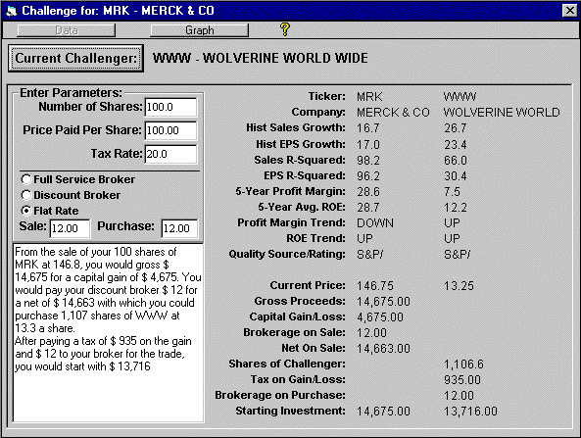
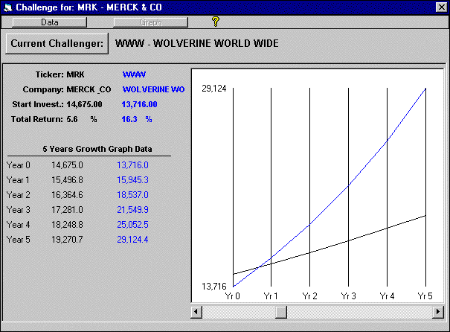

PERCENTAGE OF PORTFOLIO
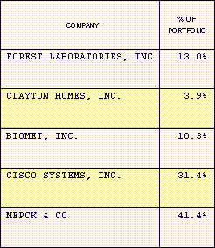
One last issue -- and, while it is partly a defensive strategy because it deals with diversification -- it is also partly an offensive strategy as well. Without going into great detail here, look at the Trend Report and see the column labeled % of Portfolio. You will see that, even if Cisco were still to reflect sufficient potential return, you might want to replace some of it with another --perhaps even in the same industry, but a smaller comer. That is because Cisco's growth has ballooned it into taking up 31.4% of the portfolio. Merck is even more, taking up 41%. That's putting an awful lot of eggs in just two baskets.
In any event, in today's market, most investors are riding the charging bull right on toward the cliff. Trouble is that they're doing it in the fog, and it's not possible to see when the cliff is approaching. Sure, it's an exciting and heady experience -- just like the rush in gambling. But, are they really ready to accept the risk?
You can't time the market, but you can make a judgment as to the market's sanity! I believe that you should let common sense prevail in spite of the spectacular gains that you find as you come closer to the brink.
With the software that NAIC makes available to its members, whether the Toolkit or Stock Analyst, Portfolio Management can be easy, fun, and very profitable as well. This workshop is admittedly more of an overview than a detailed picture, but the constraints on space do not permit more. Ask further questions on I-Club-List.
Ellis Traub
Chairman, Inve$tWare Corporation

E-Mail Participation: Robert Half International (NYSE: RHI)
Editor's note:
Laura Berkowitz sent a message to the I-Club-List after the Portfolio Management Workshop ended. She described how she applied the knowledge that she gained from the workshop to an analysis of Robert Half International (NYSE: RHI). Ellis believes that the message addresses an issue that apparently wasn't clear in the workshop. Therefore, the dialog is included here.

Laura wrote:
I was excited about the Robert Half Int'l (NYSE: RHI) SSG after recent discussions on I-Club-List. Armed with Ellis' PERT Workshop information, I've been picking apart RHI. Although the SSG looks good, PERT and PERT Worksheet-A look otherwise. I used the NAIC S&P Datafiles for the SSG data and I updated 4Q '98 and year '98 from a company press release.
PERT Worksheet-A Graph and Worksheet:
- The trend for % Sales growth is down. It dropped slowly since 2Q '97, and there is a steeper drop off from 2-3-4 Q's '98.
- The % EPS for 4Q '98 is falling behind Sales; EPS is slowing.
- Pre-tax Profit is falling at about same rate. (Although, amazingly, PTP as a % of the decreasing sales has remained steady.) Although quarterly EPS, PTP, Sales and 12 mo. EPS are very respectable, the Portfolio Trend Report definitely shows that all measurements are slowing. For example:
 | 3Q 98 from 3Q 97 | 4Q 98 from 4Q 97
Q. Sales change | 38.5% | 30%
Q. PTP change | 40.3% | 29.6%
Q. EPS change | 40.74% | 26.67%
EPS 12-mo. change | 46.26% | 38.83%
Although EPS, PTP, and Sales are increasing, they are increasing at a decreasing rate compared with historic information.
Ellis replied:
This is the important point: Growth is still excellent. It is difficult for any company to maintain sustained growth at higher than 20%. As a good company moves along its life cycle and gets bigger, it will find it difficult to sustain the same rate of growth. That will slow naturally as will the P/Es that reflect investors' confidence in that growth.
Laura continued:
It could be that the growth of RHI is slowing from its rapid growth and leveling off. Even if revenue growth slows, an efficient management can still increase EPS and Pre-tax Profit, but that is not happening. (I don't see any significant change in outstanding shares or tax rates here.)
Ellis replied:
The fact that profit margins are holding and not trending down is the significant item here. Sales, PTP, and EPS are not decreasing, but rate of their growth is slowing down as you point out. That's to be expected and normal.
Laura continued:
I am feeling uneasy because Ellis made a statement in the Portfolio Management Workshop to the effect that down trends in sales can be quite serious indicators.
I used conservative judgments on the SSG study. The present price is 35 15/16. A High P/E of 23 produced an estimated High Price of 76.3, and a Low P/E of 19.5 yields an estimated Low Price of 27.1. The Projected Average Return is 14.4% and the Total Return is 16.3%. I fear that if RHI is beginning a downtrend, the price and/or P/E will decrease and I won't realize a decent return, if any.
On the PMG graph, it's quite apparent where the P/E crossed the line and dipped below the share price. RHI's undervalued situation is apparent.
Viewing RHI from a demographic and business standpoint, it should have a bright future. Value Line gives a glowing review, although they mention "gains in RHI's core markets...will probably slow..." But numerically, increasing fundamentals at a decreasing growth rate probably won't excite the share buying public.
Ellis replied:
Downtrends in sales (not sales growth) -- especially abrupt, significant downtrends -- are, indeed, scary. We don't have that here. We still have a 30% sales growth as of the December quarter.
Laura, I'm sorry that I spooked you, but I am glad that you brought up this point. It brings out a possible misconception that everyone else shares.
FYI, I just bought Robert Half a couple of weeks ago. VBG [Very Big Grin]

Portfolio Management Workshop
Session #1 | Session #2 | Session #3 | Session #4 | Session #5 | Step-by-Step

Learn to Invest | Workshops
Home | Site Map | Search | Contact Us
Copyright © 1995 - 2002 National Association of Investors Corporation
Where Wall Street and Main Street Meet
Last updated Monday, 22-Mar-1999 16:54:14 EST

