JUNE 2002
Simply Put
The Worksheet Helps You Flag Problem Areas
Spotting Trends in the PERT-A
by Nancy Isaacs

Either manually or with the help of a computerized stock analysis program, NAIC investors plot the 10-year history of sales, pre-tax profit and earnings per share to view the trends graphically on the visual analysis of the Stock Selection Guide. In deciding whether to purchase a company's stock, we look for consistency (straight lines) and growth (upward trending lines). Based on the history, we make assumptions about future growth.

After purchase, we update the information periodically to determine whether our expectations are being met. If so, we're satisfied with our investment and hold on for the long term. If not, we use all available resources to find out why. If our research uncovers fundamental problems that appear to be of long-term significance, we may even decide to sell the stock.
We can enhance this process by taking a closer look at the fundamentals. Our tool is the Portfolio Evaluation and Review Technique (PERT) Worksheet-A, on which we enter a company's sales, pre-tax profit and earnings per share for each quarter for up to 8 years. We then calculate the growth rates for each category. This allows us to compare recent trends with historical trends, a process that can be most enlightening.
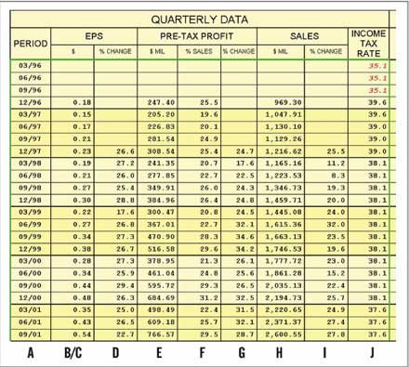
Figure 1. Quarterly information for MBNA Corporation, which is found on the left side of the PERT Worksheet-A.
Those who prepare their SSGs manually can purchase the PERT Worksheet-A from NAIC. For computer users, it's included in both Stock Analyst Plus! and Investor's Toolkit Pro and also is available as an add-on module with NAIC Classic. The form fits on a letter-size sheet of paper. Figure 1 displays the quarterly data on the left side of the form; Figure 2 on page 19 shows the last 12 months data, which is on the right side of the form. The figures are for MBNA Corporation (NYSE: KRB), a major issuer of credit cards. Figures 3 and 4 on pages 20-21 display a PERT-A for Keane, Inc. (AMEX: KEA), a consulting, e-business and information technology services firm.
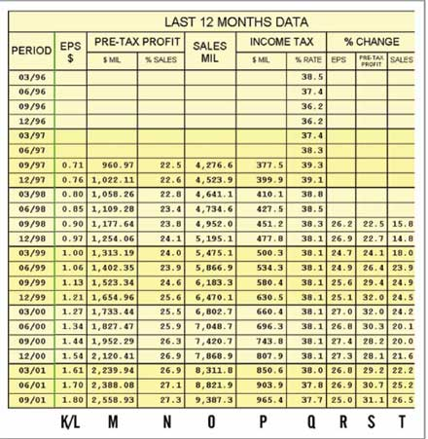
Figure 2. The right-hand side of MBNA's PERT Worksheet-A, which details the company's trailing 12 months of data.
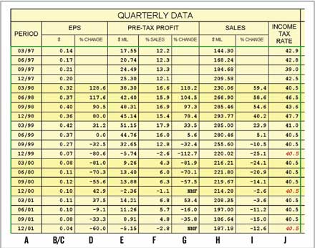
Figure 3. Quarterly data for Keane, Inc.
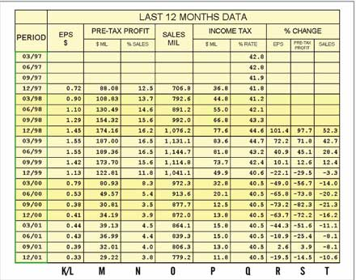
Figure 4. Trailing 12 months data for Keane.
The more recent the income statement, the more timely the data (see Figure 5 below for a simplified income statement). Annual (10-K) and quarterly (10-Q) income statements can be found on the Internet at http://edgarscan.tc.pw.com. You also can retrieve them earlier from company news releases that are usually issued the same day that quarterly earnings are. The news releases are on the company's Web site or at a variety of sites such as http://finance.yahoo.com and http://moneycentral.msn.com. Value Line provides 12 quarters of earnings and sales but not the quarterly pre-tax profit, which is essential to the PERT-A analysis.
For those who use the computerized stock analysis programs, NAIC's Web Site (www.better-investing.org) now provides S&amp;P data files for about 10,000 companies as a benefit of premium membership. The files, updated daily, include 20 quarters of data, enough to complete the PERT-A. The availability of electronic data should provide even more incentive for NAIC members to try out the software. You can download fully functional demos of all NAIC stock analysis programs from the site.
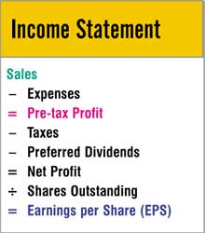
Figure 5. In any income statement, investors can find the three key numbers they use to fill out the PERT Worksheet-A: sales, pre-tax profit and earnings per share.
For those who prefer to prepare the worksheet manually, be sure to choose one data source and continue with it from quarter to quarter. You don't want to compare apples with oranges. Financials come in different flavors: as reported, normalized, from continuing operations and so forth. You can find some good definitions by clicking Investors' Resources in the menu bar at www.investware.com.
Quarterly Data
Let's review the form column by column as seen in Figures 1-4 before addressing how we can use the information to enhance our stock analysis skills.
Column A (period): The date is the final day of the period covered. The line for the period 09/01 covers data retrieved from the income statement for the quarter ending Sept. 30, 2001.
Column B/C (EPS): In this column, enter EPS for each quarter. Diluted rather than basic EPS is preferable. On the paper form, EPS is divided into two columns; this allows you to switch from Column B to Column C after a stock split. The illustrations in Figures 1-4 come from Toolkit. In computer programs the second column is eliminated because the software adjusts per-share data for splits.
Column D (percent change in EPS): This is your first calculation. The computer programs do this automatically, but the math isn't difficult. Simply compare each quarter with the year-ago quarter. Year-ago comparisons are more meaningful than sequential ones (current quarter vs. previous quarter) because of seasonal differences.
Barnes & Noble (NYSE: BKS), for example, sells 90 percent of its books the quarter of the holiday season. It makes much more sense to compare the fourth quarter of 2001 with the fourth quarter of 2000 than with the third quarter of 2001.
To arrive at a growth percentage, deduct the year-ago quarter from the current quarter, divide the result by the year-ago quarter and multiply by 100. In Columns B/C and D of Figure 1, 0.54 (EPS for 9/01) - 0.44 (EPS for 9/00) = 0.10 divided by 0.44 = 0.227 x 100 = 22.7 percent. Observe the nice, healthy trend of earnings in Column D for MBNA. Now view the same column in Figure 3 for Keane, Inc. This analysis can be quite an eye-opener.
Column E (pre-tax profit in millions of dollars): You'll find different terms for this item on the income statement, such as "income (or earnings) before income taxes (or provision for income taxes)." Again, enter a dollar amount for each quarter.
Column F (pre-tax profit as a percent of sales): To determine the pre-tax profit margin, simply divide pre-tax profit (Column E) by sales for each quarter (Column H) and multiply by 100. Using the 9/01 quarter for MBNA, 766.57 divided by 2,600.55 = 0.295 x 100 = 29.5 percent. Look for a stable or increasing trend. Again, compare MBNA's Column F with Keane's. I chose these two extreme cases for illustration purposes only.
Column G (percent change in pre-tax profit): Using the data from Column E, perform the calculation just as you did in Column D. This column corresponds to the pre-tax profit trend line on the visual analysis of the SSG. Profit margin will be steady when growth in pre-tax profit mirrors growth in sales.
Column H (sales in millions of dollars): These numbers come right from the income statement with a few special considerations regarding financial institutions and restatement of data. The Investware site provides a full explanation.
Column I (percent change in sales): Calculate the percent change from Column H using the same procedure as for Columns D and G.
Column J (income tax rate): If you are doing this manually, divide the amount of taxes on the income statement by pre-tax profit to arrive at the tax rate.
Last 12 Months Data
As you continue to use this form regularly, you will probably find yourself paying more attention to the right-hand side, for data from the last 12 months. This section, also referred to as rolling or trailing 12 months (TTM) data, allows NAIC investors to compare the quarterly TTM with the trailing data for the year-ago period.
So for 9/01, we're comparing the 12 months ending September 2001 with the 12 months ending September 2000. This comparison may be more significant than the single-quarter comparison because it smoothes out the figures, eliminating seasonal changes or an overemphasis on one erratic quarter.
Column K/L (trailing EPS): For each quarter, the amount entered equals the sum of that quarter plus the preceding three quarters from Column B/C.
For MBNA, you first enter the sum of the four quarters ending September 2001: 0.54 + 0.43 + 0.35 + 0.48 = 1.80. Then add the four quarters ending June 2001: 0.43 + 0.35 + 0.48 + 0.44 = 1.70. And so forth.
Column M (trailing pre-tax profit): For each quarter, enter the sum of the most recent four quarters of PTP from Column E.
Column N (trailing pre-tax profit as a percent of sales): Simply divide trailing PTP from Column M by trailing sales from Column O. Column N is the first place I look on the PERT-A report.
Column O (trailing sales in millions of dollars): For each quarter, enter the sum of the most recent four quarters of sales from Column H.
Column P (trailing income tax in millions of dollars): Enter the dollar amount of taxes for the most recent four quarters listed on the income statements as tax amount or provision for income taxes.
Column Q (trailing tax rate): Divide the income tax amount from Column P by the trailing PTP from Column M.
Column R (percent change in trailing EPS): The last three col-umns are the meat of the report. Complete Column R by comparing each period's EPS from Column K/L with the year-ago period. For MBNA's 9/01 period, 1.80 - 1.44 = 0.36 divided by 1.44 = 0.25 x 100 = 25 percent.
Column S (percent change in trailing PTP): Calculate the trailing growth rates from Column M.
Column T (percent change in trailing sales): Calculate the trailing growth rates from Column O.
The good news is that after the initial data entry, you update this form only once every three months. If you use a computerized program with the electronic data files, all the data entry and calculations are performed for you.
It's worth your while, nonetheless, to view the PERT Worksheet-A column by column so that you are aware of just where the comparisons come from.
Scrutinizing Pre-Tax Margins
I use the right-hand side of the PERT-A almost exclusively; I'll glance at the left side if an unusual quarter stands out. In that case, I might check the 10-Q for that quarter to get management's explanation. I then turn to Column N, which details trailing pre-tax profit as a percent of sales.
Pre-tax margins are crucial to my analysis. I hope to find a stable or increasing trend as confirmation that management is being vigilant and maintaining expenses regardless of economic or industry conditions. I rarely purchase a stock when I view a downward trend in Column N. I tend to be more flexible when I already own a stock.
In that case I make every effort to find an acceptable explanation for the downward trend. A large acquisition, for example, can wreak temporary havoc on margins because of the initial high costs of integration. I try to determine whether a problem is specific to the company or more of a general industry problem.
If margins are slipping but to a lesser degree than at other companies in the same industry, I will probably hold on to my shares. My company may end up taking market share from competitors that are in even deeper trouble. I usually go right to the ratio comparison chart at www.marketguide.com (found by clicking Education within the Stocks section of the menu) to compare my company with its industry and sector. A company most likely will discuss a decline in margins in quarterly conference calls and in the Management's Discussion and Analysis section of its 10-Q. Falling pre-tax margins mainly should alert us to the need for more investigation.
Next I go to Columns R, S and T. Ideally growth rates of sales, PTP and EPS are stable or increasing and at or above my projected earnings growth rate. Just as we like to see sales, pre-tax profit and earnings trend lines look like parallel railroad tracks on the visual analysis, we expect trailing growth rates in Columns R, S and T to be stable and in equilibrium.
I make it a point to review the growth trends in these three columns before finalizing my growth projections on page 1 of the SSG. If I notice a slowing trend, I'll probably lower my projections. A decline in growth rates is not necessarily cause for concern. Fastenal (NNM: FAST), which sells threaded fasteners and other construction and industrial supplies, is a case in point. For the eight quarters before my initial purchase, sales were growing at percentages in the mid-30s. Then sales growth declined to the mid-20s. Investors were disappointed, and the price dropped more than 40 percent.
Realizing that companies mature and cannot be expected to continue earlier growth rates indefinitely, I projected 16.5 percent earnings growth. At the time of my purchase, the PERT-A report showed sales growth at 26.4 percent; PTP, 28 percent; and EPS, 29.6 percent. Pre-tax margins were slightly lower than historical numbers, but they were steady for five sets of trailing quarters at 17.1 percent. This was about double the industry average.
For me this was a buying opportunity. It turned out to be one of my more successful investments. We're looking at growth rates in this section. Fastenal not only was earning money, it also was increasing earnings by close to 30 percent every four quarters. It was continuing to expand, though not quite so rapidly as it was as a smaller firm. For the most part, though, you should consider a decline in sales growth rates in Column T a red flag.
In Column S, beware when pre-tax profit grows at a slower rate than sales. That will show up in the profit margin, which measures the relationship between sales and pre-tax profit. The order of these three items on the income statement is significant. Earnings, which drive the price of a stock, will eventually follow a decline in sales or pre-tax profit.
The underlying strength of the NAIC methodology is its simplicity. In a short time, NAIC-style investors learn to determine whether a company is fundamentally sound by focusing on three basic measures: sales, pre-tax profit and earnings per share. We look for companies that have been growing all three consistently and increasingly over the past 5-10 years. We also seek companies that demonstrate a propensity to sustain that growth by examining the trend in pre-tax profit as a percent of sales, known as the pre-tax profit margin. Adding to the simplicity, every public company provides sales, PTP and EPS every quarter in a single report.
This is where the PERT Worksheet-A can serve as an early warning. A decline in the pre-tax profit trend signals the need for research as you try to determine the significance of the problem. Increased competition can have a long-term effect on a company. You might conclude that management is losing control of costs. Perhaps the company is relying on a single product that's being replaced by another company's new and improved product. A change in management can be a red flag.
By the time the decline hits the earnings line, the stock's price may have plummeted as well. The only option at that point may be to cut your losses and move on to a healthier company. You might even replace that firm with a competitor that has been slowly but surely gaining market share.
The Temptation of Short-Term Thinking
One concern with PERT Worksheet-A is that its use may lead to short-term thinking, which isn't a good thing. NAIC members are long-term investors. A shift in trends should be an alert. It's difficult to say how long an investor should wait before taking action. Each case is unique.
You hope you're purchasing shares of a healthy, growing company. If you subsequently notice that your original expectations are not being met, you need to become an investigator. Read the quarterly report, company press releases, analyst research reports and information posted on the company's Web site. If possible, listen to the firm's quarterly conference call.
If questions remain, you can call the investor relations department. You would be amazed at how much time a chief financial officer or director of investor relations will spend with an individual investor. But at some point, you just have to trust your own instincts.
Declining trends in the PERT-A should draw your attention. If you're still uncomfortable with the investment after doing some serious research, it may be time to sell. NAIC's Rule of Five says that for every five companies in which you invest, three will perform according to expectations, one will perform far better and one will perform far worse. You can use the information gleaned from PERT-A to eliminate the bad ones before they do too much damage to your portfolio. That will have a significant effect on your overall return.
The PERT Worksheet-A played a big part in my decision to purchase MBNA Corporation recently as well as my decision to sell Keane, Inc. about a year and a half ago. In NAIC circles, we're reminded that "buy and hold" does not mean "buy and forget." We are continually making buy, hold and sell decisions. Using the worksheet regularly can help to remove some of the uncertainty associated with these difficult decisions and might help to bolster your confidence. You'll find PERT-A to be a welcome addition to your investing bag of tricks.
Nancy Isaacs is an individual investor and NAIC member from Toms River, N.J. A recipient of the 1999 Kenfield-Burris Online Service Award, she is a "Sysop"(systems operator) for the NAIC Forum, at www.better-investing.org.

