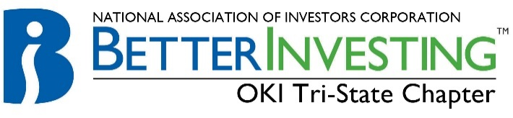

Cincinnati Model Investment Club (CinMIC)

Agenda for Sat. Apr 28, 2018 / 9:45 – 11:45AM Room C
Midpointe Library--9363 Centre Pointe Drive, West Chester, OH 45069
View our portfolio at ManifestInvesting.com: https:// www.manifestinvesting.com/clubs/630/dashboards/39194

9:45 Call to Order: | Rich Alden, Presiding Partner, greeting, attendance, proxies, note guests present and on web. RECORD
9:50 Minutes | Minutes for Mar 24, 2017 Meeting - posted to BIVIO Mar 24, 2018. Corrections or additions?
9:55 Financial Report | Current financial report, current cash balance $ .
10:00 Announcements | Classes and webinars: see BetterInvesting Magazine or “ONLINE” section opposite CONTENTS. Other investing educational sessions: “The Roundtable” and “Turn Out Tuesday” once each month sponsored by BI Mid-Michigan. Register with both by contacting: nkavula1@comcast.net.
10:05 Old Business | TBD
10:10 New Business | Latisha has submitted her resignation. June picnic at the Jacobsens?
10:25 Education | Harrison - Investment Psychology – Review of the book entitled "Extraordinary Popular Delusions and the Madness of Crowds"
10:45 Stock Study | Gerry – TBD - something in the Technology sector?
11:10 Portfolio Analysis | Marty: review and discuss “Close of the Bell” Portfolio. Sell/Buy recommendations and discussions.
11:30 Buy/Hold/ Sell | Reports need to be done approximately ONE week before Saturday meeting, discuss Buy/Hold/Sell
Stock | Symbol | Watcher | Watcher: Buy/Hold/Sell | SSG: Buy/Hold/Sell | # of Shares | % of Portfolio | Year End
Apogee | APOG | Nelson | Hold | Buy | 175 | 5.1 | Dec
Apple | AAPL | Jackie |  |  | 95 | 10.9 | Sep.
C. H. Robinson | CHRW | Dene | Hold | Hold | 150 | 9.8 | Dec
Cerner | CERN | Gregory | Hold | Buy | 70 | 2.8 | Dec
Cognizant | CTSH | Michele |  |  | 200 | 11.3 | Dec
CVS Health | CVS | Latisha |  |  | 130 | 5.9 | Dec
Danaher | DHR | Harrison | Hold | Hold | 110 | 7.7 | Dec
Fastenal | FAST | Rich | Hold | Buy | 200 | 7.0 | Dec
LKQ Corp | LKQ | Frank | Hold | Buy | 375 | 9.9 | Dec
Schlumberger | SLB | Mary | Hold | Hold | 140 | 6.7 | Dec
Signature Bank | SBNY | Craig | Hold | Hold | 110 | 9.9 | Dec
Starbucks | SBUX | Gerry |  |  | 130 | 5.2 | Sep
Tractor Supply | TSCO | Kate | Hold | Buy | 130 | 5.4 | Dec
Pounce/Watch List

Future meetings: Mid-Month Portfolio/Stock Committee: May 5, webinar; Regular meeting: May 19, Room C
May Education: Rich; Stock Study: Michele

