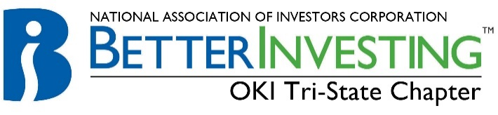

Cincinnati Model Investment Club (CinMIC)

Agenda for Sat. Sep 15, 2018 / 9:45 – 11:45AM Boardroom
View our portfolio at ManifestInvesting.com: https:// www.manifestinvesting.com/clubs/630/dashboards/39194

9:45 Call to Order: | Rich Alden, Presiding Partner, greeting, attendance, proxies, note guests present and on web. RECORD
9:50 Minutes | Minutes for Aug 18, 2017 Meeting – circulated Aug 24, 2018. Corrections or additions?
9:55 Financial Report | Current financial report, current cash balance $1,841.51. Limit orders?
10:00 Announcements | Classes and webinars: see BetterInvesting Magazine ONLINE section opposite CONTENTS. Other investing educational sessions: Register on the BI web site for “Ticker Talk” and Stock-Up”.  “The Roundtable” and “Turn Out Tuesday” occurs each month sponsored by BI Mid-Michigan Chapter. Register with both by contacting: nkavula1@comcast.net.  2019 BINC will be in Chicago, O’Hare Marriott
10:05 Old Business | Partnership Amendment Committee update - Dene
10:15 New Business | New member update? Marty/Dene  Stock study and education schedule, below  Move Nov mtg to Nov 10th?
10:20 Stock Study | Phillip Baxman: membership presentation on Facebook (FB); Oct: Cheryl Hargett membership presentation - tbd  Please note the list of pre-screened stocks below for ideas.
10:40 Education | Mary: BI presentation “One-time Tax Adjustments on the SSG“
11:00 Review & Reflection | CinMIC portfolio is now public on Manifest Investing: https://www.manifestinvesting.com/dashboards/public/RDHP243  Other topics to be determined  1-ETF discovery for hard-to-analyze sectors; 2-potential sells in the CinMIC portfolio; 3-Open discussion
11:30 Buy/Hold/ Sell | Reports need to be done approximately ONE week before Saturday meeting, discuss Buy/Hold/Sell
Stock | Symbol | Watcher | Watcher: Buy/Hold/Sell | SSG: Buy/Hold/Sell | # of Shares | % of Portfolio | Year End
Apogee | APOG | Nelson | HOLD | BUY |  |  | Dec
Apple | AAPL | Jackie | HOLD | HOLD |  |  | Sep.
C. H. Robinson | CHRW | Dene | HOLD | HOLD |  |  | Dec
CBRE Group | CBRE | Mary | BUY 10sh | BUY |  |  | Dec
Cognizant | CTSH | Michele | HOLD | BUY |  |  | Dec
CVS Health | CVS | Dene | HOLD | HOLD |  |  | Dec
Danaher | DHR | Harrison | HOLD | HOLD |  |  | Dec
Fastenal | FAST | Rich | HOLD | BUY |  |  | Dec
LKQ Corp | LKQ | Frank | BUY 25sh | BUY |  |  | Dec
Schlumberger | SLB | Mary | HOLD | BUY |  |  | Dec
Signature Bank | SBNY | Craig | HOLD | BUY |  |  | Dec
Starbucks | SBUX | Gerry |  |  |  |  | Sep
Tractor Supply | TSCO | Greg | HOLD | HOLD |  |  | Dec
Ulta Beauty | ULTA | Kate | HOLD | BUY
Pounce/Watch List

Future meetings: Mid-Month Portfolio/Stock Committee: Oct 6, webinar; Regular meeting: Oct 20, Room C
Oct: Education: Greg; Stock Study: Cheryl; new members may alter this schedule

