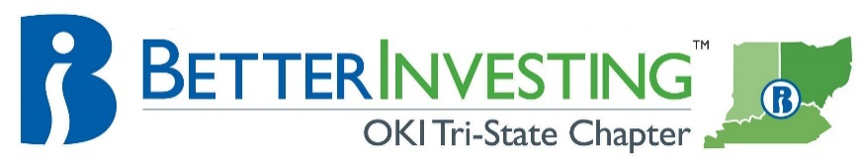

Cincinnati Model Investment Club (CinMIC)

Agenda for Sat. July 20, 2019 / 9:45 – 11:45AM
MidPointe Library - Boardroom

9:45 Call to Order: | Rich Alden, Presiding Partner, greeting, attendance, proxies, note guests present and on web. RECORD
9:50 Minutes | Minutes for June 22, 2019 Meeting – posted to bivio on xxxxxxxxxxxx, 2019. Corrections or additions?
9:55 Financial Report | Current financial report, current cash balance $xxxxxxxxx
10:00 Announcements | - Classes and webinars: see BetterInvesting Magazine ONLINE section opposite CONTENTS. Other investing educational sessions: Register on the BI web site for “Ticker Talk” and Stock-Up”.  - “The Roundtable” and “Turn Out Tuesday” occurs each month sponsored by BI Mid-Michigan Chapter. Register with both by contacting: nkavula1@comcast.net.
10:05 Old Business | - Valuation of Phillip Baxman shares $420.77, check sent
10:10 New Business | - 2019 Stock study and education schedule, below. CinMIC portfolio is now public on Manifest Investing: CinMIC Portfolio ;Pounce List Companies.
10:15 Stock Study | - Gerry: tbd  Please note this list of pre-screened stocks for ideas: Stocks to Study
10:35 Education | - Craig: Proposed group stock study method; discussion/vote; part 1 of the BI SCG presentation
11:20 Buy/Hold/ Sell – HARD STOP | Reports need to be done approximately ONE week before Saturday meeting, discuss Buy/Hold/Sell
Stock | Symbol | Watcher | Watcher: Buy/Hold/Sell | SSG: Buy/Hold/Sell | # of Shares | % of Portfolio | Year End
Apple | AAPL | Jackie | HOLD | HOLD | 95 | 11.6 | Sep.
Booking | BKNG | Rich |  |  | 2 | 2.3 | Dec
C. H. Robinson | CHRW | Cheryl | HOLD | BUY | 150 | 7.5 | Dec
CBRE Group | CBRE | Mary | HOLD | HOLD | 150 | 4.7 | Dec
Charles Schwab | SCHW | Craig |  |  | 60 | 1.5 | Dec
Cognizant | CTSH | Michele |  |  | 200 | 7.9 | Dec
CVS Health | CVS | Dene | HOLD | HOLD | 165 | 5.8 | Dec
Danaher | DHR | Harrison | HOLD | HOLD | 110 | 9.5 | Dec
Fastenal | FAST | Rich | HOLD | HOLD | 400 | 7.3 | Dec
Home Depot | HD | Nelson | HOLD | HOLD | 45 | 5.8 | Dec
LKQ Corp | LKQ | Frank | HOLD | HOLD | 400 | 6.3 | Dec
Lam Research | LRCX | Bill |  |  | 10 | 1.1 | Jun
Signature Bank | SBNY | Craig | HOLD | BUY | 110 | 8.4 | Dec
Starbucks | SBUX | Gerry |  |  | 80 | 4.3 | Sep
Tractor Supply | TSCO | Greg | HOLD | HOLD | 145 | 9.7 | Dec
Ulta Beauty | ULTA | Kate | HOLD | HOLD | 15 | 3.1 | Jan
Vanguard Healthcare ETF | VHT | Jackie |  |  | 20 | 2.1 | ---
Pounce/Watch List
Stock | Symbol | Watcher | Presented | Recommendation/Remarks
Visa | V | Harrison | 6/22/19 | Price up in last 30 days, earnings on Jul 23

Future meetings: Mid-Month Portfolio/Stock Committee: Aug 3, webinar; Regular meeting: Aug 17, Library Room C
Stock Study: Michele - TBD; Education: Jackie – TBD; new members may alter this schedule

