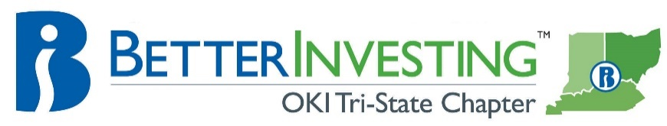

Cincinnati Model Investment Club (CinMIC)

Agenda for Sat. July 17, 2021 / 10:30a – 12:30p
Online and In-person at MidPointe Library Board Room

9:45 Call to Order: | Rich Alden, Presiding Partner, greeting, attendance, proxies. Welcome to all our guests, especially those attending for the first time. There is a handout available in the control panel tab that will introduce CinMIC’s purpose to our newcomers, and act as a reminder to our repeat visitors. RECORD
9:50 Minutes | Minutes for June 19, 2021 meeting posted to bivio on Jul 12, 2021. Corrections or additions?
…. Financial Report | - Current financial report, cash balance: $42,080.20 as of CoB July 9, 2021; $6,101.77 remaining for investment after member checks issued.
…. Announcements | - Better Investing Weekly Newsletter – First Cuts, webinars, Learning Center, news and information  - Classes and webinars: see BetterInvesting Magazine ONLINE section opposite CONTENTS. Other investing educational sessions: Register on the BI web site for “Ticker Talk” and Stock-Up”.  - “The Roundtable” and “Bull Sessions” occurs each month sponsored by BI Mid-Michigan Chapter. Register with both by contacting: nkavula1@comcast.net  - BINC is October 21-24, in Dallas
…. Resources | - CinMIC portfolios on Manifest Investing: CinMIC Portfolio  - Mid-Michigan Chapter presentation on portfolio management: https://www.youtube.com/channel/UCgGv4xQhxQnpZ34jpZzjf0A
10:00 Old Business | - Presentation schedule updated, see below
…. New Business | - Gerry update: check issued/received for $27,978.43  - Jackie $8,000 withdrawal request, check issued  - Nelson leave of absence
10:10 Stock Study | - Roger: Malibu Boats (MBUU)
10:40 Education | - Bill: Special Purpose Acquisition Companies (SPACs)
11:00 Portfolio Review | - Marty’s analysis of the CinMIC portfolio; members to address their PERT misses, core vs. non-core  - Craig/all: Club adoption of the ‘Deciding to Sell a Company’ criteria  - Use of the short form for interim stock reports
11:15 Review and Reflection | - Continuing discussion on stock reviews and portfolio management
11:30 Buy/Hold/ Sell | - Reports need to be done approximately ONE week before Saturday meeting
Stock | Symbol | Watcher | Watcher: Buy/Hold/Sell | SSG: Buy/Hold/Sell | # of Shares | % of Portfolio | Year End
Adobe | ADBE | Kate (1) | HOLD | HOLD | 20 | 6.8 | Nov
Alphabet | GOOG | Roger |  |  | 4 | 5.8 | Dec
Apple | AAPL | Jackie | HOLD | HOLD | 135 | 11.0 | Sep
C. H. Robinson | CHRW | Michele (2) | HOLD | HOLD | 93 | 4.8 | Dec
CACI International | CACI | Craig | HOLD | BUY | 35 | 5.1 | Jun
Danaher | DHR | Harrison (2) | HOLD | HOLD | 80 | 12.4 | Dec
Fastenal | FAST | Rich (1) | HOLD | HOLD | 350 | 10.6 | Dec
Fidelity Select Healthcare | FSPHX | --- |  |  | 278.7640 | 5.3 | ---
IRobot | IRBT | Bill | HOLD | BUY | 105 | 5.4 | Dec
Illumina | ILMN | Dene (1) | HOLD | HOLD | 15 | 4.0 | Dec
Ollie’s Bargain Barn | OLLI | Michele (2) | HOLD | BUY | 150 | 7.5 | Dec
Starbucks | SBUX | Harrison (2) | HOLD | HOLD | 80 | 5.3 | Sep
Tractor Supply | TSCO | Paul | HOLD | HOLD | 120 | 12.6 | Dec

Future meetings: Mid-Month Meeting: August 7, 2021, online; Regular Meeting: August 21, 2021, hybrid

Note: The Stock Study and Education schedule is in the process of revision

