Ticker: SWI |  | Reported by: D. Alden |  | Date: May 12, 2014 |  | Comments
 | Last Review SSG Data |  | Current SSG Data |  |  | 2014 First Quarter Report on April 29th, price dropped to due slightly lower forward projections from SWI.
Sales Projection | ? |  | 15% | Missed, Exceeded or  Met Expectations? |  | Met expectations
Earnings Projection | ? |  | 15% | Missed, Exceeded or Met Expectations? |  | Non-GAAP met, GAAP did not  Purchase of company
Started Projection from
  EoT L
  L A D | ?
  L Q D
  EoT L
  L A D | x
  L Q D
Section 2
2A (U,D or E) | No SSG available |  | Down | Significant Changes? |  | 2A numbers are very high and falling to a more sustainable range
2B, etc. | No SSG available |  | Down | Significant Changes? |  | 2B trending from 45% to 23%
2C, etc. | No SSG available |  | Down? |  |  | Not sure why TK6 is showing “down”, they have NO LT DEBT on their Value Line Report
Section 3
Average P/E |  |  | Value Line’s 5 yr average 35.24 | Significant Changes? |  | Value Line is predicting a lowering 5 yr out to low 30’s
Current P/E |  |  | 34.2 on SSG | Significant Changes? |  | Dropping from 2013 average of 37.3
Relative Value |  |  | 96.2 | Significant Changes? |  | No former SSG to check
Section 4
Selected High P/E |  |  | 30 (IAS never goes over a 30PE) | Significant Changes? |  | This is conservative and reflects the falling PE on VL
Selected Low P/E |  |  | 15 (Ratio of 2:1 is approx. for past 5 yr | Significant Changes?
Selected Low Price |  |  | 24.2 | Significant Changes? |  | Price Variant Quotient; lower than Recent severe Mkt low $
USDS Ratio |  |  | 2.4 : 1 | Significant Changes? |  | Conservative SSG, MI has it in the BUY range (Yellow)
Section 5C
Total Return |  |  | 13.7
PERT-A (Quarter Trend Analysis) (Enter Data from Percent of Changes Columns)
 | From QUARTERLY DATA Columns (left side) |  |  |  | From LAST 12 MONTHS DATA COLUMNS (right side)
 | Latest Quarter |  | Quarter - Year Ago |  | TTM ending latest qtr |  | TTM - Year Ago
Earnings | .23 |  | .30 |  | 1.11 |  | 1.14
PTP | 22.8% |  | 40.2% |  | 31.8 |  | 42.5
Sales | 31.5% |  | 22.2% |  | 358.4 |  | 282.2
PERT-A Comments | Sales are doing well and growing. VL is projecting 2014 earnings of 1.33 (1.17 for 2013).
Were the company’s own expectations met? Their last quarter report was full of words for the how well the pace of investment into their core business model. And how well they are working.
Were there any significant judgment changes? I am just getting to know this stock and this business model. I think that SWI is having growing pains and the management isn’t using the same metric numbers we tend to follow. Emphasis is on revenues, growth of FCF and a high level of profitability and product margin.
Is the company currently an SSG BUY, SELL or HOLD? We have held the company for over 18 months and purchased at various points: 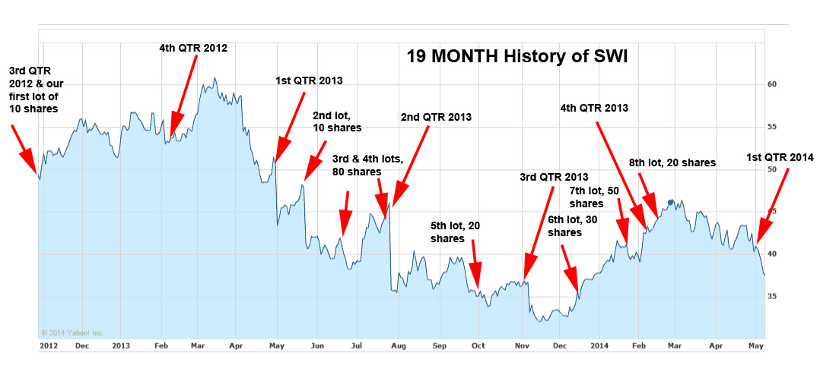
What is your recommendation: Stock is in the BUY range on a conservative SSG.
Additional comments: Just getting to know more about the way management is thinking on this business and we need to give time after a “perfect storm” of problems in 2013. Chart below shows what management looks for, their metrics. Note: revenues above 30% and FCF very high.
