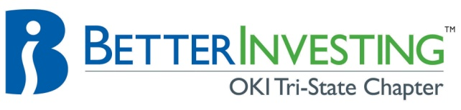

CinMic Education- Schedule for all Partner Participation
2011

PARTNER EDUCATION ASSIGNMENTS FOR UPCOMING MONTHS:
(It is fine if you would like to switch your month, but please make sure you find another partner that can change with you).

Jan | Marty Eckerle | Manifest Investing and Portfolio Management
Feb | Mark Carrozza | Extracting information from Annual Reports
March | Rose Ramsey | Completing Monthly Stock Reports
April | Kugi Chauha | Bivio.com
May | Craig Jacobsen | TBA
June | Jim Clark | TBA
July | Don Bunnell | TBA
August | Mary Thomas | TBA
September | Larry Averbeck | TBA
October | Betsy Eller | TBA
November | Dene Alden | TBA
December | Jackie Koski | 10 things every investor should know about their 401K choices

As we all know, Education is one of the primary focuses of our Investment Club. In order to help make sure that all partners contribute to the Education portion of our monthly meetings, I have assigned partners for each month for the next 6 months. I wanted to make sure that anyone who has not presented in the past 12 months, be assigned a month. If you are newer to the club and would like assistance with your presentation, we have a lot of knowledgeable and experienced partners that will be happy to help. Remember that you do not have to be an expert on your topic. You will learn a great deal by simply preparing your presentation; which you can then share with the Club and our Guests. Since we are a Model Club, it is great to present topics that everyone (Partners and Guests) can easily follow.

Jackie Koski
Vice President, Cincinnati Model Club

