Selling Stocks

August 15, 2009
Craig Jacobsen

Today’s environment
Challenging anytime—more challenging in today’s economy.

Fear with today’s market—emotions are never a good reason to sell.

Tougher to identify stocks to sell with a poor economy.

Common sense & rational thinking needed. PATIENCE TOO!

Valid Reasons to Sell
Fundamentals have changed
Sales growth
Earnings growth
Pre-tax profit margin
Increasing debt
Better alternative—do we have? Either ‘yes’ or find some.
Need the money
Portfolio diversification

Selling requires similar analysis to buying—tough to do in this environment.
Sales, earnings, pre-tax profits, etc
Compare fundamentals to peers
Ask yourself—when will industry recover
Financial strength important in this economy
Balance sheet
Debt to equity
Money needed to weather recession
If high debt, can they obtain or bear more?

How much deterioration to put up with?
Suggest one bad quarter is an alert
Suggest action after 3 quarters of poor performance

Portfolio Improvement
Get rid of dogs
Achieve investment nirvana (better opportunities)
Cut stocks that hurt the least
Smallest potential return. Selling it improves the portfolio return.
Look at Upside/Downside ratios
Low total returns

Selling Mistakes
Selling too soon—do an aggressive SSG.
Holding too long—emotional attachments. (Stick to fundamentals).
Wait for price to recover to the price I paid. (Better off taking loss and buying another stock).
Can’t admit you made a mistake.

Danaher
Fundamentals
Quarterly Trend Analysis
Sales—4 quarters of deterioration
EPS-----4 quarters of deterioration
PTP % of sales—some deterioration
Debt
Typically in low-mid 20% range debt to total capital
Currently 22%
Business
32% Professional instrumentation (testing, environmental)
27% Medical technologies
29% Industrial technologies (product ID, sensors, controls)
12% Tools & components (Craftsman, etc)

Good businesses to be in?

Industry/competitors

When will manufacturing turnaround?

Future Prospects
When will manufacturing turn around?
Analysts expect 6% earning growth in 2010

One scenario:
Club SSG shows 8% yielding $6.22 EPS in 5 yrs. Value Line says $4.85.
U.S. business inventories fell for 10th straight month in June. Longest since 15 mos in 2001-2002.
On the prowl for acquisitions.
$1.3 B in cash
$1 B available via comml paper program
CEO says “very busy on the acquisition front.”

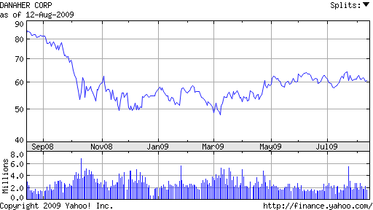

8.6% of our portfolio.
Value Line comments:
We think these shares are fairly
valued at this time. Appreciation potential
3 to 5 years hence is subpar.
Erik M. Manning July 24, 2009

