Cincinnati Model Investment Club Minutes
West Chester Mid-Pointe Library Boardroom – Jan 20, 2018

Call to Order: Presiding Partner Richard Alden called the meeting to order at 9:45a. Proxies where noted, one in-house guest – Glenna Baumbaugh. Guests on webinar: Linda Miller, Linda Margolis and Susan Tanoe.

Name | Here | Proxy | Name | Here | Proxy
Jackie Koski | X |  | Harrison Baumbaugh | X
Betsy Eller, Financial Partner | X |  | Mary Thomas | X
Craig Jacobsen |  | Marty | Gregg Hopkins | web | Jackie
Marty Eckerle | web |  | Latisha Douglas |  | Marty
Gerry Geverdt |  | X | Frank Bicknell |  | Michele
Dene Alden, Volunteer Recording | X |  | Michele Grinoch | X
Richard Alden, Presiding Partner | X |  | Kate Lester |  | Dene
 |  |  | Nelson Page | X | Dene
Note: Parentheses denote provisional presence or proxies should members not be present for the full meeting

Recording Partner’s Report: Minutes of the Dec 17 meeting were approved as posted.

Financial Partner’s Report:
- Current cash: $1,394.25; minus $400 for ManifestInvesting subscription leaves $994.25.
- There are no limit orders
- Jan. report was filed for audit.

Announcements: Classes and webinars:

- Marty announced that the new OKI Tri-State Chapter web pages are now “live” with new format.
- Classes and webinars: see BetterInvesting Magazine “ONLINE” section opposite CONTENTS or visit the web site under Events.
- “The Roundtable”, “Turn Out Tuesday” and “Investing Topics with Mark and Ken” are sponsored by BI Mid-Michigan. Register for any of them by contacting: nkavula1@comcast.net.
- The OKI Chapter will have their spring educational event on April 21, 2018 in Dayton at the Holiday Inn opposite Wright State.
- Check out Stock Up and Ticker Talk on the BI web site
- Marty posted a table of events with dates and information, will distribute to members:
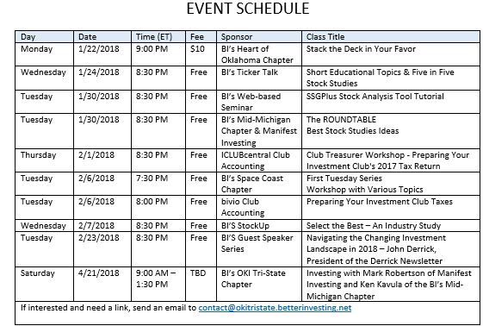

Old Business:
- Dene made a motion to pay the $400 ManifestInvesting annual fee out of the general cash fund. Seconded by Jackie. Motion passed 11/2/0

New Business:
- March 17 meeting date conflicts with the yearly Shamrock Shuffle Charity Run. Registration is held at the Mid Pointe Library Auditorium. Motion made to move date ahead to March 24, Gerry/Mary, motion passed 13/0/2
- April 21 meeting date conflicts with OKI Tri-State Chapter Spring Educational Event in Dayton. Motion made to move date ahead to April 28, Gerry/Dene, motion passed 13/0/2.

Education: Michele Grinoch - “Cash Flow”
- Michele presented a revised and up-dated educational segment on Cash Flow.
- The original presentation can be found on the new OKI Tri-State Chapter web page under News and Articles as a “MINI EDUCATIONAL” segment along with other classes.
- She covered accrual accounting, operating and investing activities of companies using cash for plant and equipment as long term improvements; “net cash from operational activities” should be going in same direction as EPS; “cash is king” and cash flow should always be part of your investment research.

New Stock Presentation: None this month, continuation of the Portfolio Review

Portfolio Analysis Stocks covered this month were CVS and LKQ
- CVS, Marty reported in watcher Latisha Douglas’s absence
  - Adjustments were made to SSG; and a group discussed the additional debt from acquisition of Aetna.
  - Most mergers and acquisitions do not go well and this one will change the CVS business/market plan.
  - CVS will have a high ratio of interest 11:1
  - Therefore the group felt that this stock is a possible “ASF” (available for sale) should the stock fail to perform.
- LKQ, Michele Grinoch
  - LKQ is performing well, one of our highest growth of revenues and EPS in the portfolio.
  - They tend to make very good acquisitions and are controlling debt
  - Agreed SSG has LKQ in the hold range.

Close of the Bell: Marty carefully explained in great detail the excel spread sheet of data showing a number of points that the club should consider. He showed the six bottom tabs: CinMIC Portfolio, Monthly Update, Triple Play, MI Monthly Comparison, Growth Potential and IRR Report.

Portfolio Review:

Stock | Symbol | Watcher | Watcher: Buy/Hold/Sell | SSG: Buy/Hold/Sell | Report posted: | # of Shares | % of Portfolio | Year End | Next Earnings Report:
Apogee | APOG | Nelson | BUY 10 | Buy |  | 130 | 3.8 | Dec
Apple | AAPL | Jackie | HOLD | HOLD |  | 95 | 10.9 | Sep.
C. H. Robinson | CHRW | Dene | HOLD | HOLD |  | 150 | 9.2 | Dec
Cerner | CERN | Gregory | HOLD | HOLD |  | 60 | 2.7 | Dec
Cognizant | CTSH | Michele | HOLD | HOLD |  | 200 | 9.9 | Dec
CVS Health | CVS | Latisha | HOLD | HOLD |  | 130 | 6.7 | Dec
Danaher | DHR | Harrison | HOLD | HOLD |  | 110 | 7.1 | Dec
Fastenal | FAST | Rich | HOLD | HOLD |  | 200 | 6.9 | Dec
Gilead | GILD | Dene | HOLD | HOLD |  | 55 | 2.9 | Dec
LKQ Corp | LKQ | Frank | HOLD | HOLD |  | 375 | 10.4 | Dec
Schlumberger | SLB | Mary | HOLD | HOLD |  | 140 | 6.9 | Dec
Signature Bank | SBNY | Craig | HOLD | HOLD |  | 110 | 11.3 | Dec
Starbucks | SBUX | Gerry | HOLD | BUY |  | 120 | 4.7 | Sep
Tractor Supply | TSCO | Kate | HOLD | HOLD |  | 110 | 5.8 | Dec
 | Stocks on “Pounce / Watch List”
ULTA | ULTA | Ian | Buy Range: 176 to 234.1 |  |  | 0 | 0 | Jan | 12-07

Buy/Sell Decisions: (motion/second: action, type, yes/no/abstain)
- Dene/Harrison: sell 5 sh of GILD @ window to raise cash, FIFO, 11/4/0, hand vote
- Gerry/Dene: buy 10 sh SBUX @ window, 9/6/0, ballot
- Nelson/Marty: buy 10 sh APOG @ window, 11/4/0, ballot

Next Meeting:
Mid-month Study Group: Feb 3, Boardroom, 10:00AM to Noon; cover TSCO and DHR,
Regular meeting in Feb, Saturday, Feb 17th, 9:45-11:45AM; BOARDROOM

Education and Stock Presentation Schedule for 2018/2019:
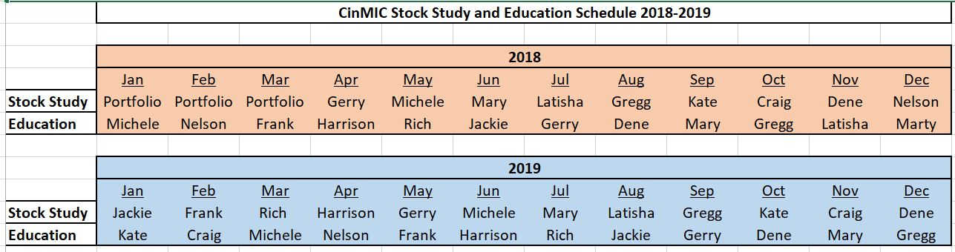

Adjourned: by Rich at 11:50AM

Submitted by Dene Alden, temp recording partner

