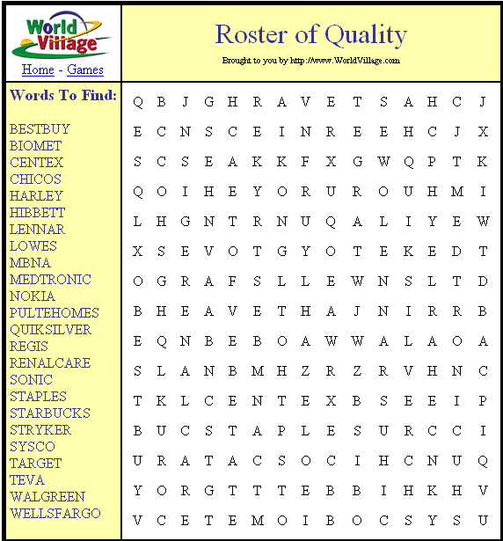

This free Word Find Creator is a great way to learn about new stocks! This is a partial list of the January, 2005 Investware Roster of Quality picks.

