 ”Byte into an Apple”

Apple Inc. (AAPL)
www.apple.com
Sector: Technology Sub-Industry: Computer Systems
Size: Large Cap Navellier Risk: Moderately Aggressive
Prepared by: Ron Thorson

Introduction:
In 1974, when Steve Jobs was eighteen, he started a business with Hewlett-Packard co-worker Steve Wozniak. Their business was based on the theory that the toy whistle in Captain Crunch cereal boxes could produce AT&T’s long distance carrier tones. Their “blue boxes” was to provide an illicit free long distance service to customers.

Two years later, Jobs and Wozniak built a computer (Apple II) for the Homebrew Computer Club. The two sold the Apple II as home-assembled computer kit. Apple Computer Inc. incorporated in January of 1977. The company name changed to Apple Inc. in 2007. Steve Jobs has served as CEO since 1997. The company is based in the town where it was founded: Cupertino, California.

Apple products and services are famous for their aesthetic and simple design. They are also known for their high customer loyalty. According to JD Power Associates, Apple has the highest brand recognition and repurchase loyalty of any computer manufacture.

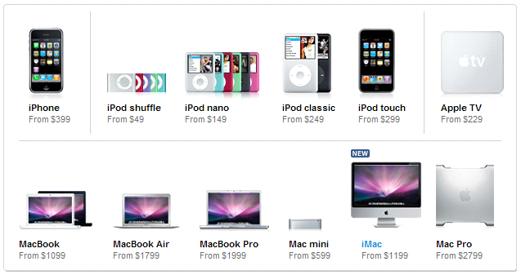
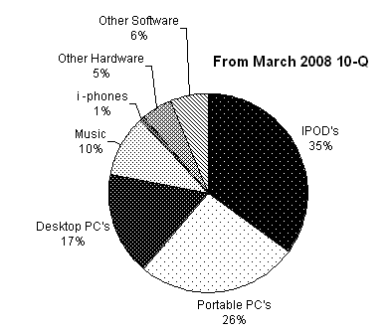
Today, Apple is a multinational corporation that develops, sells and supports a line of personal computers, portable media players, mobile phones, computer software, hardware and hardware accessories. Apple employees over 20,000 employees worldwide and annual sales for fiscal year 2007 (ending in September) was $24.01 billion.

A Company of Innovation:
In Business Week’s April 28 issue they selected the top 25 most innovative companies. Apple was selected number one. Looking at all of their inventive product lines they are a company that is hard to classify.
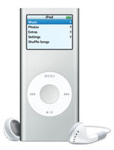
Apple is in the entertainment business. Apple’s portable MP3 player, the iPod, accounts for the largest percentage of revenue for Apple, and currently Apple dominates the MP3 market with a 70% share. As of September 2007, there have been over 150 million iPods sold around the world since they first were introduced in 2001. However, sales are dropping and they are loosing market share. SanDisk has 11.2% of the market, Creative has 3.6% and Microsoft accounts for 2.5%. The remaining 12.8% is made up of a number of small companies.

Music downloaded from Apple’s iTunes Store has now surpassed Walmart as the number one music seller. Apple has sold more than 3 billion songs since 2003. Apple has even partnered with Nike allowing runners to sync and monitor their runs with iTunes. Apple is also pairing iTunes with Apple TV, a set-top video device intended to bridge the online movie content with high definition televisions. Apple has a 80% market share of the music and video download market.

Apple is in the telecommunications business. The iPhone first became available in June of 2007, and it’s a device that is a mix of an iPod, web browser and a smart phone. Although the iPhone accounts for only one percent of current revenues, they are aiming to sell ten million iPhones in 2008. They sold 1.7 million mobile phones in the 1st quarter of 2008. The world cellular phone business rose by 10% to reach 1.1 billion phones sold in 2007. The iPhone took a 0.6% share of the world’s cell phone volume in 2007.

Apple is in the computer hardware business. In the first quarter of 2008, over 43% of Apple’s revenues came from their desktop and portable computers. Their computers are based on the Apple’s OS X operating system which is UNIX based. Two poplar features of this operating system is that its virus free and better suited for digital music and digital pictures.

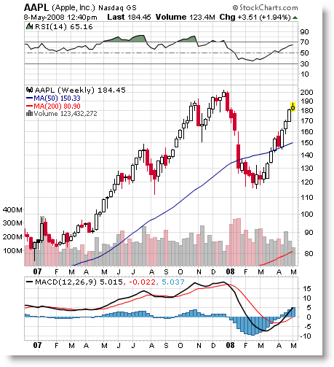
Hot Stock in a Hot Sector:
In January 2008, the stock price for Apple plunged after their January 23rd conference call when they announced that they expected to earn 94 cents a share on $6.8 billion in sales for the upcoming 2nd quarter. Analysts’ consensus estimates were for $1.09 a share on revenue of $6.99 billion. This came after they announced that earnings had climbed 58% (earnings of $1.76 per share on revenue of $9.6 billion).

Apple is known for giving very conservative guidance on their conference calls, but their January announcement came at a very bad time for Apple’s stock price. Recession fears and the fear of cutback in consumer spending were very high in January 2008, and stock prices for the entire technology sector were negatively impacted. The result was a lowering of nearly 40% of Apple’s stock price from the 52 week reached in December of 2007.

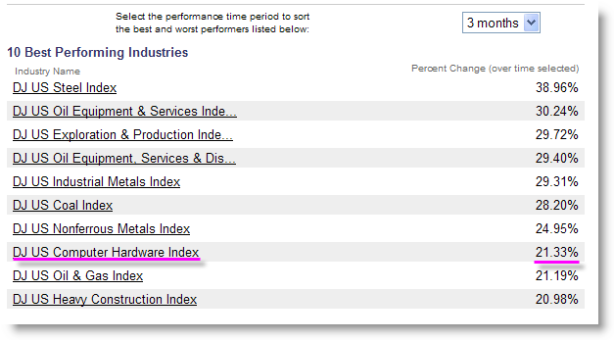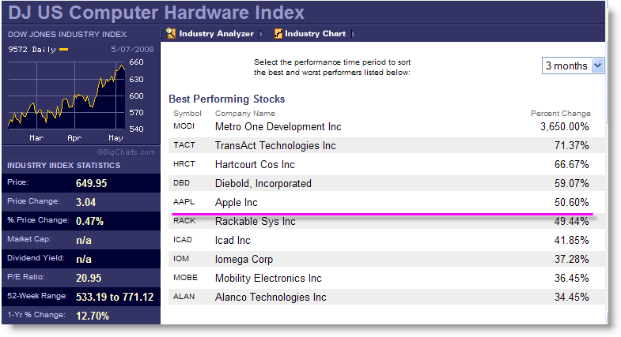

BigCharts.com is showing that the US computer hardware industry is seventh hottest sector of all domestic stock sectors in the past few months. Only industries in the energy and material sectors are performing better. Within the US computer hardware industry Apple is the fifth best performing company. Value Line’s April, 2008 Investment Summary ranks the Computers/Peripherals sector 13th in order of timeliness. Per Value Line, Apple rates a “3” for timeliness.

Pros:

- According to Standard & Poors, PC unit sales grew at three times the industry in the past couple of months. Sales of Mac computers increased 51% (2.29 million units) in the March 2008 quarter over the same quarter in 2007. This came in light of recession fears with consumers. With Microsoft experiencing problems with their new VISTA operating systems, switching Windows users to Apple PC’s is an enormous opportunity.
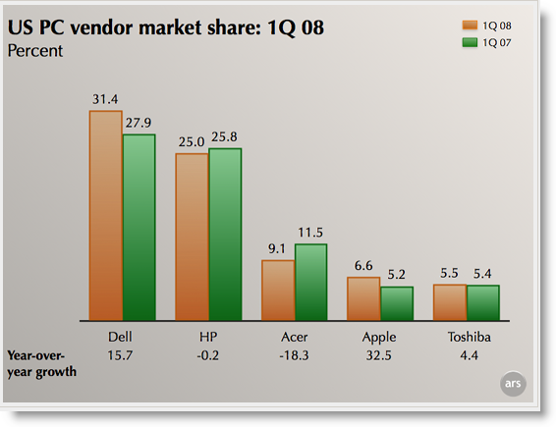

- Piper Jaffray analyst Gene Munster predicts that Apple will sell 45 million iPhones in 2009. According to Bank of America analyst Scott Craig, for every million iPhones Apples sells it adds $400 million to their bottom line. By selling 45 million phones that would generate an additional $5 billion in revenue. To put that number in perspective that would equal Apple’s net income for 2007. A new generation of the iPhone (2.0) will be released at the end of June 2008 that will allow for open source development.

- The third fastest segment of the entertainment industry is video games. Apple is moving to add video games to the iTunes product catalog. The 150 million of iPod users is large pool of potential customers for future video game downloading.

- The 208 Apple retail stores (most in the US) have had incredible success. It was reported in April’s conference call that sales grew by 74%.year over year driven by the traffic of 33.7 million visitors, which was an increase of 57% from 2Qtr 2007. It was also reported that 50% of sales were to new Mac users. Apple is planning on opening stores in Australia, China and Switzerland in the coming months.

- Apple is sitting on $19.4 billion in cash, and they have no debt. There was no talk of any stock buyback or any company acquisitions in the last conference call, but the potential is there.

Cons:

- Nearly sixty percent of Apple sales are in the US. This makes the company more susceptible to a US recession than with some of its competitors.

- Apple has received a lot of criticism of not notifying customers of outstanding problems until the fix is released. This subjects the company to negative news, and the stock has shown a tendency to react to bad news.

- CEO Steve Jobs has had reported health problems in 2006. His departure from the company could spawn a stock sell off.

Other Information from the 2nd Qtr 2008 Conference Call:

- Revenue in the March 2008 quarter was $7.52 billion which is up $2.2 billion over the same quarter of 2007.

- Revenue growth in the 2nd Qtr increased 43% year over year (21% growth was experienced for the same quarter last year). Revenue grew by 47% for International sales while US sales increased by 40%.

- The US education market created a 35% greater demand for Mac’s year over year. This was the highest quarterly growth rate in over eight years.

- Operating margin for the quarter increased by 17.5%. Net income for the quarter was $1.05 billion, which was a 36% increase over last year. This generated a $1.16 earnings per share, which exceeded the $1.10 analyst estimate.

As of May 12, Reuters is reporting that institutions are net buyers.
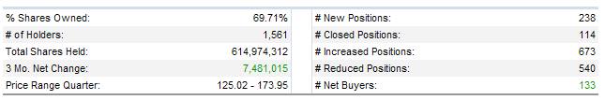

Analyst Estimates and Company Guidance:

 | 5 Year Sales | 5 Year EPS
Manifest Investing | 22.5% | 20.0%
Value Line | 22.0% | 25.0%
Morningstar | 18.4% | -
Yahoo | - | 22.96%

In the March 29, 2008, conference call they are targeting revenue of $7.2 billion for the June quarter. They expect June earnings to be “about a $1.00”. The analyst consensus is EPS of $1.07 (a 15.93% growth rate over last year).

Judgments on the SSG:

I selected 21% for 5yr sales growth (close to the average of analyst estimates above). I selected Manifest Investments more conservative 20% figure for 5 year EPS. I used the five year average high PE (49.4), which was in-line with the Reuter numbers below. For the average low PE, I used 21.1 which is lower than the SSG average, but more in line with Reuters past history.
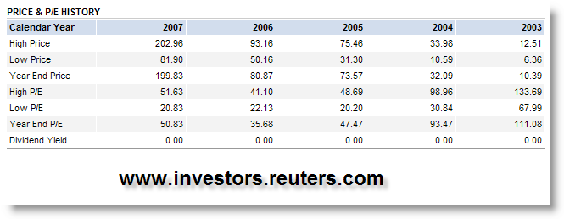

On May 9th, at a price $183.45, the SSG has 5.1 to 1 upside, 100.00 % relative value, and a return of 18.3% to 26.6%. Apple is in the BUY range at this time.

