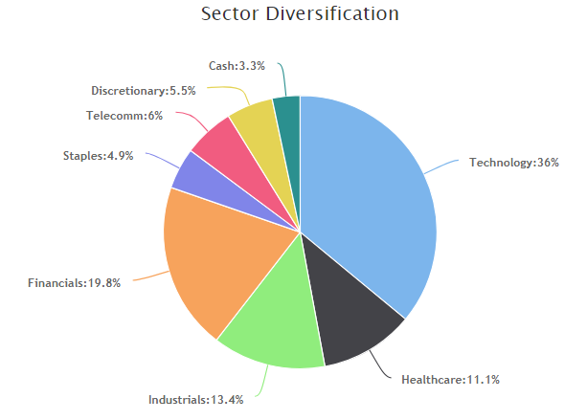

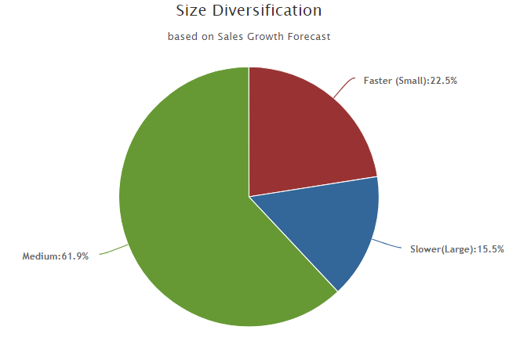

Sales Growth 7% to 12%

AAPL, ABBV, AL, ASR, CERN, CTSH, DY, GNTX, MSFT, TROW, and V

Sales Growth below 7%

BRK-B, CHRW and CVS

Sales Growth above 12%

GOOG, IPGP, LKQ AND OZRK