Model Investment Club of Northern Virginia (MicNOVA)
DC Chapter of Better Investing
Minutes for the December 13, 2022 (Online Meeting)

Members Present: Sheryl Patterson, Gladys Henrikson, Arvind Krishna, Pat Onufrak, Ty Hughes, Paul O Mara, Janet Lewis, Maskey Krishnarao, Kathy Emmons, Amy Laing, Jo Murphy
Members Absent: Baskar Arumugam
Proxies for Members: Gladys for Baskar
Visitors/New Attendees Present: Paul Daku, Lee Outlaw, Fred Beckman, Carol Cuddihy, Catherine Duthie, Carmen Dudley, Eveline Lloyd, Cathy Duthie, Valerie Smith, Ravi Sundeer, Patrick Smith (onemuffin@gmail.com), Dave Lock, Doss, Adam

Sheryl Patterson started the meeting since the scheduled meeting lead Baskar could not attend because of his work situation. Sharyl became the designated meeting lead. She welcomed everyone including new visitors; explained the club’s purpose & objectives; reviewed announcements of upcoming events; displayed the BI Disclaimer; and conducted the meeting.

- Secretary’s Report – Arvind and Maskey
Nov 08, 2022 Meeting Minutes report was presented by Arvind. Motion was made to accept minutes and seconded. Minutes were approved. Gladys has posted the Minutes in the Bivio folder.

- Treasurer’s Report - Gladys
Gladys presented the Treasurer’s Report indicating the availability of over $6,000 ($6,200) available to buy stocks. Sheryl made the motion to accept Treasurer’s report and Jo seconded. Treasurer’s report was accepted by the Partners and posted in the BIVIO folder. Gladys also asked for volunteers to assist in treasury activities for conducting audit.
Treasurer has appointed a 2022 Financial Audit committee for conducting audit of MICNOVA 2022 Accounts - Kathy, Paul, Maskey, and Jo

- Education & New Stock Presentation Timetable for 2023: by Sheryl
Partners are requested to identify their 2023 Education and Stock Presentation titles for the next 3 months in advance, so that Carol Cuddihy can submit them onto our BI webpage.

- Education – “Template For Use of Analyst’ Consensus Estimates for Projecting Future Sales/EPS Growth for SSG” - by Amy
Amy presented the educational seminar “The Analysts’ Consensus spreadsheet”, initially developed by Sheryl and it is available in Bivio under Education. Members can use this template to develop LT Sales and EPS estimates that are used in the SSG during a stock analysis.

- New Stock Presentation (COSTCO) – by Maskey
Maskey presented a comprehensive analysis of new COSTCO stock. SSG analysis indicates “Hold”. The SSG Buy range is from $360 - $442. Costco, although a stellar stock, the high price and PE places it currently in the Hold category. Recommend “BUY up to $354.2 (with 3:1 upside – downside ratio and 15% Total Return).

- Stock Watcher Quarterly Reports Presented:
- CBOE (Maskey) – SSG recommends “Hold”
- Adobe (Kathy) – SSG recommends (Buy), Kathy advised buying more (although the club currently has a healthy position)
- Google (Jo) – SSG says “Buy”, although it's in the Buy range for individual investors, the club has a healthy position already. Hold for MICNOVA Portfolio
- Apple (Paul) - Paul reported on Apple with SSG results, "BUY range" for individual investors, but club already has a significant stake
- EPAM (Baskar) - Baskar was not available to report on EPAM, so this stock report will be added to the January agenda.
Stock Watchers (Please share the Online SSG with all MICNOVA members going forward)

- Watch List Stocks Review – by Sheryl
We are searching for stocks with a PAR <10; Quality <70, and Growth < 8.
Based on this criteria, Sheryl identified 3 prospective stocks on the watch list for which MicNova Partners discussed for purchase:
- Fox Factories (FOXF - Upside Downside Ratio: 3.7 to i to 1; 31.1% Return, BUY Range
- Simpson Mfg. (SSD) – Upside Downside Ratio: 6.1 to 1; BUY Range
- Western Alliance Banks (WAL) - Upside Downside Ratio: 3.3 to 1; BUY Range
Sharyl mentioned that Robertson (Manifest Investing) discussed about reassessing GNRC.
Gladys indicated that Ken Kavula (BI) mentioned many times positive financials aspects of Western Alliance (WAL) – specifically its “Return on Assets”.
Ty mentioned that WAL would be a good stock to buy for the MICNOVA Portfolio.
Ty also mentioned that SSD is similar to FASTENEL – Ty presented a hopeful LT view for SSD

Ty presented new ideas for stocks from the IAS and Small Cap Stock portfolios he has published for MicNova among the Watch Lists. Links for studying Stocks are as follows:

Investor Advisory Service (Dec 2022)
https://www.manifestinvesting.com/dashboards/public/DWVAZHW
Small Cap Informer (Dec 2022)
https://www.manifestinvesting.com/dashboards/public/V9NMYYT
MI Best Small Companies (2023)
https://www.manifestinvesting.com/dashboards/public/3NWDK4E
- Decision Buys/Sells: Partners
The club voted to buy $3.0K of WAL and $3.1K of SSD. Jo made the motion for WAL and Gladys seconded. The motion passed. Sheryl made the motion for SSD and Ty seconded. The motion passed.
Stock purchase decisions by Partners based upon their motions as indicated above were executed as follows:

Gladys later reported these stock purchases based on the Club Members votes (Note WAL in 2 transactions):  Purchased 37 shares Western Alliance Bancorporation (WAL) at 61.37 per share | $2270.69
12/14/2022 | Purchased 32 shares Simpson Manufacturing Co. Inc (SSD) at 95.605 per share | $3,059.36
12/15/2022 | Purchased 14 shares Western Alliance Bancorporation (WAL) at 57.08 per share | $799.12

- Member Questions and other Matters - Partners
No specific questions and/or comments were raised. Ty mentioned that MICNOVA member Tax allocations for 2022 tax planning purposes have been provided in the BIVIO-MICNOVA Section - Accounting

- Next Month Meeting Reminders – Jan 10, 2023:
Education | TOPIC: | 01/10/2023 (Ty Hughes)
New Stock Presentation | STOCK: Simpson Mfg: | 01/10/2023 (Baskar)
Stock Watcher Reports Due | - EPAM  - VRTX  - Monster  - GNTX  - FND (postponed from Dec, per Pat))  - TSCO | Baskar  Arvind  Amy  Ty  Pat  Paul
Portfolio Reports
Watch List Reports |  | Sheryl

2023 BI and Community Events & Announcements

Wed Dec 21 - 7:00 - 9:00 PM  Wed Jan 18 - 7:00 - 9:00 PM  (3rd Wednesday of each Month) | MCMC Monthly Meeting  https://global.gotomeeting.com/join/745127301.  (For supported devices, tap one-touch number below to join instantly.)  Or use your phone United States: +1 (872) 240-3311  - One-touch: tel:+18722403311...Access Code: 745-127-301
Mon Jan 9 2023 - 7:00 - 8:15 PM | Digging into BI Magazine  Registration (free webinar) URL:  https://register.gotowebinar.com/rt/6574788583850753036  Webinar ID:729-893-259
Fri Jan 6 2022 08:00 - 09:00 PM | DC Chapter Monthly Meeting  https://meet.goto.com/654059957  Access Code: 654-059-957
Tue Jan 10 - 7:00 - 9:00 PM  (2nd Tuesday of each Month) | MicNOVA Monthly Meeting Online  https://global.gotomeeting.com/join/251997157  Access Code: 251-997-157
Tue Jan 17 2023 - 7:30 - 9:00 PM  (3rd Tuesday of each Month) | Money Matters Book Discussion. Chip War: The Fight for the World's Most Critical Technology by Chris Miller  Online via GTM: https://global.gotomeeting.com/join/804623085  or dial in using your phone: United States: +1(646) 749-3122  One-touch: tel:+16467493122.,,Access Code: 804-623-085
Monday Jan 23, 2023 - 7:00 - 8:15 PM | Digging into BI 2021 Review  Registration (free webinar) URL:  https://attendee.gotowebinar.com/rt/6574788583850753036  Webinar ID 473-379-707

Schedule: New Stock Presentation, Planning and Monthly Meeting Chair
 | Name | Education | New Stock Presentation | Conduct MicNOVA Monthly Meeting | Conduct MicNOVA Planning Meeting
1 | Patterson, Sheryl | 5/9/23 | 10/11/2022 | 12/13/2022 | 12/6/2022
2 | Hughes, James (Ty)* | 1/10/23 | 04/12/2022 | 10/11/2022 | 10/4/2022
3 | Krishnarao, Maskey | 2/14/23 | 12/13/2022 | 5/9/23 | 5/2/2023
4 | Krishna, Arvind | 7/11/23 | 11/8/2022 | 8/8/2023 | 8/1/2023
5 | Arumugam, Baskar | 9/13/22 | 1/10/2023 | 6/13/2023 | 6/3/2023
6 | Henrikson, Gladys | 10/11/22 | 8/8/23 | 1/10/2023 | 1/3/2023
7 | Murphy, Josephine(Jo)* | 8/8/23 | 6/13/2023 | 7/11/2023 | 7/4/2023
8 | Emmons, Elinor(Kathy) | 4/11/23 | 3/14/2023 | 9/13/2022 | 9/6/2022
9 | Laing, Amy | 12/31/22 | 2/14/2023 | 3/14/23 | 3/7/23
10 | Onufrak, Patricia | 6/13/23 | 7/11/2023 | 2/14/2023 | 2/7/2023
11 | O’Mara, W. Paul | 11/8/22 | 09/13/2022 | 11/8/2022 | 11/1/2022
12 | Lewis, Janet | 3/14/23 | 5/9/23 | 4/11/2023 | 4/4/2023

For Future Education Topics:
See BI Ticker Talk, Stock-Up, and Learning Modules for ideas

Schedule: Education Topics For 2023

Title | Presenter
How to do a First Cut | Sheryl
Please go to BI Website Ticker Talk to find the best topics for your Education Schedule. Come up with ideas and provide your schedule and topic next month

MicNOVA Portfolio and Stock Watchers: Updated with closing prices as of DEC 31 – 2022

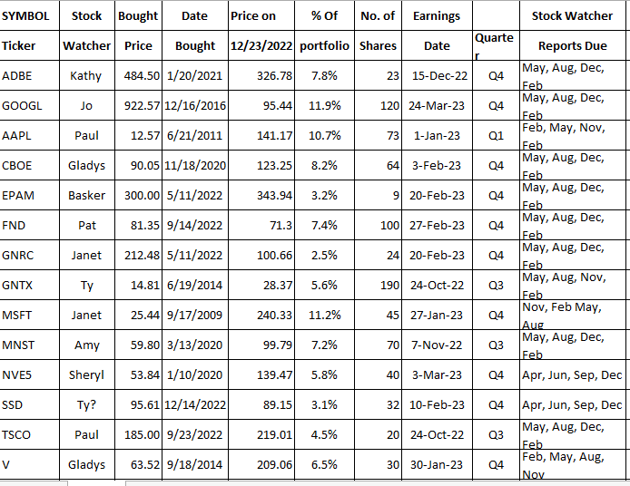

Meeting Adjourned: Sheryl
Minutes Submitted by Arvind Krishna; Portfolio Stocks’ Earnings Calendar updated by Maskey Krishnarao

