Model Investment Club of Northern Virginia (MicNOVA)
DC Chapter of Better Investing
Minutes for the January 10, 2023 (Online Meeting)

Members Present: Sheryl Patterson, Gladys Henrikson, Arvind Krishna, Ty Hughes, Paul O Mara, Maskey Krishnarao, Kathy Emmons, Amy Laing, Jo Murphy, Baskar Arumugam
Members Absent: Pat Onufrak, Janet Lewis
Proxies for Members: None
Visitors/New Attendees Present: Lee Outlaw, Fred Beckman, Anne Bradley, Carol Cuddihy, Catherine Duthie, Eveline Lloyd, Valerie Smith, Gerald Torres, Patrick Smith (onemuffin@gmail.com), Monte.

Gladys, as the designated meeting lead, conducted the meeting. She welcomed everyone including new visitors; explained the club’s purpose & objectives; and displayed the BI Disclaimer.

- Secretary’s Report – Maskey
Dec 13, 2022 Meeting Minutes report was presented by Maskey. Motion was made to accept minutes and seconded. Minutes were approved. Gladys has posted the Minutes in the Bivio folder.

- Treasurer’s Report - Gladys
Gladys presented the Treasurer’s Report indicating the availability of $597.82 available in cash to buy stocks. Paul moved to accept Treasurer’s report and Jo seconded. Treasurer’s report to date was accepted by the Partners.
Treasurer has appointed a 2022 Financial Audit committee for conducting audit of MICNOVA 2022 Accounts – 4 partners are included in the Audit Team - Kathy, Paul, Maskey, and Jo. Gladys indicated that audit materials will be out in next two days.

- Education & New Stock Presentation Timetable for 2023 – Baskar/Sheryl/Gladys
Partners are requested to identify their 2023 Education and Stock Presentation titles for the next 3 months in advance, so that Carol Cuddihy can submit them onto our BI webpage.
IMPORTANT NOTE: BI Membership Renewal is Due - Reminder to renew.
Login to BI Website: MyAccount->Email and Product Subscription Information

- Education – “Introducing Stock Comparison Guide” - by Ty
Ty Hughes demonstrated how to use the SSG Stock Comparison Guide and warned that it should only be used to compare stocks in the same industry, otherwise the comparisons can be meaningless.

- New Stock Presentation Clearfield Inc.(CLFD) – by Baskar
Baskar presented a comprehensive analysis of new stock CLFD. Clearfield (CLFD) is a small Fiber Optic company serving rural areas and bringing them a faster transmission and fiber based connectivity much better than broad band. SSG resulted in “Hold”. Baskar noted the present price of this fast growing and well-managed company is a bit too high. Therefore, the club voted to add it to our MicNova Portfolio Watch list.

- Stock Watcher Quarterly Reports Presented:
- EPAM (Baskar) – SSG recommends “BUY”
- VRTX (Arvind) – SSG recommends “Hold”. Recommended Buy when it drops at/or below $252/share. Current Price Jan 09 ($283). Buy Range: $195.5 - $251.9
- TSCO (Paul) – SSG says “Hold”. Paul said 4th Qtr. earnings coming out soon; Update report in February 2023
- MNST (Amy) – SSG says “Hold”
- GNTX (Ty) – SSG says “Hold”. Ty recommended “Challenge”. There are certain supply issues with this stock
- SSD (Ty) – Both SSG and Ty recommended “Buy”. Original SSG was done on 09/09/2022.

Stock Watchers (Please share the Online SSG with all MICNOVA members going forward)

- Watch List Stocks Review – by Sheryl
New stock (CLFD) presented by Baskar was added to the Watch list.

- Portfolio Review: Best and Worst Stocks in 2022 – by Ty
Ty pointed out this review is not too useful this year, because of stock turnover and recent downturn in technology. For example, MicNova's biggest losers, technology stocks, are not really losers. He looked at 1-3-5 yr. horizon for each stock. For stocks held for I yr. – VRTX and MNST are winners. For stocks bought in 2022 – TSCO and EPAM are winners. MICNOVA sold in 2022 stocks – ANCTF, BRK.B, AQN.

Ty later issued a year-to-date performance report for our MicNOVA portfolio. The "IRR for Period" is for January. Ignore the "Annualized IRR" because projecting a short period of time for the full year is not particularly useful.
Thus far for January, we are ahead of the market, 8.81% vs. 6.67% for the total market index. We also are ahead of the S&P 500, 8.81% vs. 6.02%.
Our best company performers for January are WAL (+24.9%) and FND (+24.7%). Our laggards are CBOE (-2.7%) and NVEE (-0.03%).
GNRC, GOOG, and WAL are on the top of our Manifest Investing dashboard for 5-year projected annual return.
- Decision Buys/Sells: Partners
Paul moved and Jo seconded that we buy 4 more shares of SSD at market. The club approved the buy with no objections. Note on Jan 11, Gladys sent an email that TDA confirmed MicNova's buy of 4 more shares of SSD at $97.85/share
- Member Questions and other Matters - Partners
No specific questions and/or comments were raised. Ty mentioned that MICNOVA member Tax allocations for 2022 tax planning purposes have been provided in the BIVIO-MICNOVA Section - Accounting

- Next Month Meeting Reminders – Feb 14, 2023:
Education | TOPIC: Three Financial Statements: Balance Sheet, Income Statement & Cash Flow | 02/14/2023 (Maskey)
New Stock Presentation | STOCK: Lululemon (LULU) | 02/14/2023 (Sheryl /traded with Amy)
Stock Watcher Reports Due | Adobe –Kathy  Apple – Paul  Microsoft – Janet  Tractor Supply (Update)- Paul  Visa – Gladys  Western Alliance Bancorp - Maskey | Kathy  Paul  Janet  Paul  Gladys  Maskey
Portfolio Reports |  | Ty
Watch List Reports |  | Sheryl

2023 BI and Community Events & Announcements

Wed Jan 18 07:00 - 09:00 PM  Wed Feb 15 07:00 - 09:00 PM  (3nd Wednesdays of Month) | MCMC Monthly Meeting  https://global.gotomeeting.com/join/745127301  You can also dial in using your phone.  (For supported devices, tap a one-touch number below to join instantly.)  United States: +1 (872) 240-3311  - One-touch: tel:+18722403311,,745127301#  Access Code: 745-127-301
Mon Jan 23 07:00 - 08:15 PM | Digging into BI Magazine: Review of 2021
Mon Feb 6 2023 07:00 - 08:15 PM | Digging into BI Magazine  Registration URL: https://register.gotowebinar.com/rt/6574788583850753036  Webinar ID:729-893-259
Fri Feb 3 2023 08:00 - 09:00 PM | DC Chapter Monthly Meeting
Tue Feb 14 07:00 - 09:00 PM  (2nd Tuesdays of Month) | MicNOVA Monthly Meeting Online
Tue Jan 17 2023 07:30 - 09:00 PM  (Third Tuesdays of Month) | Money Matters Book Discussion. Chip War: The Fight for the World's Most Critical Technology by Chris Miller  Online via GTM: You can also dial in using your phone.  United States: +1(646) 749-3122  One-touch: tel:+16467493122,,804623085#  Access Code: 804-623-085

Schedule: New Stock Presentation, Planning and Monthly Meeting Chair
 | Name | Education | New Stock Presentation | Conduct MicNOVA Monthly Meeting | Conduct MicNOVA Planning Meeting
1 | Patterson, Sheryl | 5/9/23 | 2/14/2023 | 12/13/2022 | 12/6/2022
2 | Hughes, James (Ty)* | 1/10/23 | 04/12/2022 | 10/11/2022 | 10/4/2022
3 | Krishnarao, Maskey | 2/14/23 | 12/13/2022 | 5/9/23 | 5/2/2023
4 | Krishna, Arvind | 7/11/23 | 11/8/2022 | 8/8/2023 | 8/1/2023
5 | Arumugam, Baskar | 9/13/22 | 1/10/2023 | 6/13/2023 | 6/3/2023
6 | Henrikson, Gladys | 10/11/22 | 8/8/23 | 1/10/2023 | 1/3/2023
7 | Murphy, Josephine(Jo)* | 8/8/23 | 6/13/2023 | 7/11/2023 | 7/4/2023
8 | Emmons, Elinor(Kathy) | 4/11/23 | 3/14/2023 | 9/13/2022 | 9/6/2022
9 | Laing, Amy | 12/31/22 | 10/11/2022 | 3/14/23 | 3/7/23
10 | Onufrak, Patricia | 6/13/23 | 7/11/2023 | 2/14/2023 | 2/7/2023
11 | O’Mara, W. Paul | 11/8/22 | 09/13/2022 | 11/8/2022 | 11/1/2022
12 | Lewis, Janet | 3/14/23 | 5/9/23 | 4/11/2023 | 4/4/2023

For Future Education Topics:
See BI Ticker Talk, Stock-Up, and Learning Modules for ideas

Next 3 Months - Reminders
Feb 2023 | Education | Three Financial Statements: Balance Sheet, Income Statement & Cash Flow | Maskey
Feb 2023 | New Stock | Lululemon | Sheryl
Mar 2023 | Education | Back to the Basics | Janet

Schedule: Education Topics For 2023
Title | Presenter
How to do a First Cut | Sheryl
Please go to BI Website Ticker Talk to find the best topics for your Education Schedule. Come up with ideas and provide your schedule and topic next month

MicNOVA Portfolio and Stock Watchers: Updated with closing prices as of 01/28/2023

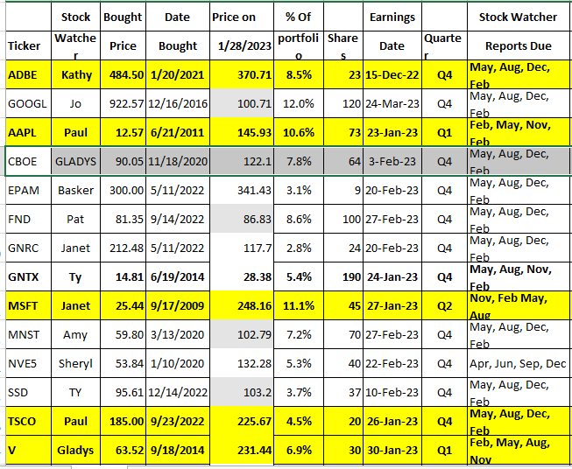
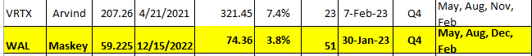

Meeting Adjourned: Gladys
Minutes Submitted by Arvind Krishna; Portfolio Stocks’ Earnings Calendar updated by Maskey Krishnarao

