Banks
Banks take deposits from savers, paying interest on some of these accounts. They pass these funds on to borrowers, receiving interest on the loans. Their profits are derived from the spread between the rate they pay for funds and the rate they receive from borrowers. This ability to pool deposits from many sources that can be lent to many different borrowers creates the flow of funds inherent in the banking system. By managing this flow of funds, banks generate profits, acting as the intermediary of interest paid and interest received and taking on the risks of offering credit.
Once upon a time, life was easy, even banks business model was simple. Have you ever heard of a 3-6-3 business model?
In the old days, banks paid depositors 3%, lend it out for 6% and being on the Golf Course by 3 PM.
According to the OTS, the first S & L was formed in 1831, the Oxford Provident Building Association and made a home loan in the amount of $375 to a local lamplighter named Comly Rich. That home still stands on Orchard Street in Philadelphia County, Pennsylvania.
By the late 1890s, there were more than 5,000 savings associations across the country. By the 1920s, there were about 12,000 savings associations. Industry growth during this time was fueled largely by the influx of Americans into the cities from rural areas, driving up the demand for housing.
The end to these boom times came in the early 1930s when the Great Depression devastated the housing market and caused many savings associations to fail. The federal government stepped in and created various agencies to provide funding for savings associations and establish a regulatory system to promote home ownership. (Federal Home Loan Bank System of 12 Regional Federal Loan Banks, Federal Home Loan Bank Board and the Federal Savings and Loan Insurance Corporation to insure deposits at the nation’s savings and loan institutions).
In the 1950s and 1960s, S & L originated two-thirds of the nation’s home mortgages.
In the late 1970’s interest rates rose sharply and competition for deposits increased dramatically, also, a ban on adjustable rate mortgages locked S & L into long-term fixed-rate mortgage loans that did not help their bottom line.
In the early 1980s, interest rates climbed to unprecedented levels, undermining the viability of the S & L business model. Many of them were economically insolvent. In an effort to help the industry “grow” out of its problems, the government deregulated the lending and investment powers of savings and loans, and gave them full access to federally insured deposits to fund their new lending and investment powers. Marginally profitable and unprofitable savings and loans began to engage in aggressive and risky investment and lending strategies that compounded their existing problems. As a result, hundreds of S&Ls failed and closed in the late 1980s and early 1990s.
In 1989, Congress passed a law that dramatically restructured the banking business, moved deposit insurance for savings associations to the FDIC and established the OTS to supervise, charter and regulate the thrift industry.
Today, the thrift industry has fewer () institutions than in the past, but the industry assets still exceed $1 trillion.
Basically, there are two types of bank in North America.
Regional (and Thrift) Banks – these are smaller financial institutions, which primarily focus on one geographical area within a country, in the US, there are six regions: Southeast, Northeast, Central, etc. Providing depository and lending services is the primary line of business for regional banks.
Major (Mega) Banks – their main scope is in the financial centers like New York, where they get involved with international transactions and underwriting.
Some of their business lines are:
Community Banking – complete line of diversified financial products and services for consumers and small business.
Wholesale Banking – provides financial solutions to businesses across the US and with annual sales generally in excess of $10 million and to financial institutions globally. Products include middle market banking corporate banking, CRE, treasury management, asset based lending, insurance brokerage, foreign exchange, equipment finance, corporate trust, investment banking, capital markets and asset management.
Wealth, Brokerage and Retirement – provides a full range of financial advisory services to clients.

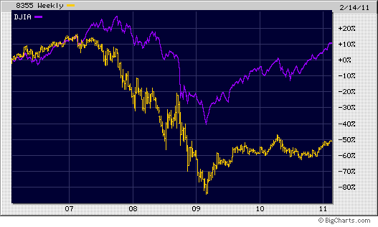
DJ US Bank Index vs. DOW (5 years)
How have some of these companies performed? (Using a large cap financial mutual fund, BAC, JPM, WFC and DOW, as an example in the past?(charts dating back to 1998 to present).
The sharp drop in late 2008 and early 2009 indicate the steepest drop in their stock prices during our most recent financial crisis.
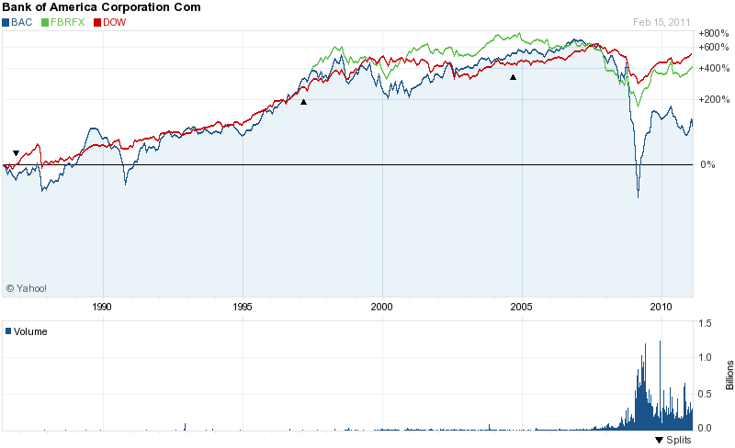

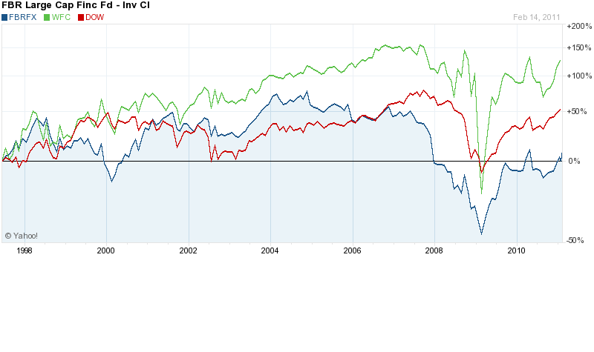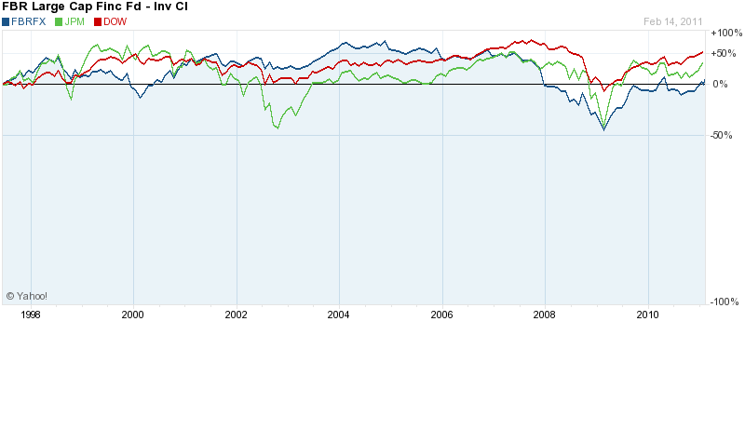
Is the worst over? In 2010, there were 157 failed banks, highest since 1992. There are 7,770 insured depository institutions, 96% are well capitalized, according to FDIC.
Should we be investing in bank stocks now?
Some Key statistics:
Key Statistics
FDIC Insured Institutions as of 2/10/2011
Financial Data as of 9/30/2010*
($ in millions)
 | Number | Total  Assets | Total  Deposits
Commercial Banks | 6,506 | $12,131,586 | $8,373,788
FDIC-Supervised | 4,299 | 1,938,215 | 1,485,791
OCC-Supervised | 1,382 | 8,463,635 | 5,635,188
Federal Reserve-Supervised | 825 | 1,729,735 | 1,252,809
Savings Institutions | 1,127 | 1,250,689 | 898,977
OTS-Supervised | 729 | 926,550 | 660,350
FDIC-Supervised | 398 | 324,139 | 238,627
Total Commercial Banks &  Savings Institutions. | 7,633 | 13,382,274 | 9,272,765
U.S. Branches of Foreign Banks | 10 | 28,704 | 21,174
Total FDIC-Insured Institutions | 7,643 | 13,410,978 | 9,293,940
From October 1, 2010 - February 10, 2011:
Newly Established | 6 | N/A | N/A
Merged / Closed | 133 | 52,667 | 44,643
Failed** | 44 | 16,446 | 14,424
*Adjusted for mergers
**Excludes open bank assistance transactions.
Data for records processed through: 2/9/2011

Some key Terms, laws and websites to read about:
Net Interest Margin (NIM)
Return on Average Assets (ROA)
Nonperforming Assets (NPA)
Net Charge-offs/Average Loans
Regulatory Capital Categories for Banks and S&Ls (Tier-1 leverage ratio, Tier-1 risk-based capital ratio and Risk-adjusted capital ratio)
Basel Accord
BKX
Yield Curve

Financial Services Modernization Act
Glass Stegall Act of 1933
Banking Act of 1935
Consumer Protection Act of 1968 (Truth in Lending Act)
Gramm Leach Bliley Act of 1999
Sarbane Oxley Act of 2002
Dodd Frank Wall Street Reform and Consumer Protection Act
Fed Funds
Discount Rate
Federal Reserve Board
FDIC
OCC
OTS
American Bankers Association
S&P/Case-Schiller National Housing Index
Moody’s/real Commercial Property Price Index

Lets take a look at a few top rated largest bank using SSG.
Take it away Sharon, showing them what is in your wallet.

