Cognizant (CTSH) Q2 Earnings Beat Estimates, Revenues Up Y/Y
Cognizant (CTSH) reports better-than-expected bottom-line figure in second-quarter 2018. Revenues come within the guided range.
Cognizant Technology Solutions Corp. CTSH reported second-quarter 2018 non-GAAP earnings of $1.19 per share, which beat the Zacks Consensus Estimate of $1.10 and increased 28% from the year-ago quarter. The figure was better than management’s expectation of $1.09 per share.
Revenues of $4.01 billion missed the Zacks Consensus Estimate of $4.02 billion. Nevertheless, the figure increased 9.2% year over year driven by growth in all the four domains. The figure was within the guided range of $4-$4.04 billion.
The company adopted ASC 606 (new revenue standard)**, which positively impacted revenues by $31 million, income from operations by $38 million and earnings by 5 cents per share.
Quarter Details
Segment-wise, Financial services (36.7% of revenues), which includes insurance, banking and transaction processing, grew 4.5% year over year to $1.47 billion.
Healthcare (28.9% of revenues) grew 10.1% year over year to $1.16 billion. Top-line growth can be attributed to steady demand across payer clients and increasing interest in the company’s digital, analytics, cloud and virtualization solutions.
Products and Resources (21% of revenues) continued its growth momentum and improved 12.4% year over year to $840 million driven by growth in manufacturing and logistics clients.
Communications, Media and Technology (13.5% of revenues) were $541 million, up 15.8% from the year-ago quarter.
Region-wise, revenues from North America increased 7.6% year over year and represented 76.6% of total revenues. Europe revenues (17.2% of revenues) increased 19.2% from the year-ago quarter to $690 million. Rest of the World (6.2% of revenues) advanced 3.8% to $249 million.
Selling, general & administrative (SG&A) expenses, as a percentage of revenues, declined 110 basis points (bps) from the year-ago quarter to 20.1%.
Cognizant reported non-GAAP operating margin of 22%, which expanded 200 bps from the year-ago quarter.
In the quarter ended Jun 30, 2018, cash and cash equivalents (and short-term investments) were $4.25 billion, down from $4.83 billion reported as of Mar 31, 2018.
Guidance
For the third quarter of 2018, Cognizant expects revenues in the range of $4.06-$4.10 billion. Non-GAAP earnings are anticipated to be at least $1.13 per share. The Zacks Consensus Estimate for revenues and earnings is currently pegged at $4.12 billion and $1.14 per share, respectively.
For 2018, revenues are projected between $16.05 billion and $16.30.
Non-GAAP operating margin is expected to be roughly 21%. Non-GAAP earnings are projected to be at least $4.50 per share, up from the previous guidance of $4.47 per share.
The Zacks Consensus Estimate for revenues and earnings is currently pegged at $16.22 billion and $4.47 per share, respectively.
Zacks Rank & Stocks to Consider
Cognizant currently carries a Zacks Rank #3 (Hold).

** ASC 606 (new revenue standard)
In May 2014, FASB issued Accounting Standards Update (ASU) 2014-09, Revenue from Contracts with Customers (Topic 606), and the International Accounting Standards Board (IASB) issued International Financial Reporting Standards (IFRS) 15, Revenue from Contracts with Customers.
The revenue recognition principle is a cornerstone of accrual accounting together with the matching principle. They both determine the accounting period, in which revenues and expenses are recognized. According to the principle, revenues are recognized when they are realized or realizable, and are earned (usually when goods are transferred or services rendered), no matter when cash is received. In cash accounting – in contrast – revenues are recognized when cash is received no matter when goods or services are sold.
Cash can be received in an earlier or later period than obligations are met (when goods or services are delivered) and related revenues are recognized that results in the following two types of accounts:
- Accrued revenue: Revenue is recognized bfore cash is received.
- Deferred revenue: Revenue is recognized after cash is received.
Revenue realized during an accounting period is included in the income.
Source: https://www.simplilearn.com/revenue-recognition-rar201-article
Core principle and key steps - ASC 606
The core principle underlying the guidance in ASC 606, which is included in ASC 606-10-10-2, is to “recognize revenue to depict the transfer of promised goods or services to customers in an amount that reflects the consideration to which the entity expects to be entitled in exchange for those goods or services.” ASC 606-10-05-4 sets out the following steps for an entity to follow when applying the core principle to its revenue-generating transactions:
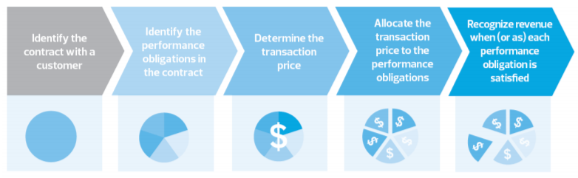
ASC 606 provides extensive guidance on how each one of these steps should be applied. In doing so, it addresses and provides application or implementation guidance on a variety of common revenue recognition transactions and issues, including those related to licenses, collectibility, contract modifications, identifying performance obligations (i.e., units of account), variable consideration, consideration payable to customers, return rights, warranties and bill-and-hold arrangements, among many others. The implementation guidance in ASC 606-10-55 provides almost 70 examples (many with multiple variations of the facts) that are based on transactions in a variety of industries, including manufacturing, retail, software, construction, real estate, financial services, professional services and health care, among many others.
Source: https://rsmus.com/content/dam/mcgladrey/pdf_download/wp_nt_aud_all_revenue_recognition_overview_of_asc606.pdf

