Cognizant (CTSH) Q4 Earnings Beat Estimates, Revenues Up Y/Y
Zacks Equity Research
Zacks•February 6, 2019
Cognizant Technology Solutions Corp. CTSH reported fourth-quarter 2018 non-GAAP earnings of $1.13 per share that beat the Zacks Consensus Estimate of $1.05. The figure increased 9.7% from the year-ago quarter and was also better than management’s earnings expectation of at least $1.05 per share.
Revenues of $4.129 billion comfortably surpassed the consensus mark of $4.114 billion. The figure improved 8.8% at constant currency (cc) year over year, driven by growth in all four domains. The figure was almost in line with the higher end of the guided range of $4.09-$4.13 billion.
Quarter Details
Segment-wise, Financial services (35.1% of revenues), which includes insurance, banking and transaction processing, grew 2.8% year over year to $1.45 billion. The company witnessed strong growth among insurance customers. Clients focused on cost optimization, regulatory compliance, and the adoption and integration of digital technologies.
Healthcare (29.1% of revenues) grew 7% year over year to $1.20 billion. Per management, compliance, integrated health management, claims investigative services, claims processing, enrollment, membership and billing were the primary focus of clients.
Products and Resources (21.6% of revenues) continued its growth momentum and improved 15.4% year over year to $891 million, driven by growth in energy and utilities customers as well as manufacturing and logistics customers.
Cognizant Technology Solutions Corporation Price, Consensus and EPS Surprise
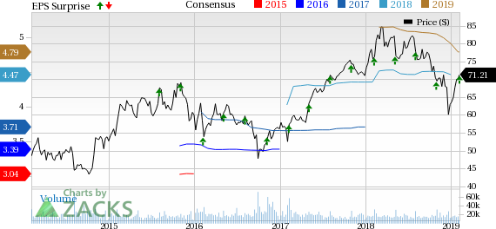
Cognizant Technology Solutions Corporation Price, Consensus and EPS Surprise | Cognizant Technology Solutions Corporation Quote

Communications, Media and Technology (14.2% of revenues) were $585 million, up 20.1% from the year-ago quarter.
Digital revenues grew almost 25% on a year-over-year basis and accounted for 30% of total revenues in the reported quarter.
Further, Consulting & Technology services accounted for 58.2% of revenues. Moreover, outsourcing services contributed 41.8% of revenues. Additionally, roughly 36.6% of Cognizant’s revenues were from fixed price contracts.
Region-wise, revenues from North America increased 6.5% year over year and represented 76.1% of total revenues.
Revenues from Europe increased 20.3% from the year-ago quarter and accounted for 17.9% of total revenues. Revenues from the United Kingdom jumped 17.9% and accounted for 8% of total revenues. Rest of Europe revenues increased 22.3% and accounted for 9.9% of total revenues.
Rest of the World revenues rose 4.7% and represented 5.9% of total revenues. Asia Pacific continued to be negatively impacted by lower spending from certain large banking customers.
Operating Details
Selling, general & administrative (SG&A) expenses, as a percentage of revenues, increased 50 basis points (bps) from the year-ago quarter to 18.8%.
Headcount increased 7,400 sequentially and 21,600 year over year. Quarterly annualized attrition was 19%, up 1% year over year.
Cognizant reported non-GAAP operating margin of 19.5%, which contracted 20 bps from the year-ago quarter.
Balance Sheet
As of Dec 31, 2018, cash and cash equivalents (and short-term investments) were $4.51 billion, down from $4.76 billion as of Sep 30, 2018.
Cognizant generated $702 million in cash from operations. The company bought back 3.6 million shares in the reported quarter.
Cognizant declared a quarterly cash dividend of 20 cents per share payable on Feb 21, 2019.
Guidance
For the first quarter of 2019, Cognizant expects revenues to grow between 7.5% and 8.5% at cc. The Zacks Consensus Estimate for revenues is currently pegged at $4.22 billion that indicates year-over-year growth of 7.9%.
For 2019, revenues are projected to grow between 7% and 9% year over year at cc. The consensus mark for revenues is currently pegged at $17.38 billion that indicates year-over-year growth of 7.9%.
Non-GAAP operating margin is expected to be roughly 19%. Non-GAAP earnings are projected to be at least $4.40 per share.
The Zacks Consensus Estimate for earnings is currently pegged at $4.80 per share.
Cognizant expects to utilize almost 50% of its global free cash flow annually for dividends and share repurchases. Management expects to maintain a dividend payout ratio of roughly 20%. Moreover, the company plans to reduce outstanding share count by almost 1% annually.
Moreover, Cognizant plans to use roughly 25% of free cash flow for acquisitions.
Zacks Rank & Stocks to Consider
Cognizant currently has a Zacks Rank #3 (Hold).

