CTSH STOCH WATCHERS REPORT
ISSUES
Sales are slowing. New presidential administration may create some issues with outsourcing companies and workers here on Visas (H1-B visa program).
BREXIT – Sharp weakening of the pound sterling will have a negative impact on our second-quarter (2016) revenue of approximately $40 million.
Affordable Care Act - Uncertainties
FCPA - Foreign Corrupt Practices Act / Ongoing

Q4 revenue was $3.46 billion, up 0.3% sequentially and 7.1% year-over-year.
We had a negative currency headwind which impacted sequential revenue growth by $23 million or 70 basis points and year-over-year revenue growth by $51 million, or 160 basis points.

Non-GAAP operating margin which excludes stock-based compensation expense and acquisition-related expenses was 18.7%. Non-GAAP EPS of $0.87 was within our guidance range of $0.85 to $0.88.

Non-GAAP operating margins in Q4 were below our normal range due to certain investments that we made in 2016 in our Digital Operations business in certain geographies, combined with approximately $20 million of costs incurred in the quarter due to the ongoing FCPA investigation.

Revenue from:
consulting and technology services 57.5%
outsourcing services 42.5%

Consulting and technology services grew 0.5% sequentially and 5.9% yoy.
Outsourcing services revenue was roughly flat versus last quarter and grew 8.7% yoy.

FCPA investigation - We have identified a total of approximately $6 million in potentially improper payments relating to company-owned facilities in India, an increase of $1 million from what we reported at the end of the third quarter.
During the fourth quarter we recorded an out-of-period correction of $1 million. To-date, of the identified $6 million in potentially improper payments, we have now recorded a total of $4.1 million in corrections.
Full-year 2016 revenue was $13.49 billion, which represented 8.6% growth over 2015, including a negative currency impact of 120 basis points. Non-GAAP operating margin was 19.5% and non-GAAP EPS was $3.39.
Digital revenue for the full-year 2016 represented approximately 23% of total revenue and is growing well above the company average. CTSH’S NEW CASH COW
Announced a plan that will accelerate Cognizant's shift to digital services and solutions.
- Cognizant Digital Business helps clients architect and implement new digitally-enabled business models.
- Cognizant Digital Operations reinvents and manages our clients' most essential business processes.
- Cognizant Digital Systems & Technology simplifies, modernizes, and secures client applications, platforms, and infrastructure. Going forward, we'll invest to scale these digital practice areas aggressively across industries and geographies both organically (training) and through acquisitions ('Tuck-In Acquisition' made for the sole purpose of merging it into a division of the acquirer.)

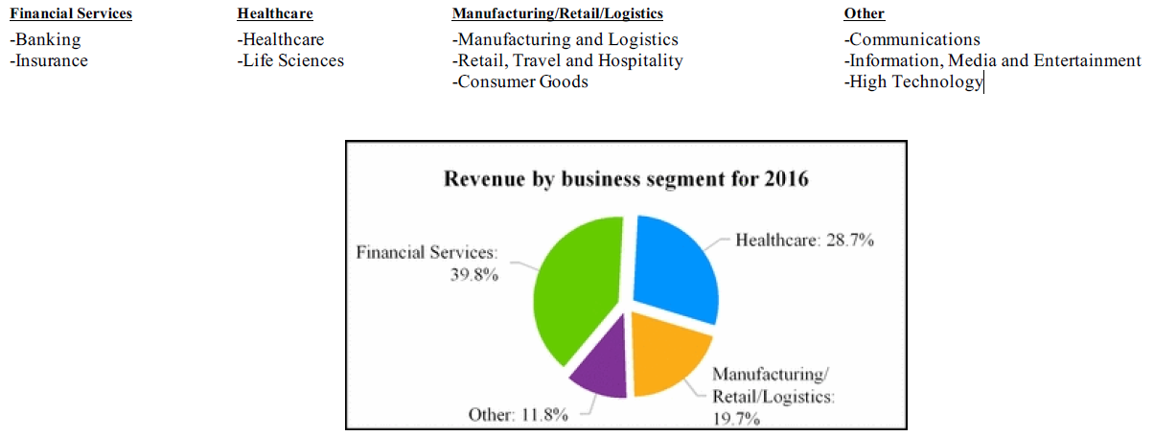

Banking and Financial Services segment which consists of banking, capital markets, insurance, and transaction processing clients was down 1.5% sequentially and up 3.5% year-over-year, as many continue to struggle with the macro economic situation.
Healthcare segment, which consists are of payer, provider, pharmaceutical, biotech, and medical device clients grew 1.2% sequentially and 5.6% year-over-year

For the year ended December 31, 2016, the distribution of our revenues across geographies was as follows:
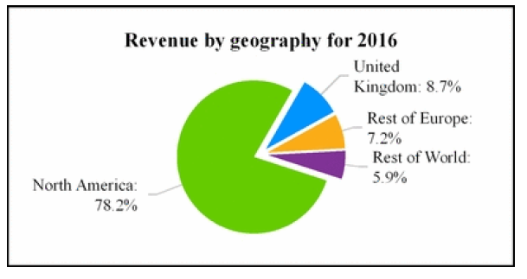
North America grew 0.2% sequentially and 7.2% year-over-year. Europe declined 0.4% sequentially after a 3.5% negative currency impact, and grew 2.7% from last year after a 9.5% negative currency impact. Continental Europe grew 7.4% sequentially and 21.9% over the prior year.
The UK declined 6.8% sequentially and 10.8% year-over-year after a 4.2% and 15.4% negative currency impact, respectively. Continuous strong transaction in the rest of the world which was up 2.9% sequentially and 17.8% yoy.

H1-B visa program
Continue to build our teams in the U.S. and in other geographies around the world where we operate. Taking steps to ensure that we have access to a robust supply of talent in the U.S. In 2016, we hired over 4,000 U.S. citizens and residents. Over the next several years, we plan to significantly increase the size of our U.S. workforce.
For over five years, we have had an active program to recruit qualified students from the undergraduate and MBA schools across the country.

Enhancing our financial model in two principal ways.
First, we are instituting a robust capital return program. Over the next two years, we expect to return a total of approximately $3.4 billion in capital through a combination of dividends and share repurchases. We are initiating a quarterly cash dividend of $0.15 per share starting in Q2 which will amount to approximately 1% dividend yield based on yesterday's closing price.
The capital return plan is expected to be funded by current U.S. cash balances, future U.S. cash flows, and incremental debt financing. Beginning in 2019, we plan to return 75% of U.S. free cash flow to shareholders through a combination of dividends and share repurchases.
Second, we are changing how we manage our operating margins. We will strive to balance our revenue and profitability, and in doing so, we'll move beyond the historical 19% to 20% non-GAAP operating margin target (we believe that we can expand our margins to 22% in 2019).

Guidance
Full-year 2017, we expect our revenue to be within a range of $14.56 billion to $14.84 billion, representing full-year growth of 8% to 10%.
We expect non-GAAP operating margins to be at least 18.7% during Q1 and at least 19.5% for the full-year 2017.
For the full year, we expect to deliver non-GAAP EPS of at least $3.53. This guidance anticipates a full-year share count of approximately 597 million shares and a tax rate of approximately 26.6%. This guidance also includes the impact of the $1.5 billion accelerated share repurchase which we expect to commence in Q1 subject to market conditions.

CTSH last announced its quarterly earnings data on Wednesday, February 8th. (Q4)
$0.87 earnings per share (EPS) for the quarter, beating the consensus estimate of $0.86 by $0.01, CTSH expected to deliver non-GAAP EPS of at least $0.83.
Share count of approximately 611 million shares and a tax rate of approximately 26%.
Revenue of $3.46 billion for the quarter, compared to analysts’ expectations of $3.49 billion. CTSH expected our revenue to be within a range of $3.51 billion to $3.55 billion.
Return on equity of 18.83% and a net margin of 11.52%.
The company’s revenue for the quarter was up 7.1% compared to the same quarter last year. During the same period last year, the firm earned $0.80 earnings per share.
Over the last quarter, insiders sold 16,548 shares of company stock worth $979,255. Insiders own 0.81% of the company’s stock.
Agreement with Elliott Management.
In November, Elliott sent a letter to Cognizant outlining ways they could help their stock.
Cognizant has now agreed to some of Elliott's proposals.
- They're going to add three new board members from Elliott.
- Cognizant also plans to return $3.4 billion to shareholders over the next two years. CTSH currently has a bank account of more than $2 billion.
- Next quarter, they plan to start a dividend of 15 cents per share.

52 Week Range - 45.44 - 63.23

EPS
1Q 2016 2Q 2016 3Q 2016 4Q 2016 1Q 2017
03/03/2016 06/29/2016 09/2015 12/2016
.8 .87 .86 .87 .87

Sales EPS
Yahoo 12.59
MI 12.1 $6.09
NASDAQ $4.59 (12/2019)

