Company Name: Netflix (NFLX)
Source | Sales Estimate | Earnings Estimate
Value Line | $32600M(CY) & $36350(NY)  $47000(4 yrs), 9.58% CAGR  VL 11.0% | $11.20(CY) & $12.50(NY)  $15.10(4 yrs.), 7.76% CAGR  VL 12.5%
Morningstar | %, (5 yrs) – Not avail
Manifest Investing | 9.7% | $16.70
Yahoo Finance | $32.4M (CY)  $35.32M (NY) | $10.9 (CY)  $11.95 (NY), 12.42% (5 yrs.)  76.94% Past 5 years
Seeking Alpha | $8.31 (CY), 7.83%  NY ? | $1.59 (CY) 19.82%  NY ?
Zacks |  | $10.25 (NY), $17.7 (5 yrs.)
Company Website
BI Member Sentiment | 13.3% (5 yrs.) | 12.1% (5 yrs.)
First Cut (__/____) | N/A | N/A
Current Year Range  Next Year Range | $32.4 to $32.6  $35.32 to $36.35 | $10.9 to $11.2  $10.25 to $12.50
4 to 5 year range | 9.58% to %13.3 | 7.76% to 12.42%  $15.10 to $16.70
Debt Analysis For (Netflix)

Debt Analysis | BI Guidance | ______ (Trend) | Industry | Comments
Debt to Capital (D/C) | <= 50% | DOWN |  | In the right direction
ROE | >=15% | UP |  | In the right direction

Additional data points:
https://www.bloomberg.com/news/articles/2022-06-27/netflix-s-plan-to-fix-its-subscription-crisis-starts-in-asia
https://www.nytimes.com/2022/05/10/business/media/netflix-commercials.html
https://www.fastcompany.com/90743720/netflix-password-sharing-crackdown-faq
https://www.usnews.com/360-reviews/technology/streaming-services#

Lastly, analysts expect a 6.8M more members during 2022 (79% from Asia) – currently 15% accounts are from Asia, however there’s a slowdown already happening on subscriptions in that region.
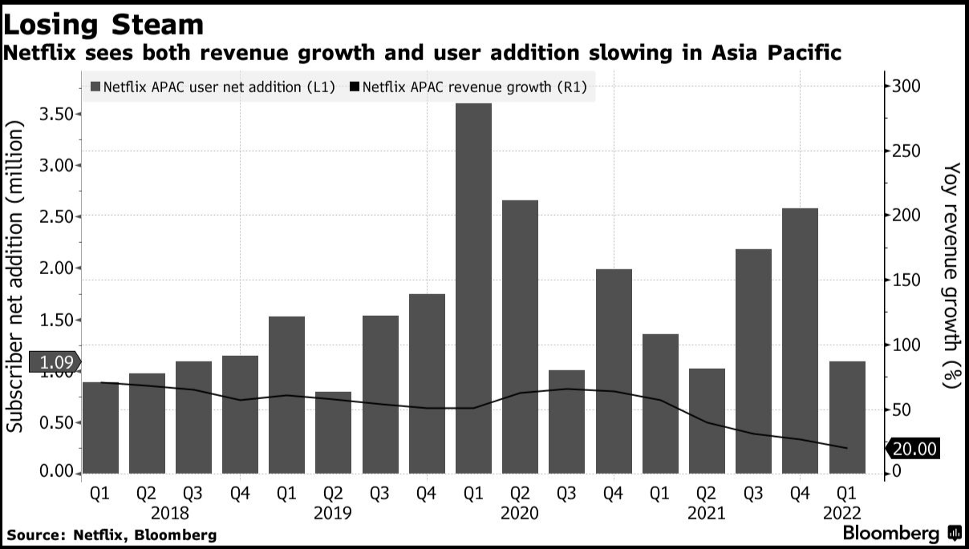

The SSG gives a 83.4% High P/E on avg but based on the information above, I decided to use a 20% P/E as a maximum for this study with a high price of 317.9 and a low price of 162.7 – My recommendation is to keep the stock and monitor it for the rest of the year as the plans for shaking down on password sharing, adds supported low-tier subscription and Asia plans pan-out. After all, Netflix is still the #1 VOD service currently.

