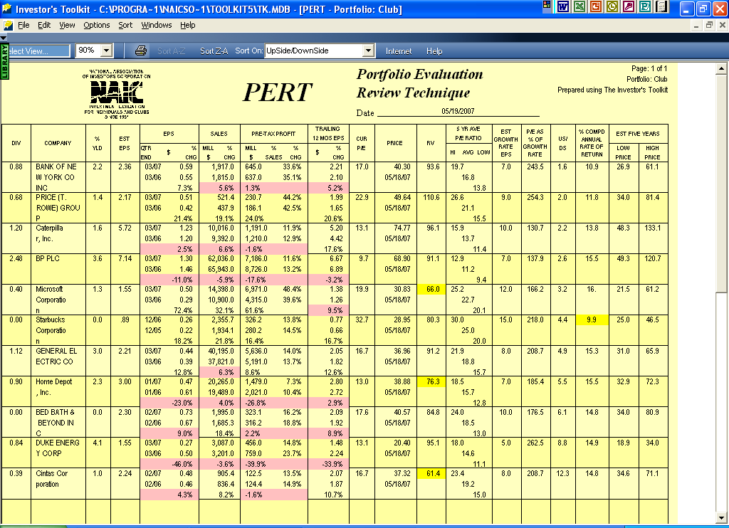

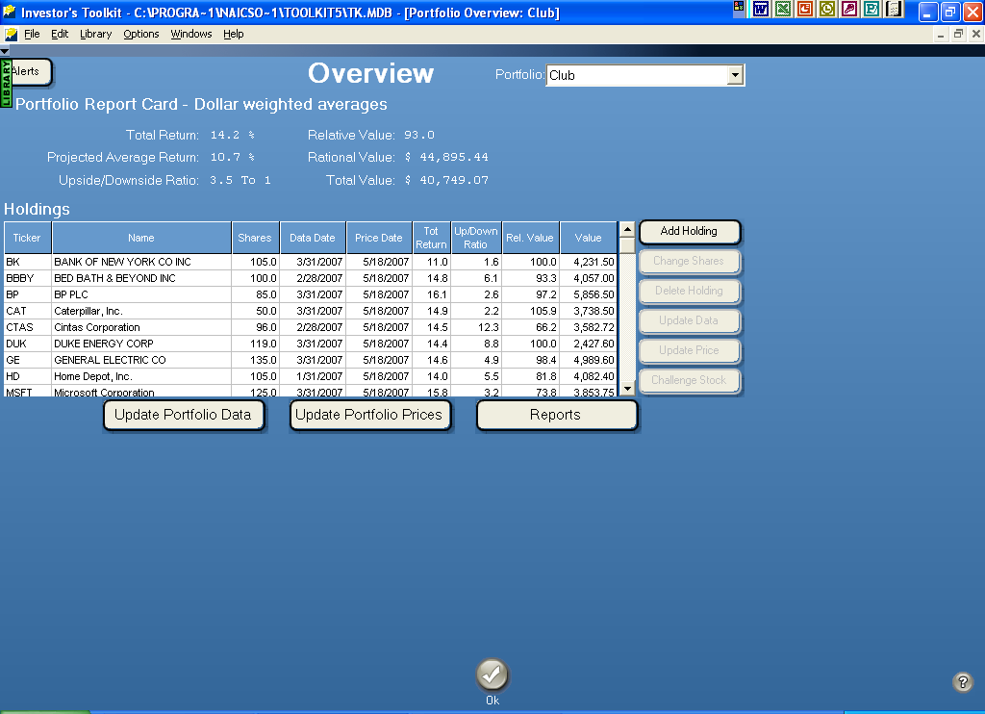

PORTFOLIO SUMMARY 05/19/07
NAME: Club
------------------------------------------------------------------------------------------------------------------------
TOT REL BUY SELL
TICKER COMPANY NAME DATE PRICE P/E RET VAL U / D BLW ABV % Port REC
------------------------------------------------------------------------------------------------------------------------
BK BANK OF NEW YORK 05/18/07 40.30 18.2 11.02 100.0 1.6 35.5 52.6 9.40%
TROW PRICE (T. ROWE) GR 05/18/07 49.64 24.9 11.79 120.3 2.0 45.9 69.6 5.51%
CAT Caterpillar, Inc. 05/18/07 74.77 14.4 14.91 105.9 2.2 69.5 111.9 8.30%
LIFC Lifecell Corp 05/18/07 28.50 42.5 11.94 119.0 2.3 26.8 42.3 9.49%
BP BP PLC 05/18/07 68.90 10.3 16.14 97.2 2.6 67.1 102.9 13.01%
MSFT Microsoft Corporat 05/18/07 30.83 22.3 15.81 73.8 3.2 31.4 51.3 8.56% Buy
SBUX Starbucks Corporat 05/18/07 28.95 37.6 9.94 92.4 4.4 30.4 41.1 3.21% Buy
GE GENERAL ELECTRIC 05/18/07 36.96 18.0 14.55 98.4 4.9 39.7 57.2 11.08% Buy
HD Home Depot, Inc. 05/18/07 38.88 13.9 13.97 81.8 5.5 42.7 62.4 9.07% Buy
BBBY BED BATH & BEYOND 05/18/07 40.57 19.4 14.80 93.3 6.1 45.7 69.2 9.01% Buy
DUK DUKE ENERGY CORP 05/18/07 20.40 13.8 14.36 100.0 8.8 22.6 30.2 5.39% Buy
CTAS Cintas Corporation 05/18/07 37.32 18.0 14.55 66.2 12.3 43.7 62.0 7.96% Buy

