SSG and Ratios
A ratio is the change in difference between two numbers, listed as a percentage.

Sec. 1 MRQ vs. Year ago EPS & Sales
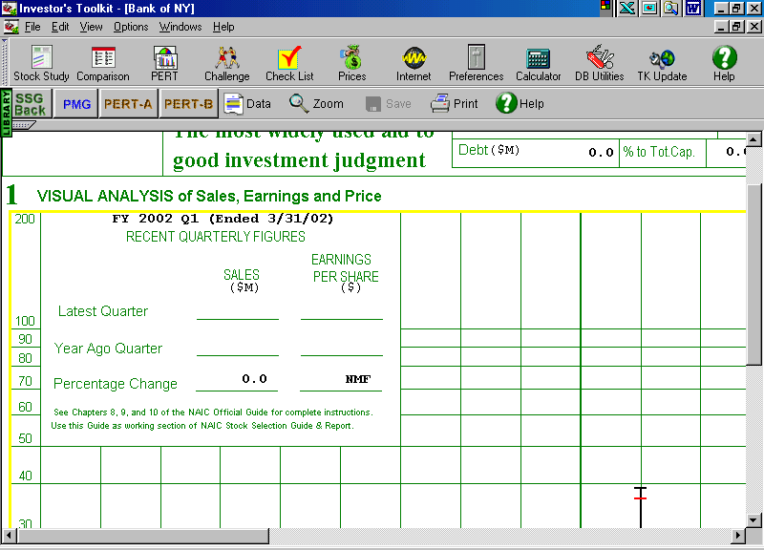

N-O x 100 = Rate of
O Change

= New
= Old

Pretax Profit or PTP (see worksheet) Charted in pink on Sec. 1 denoted with a (P)
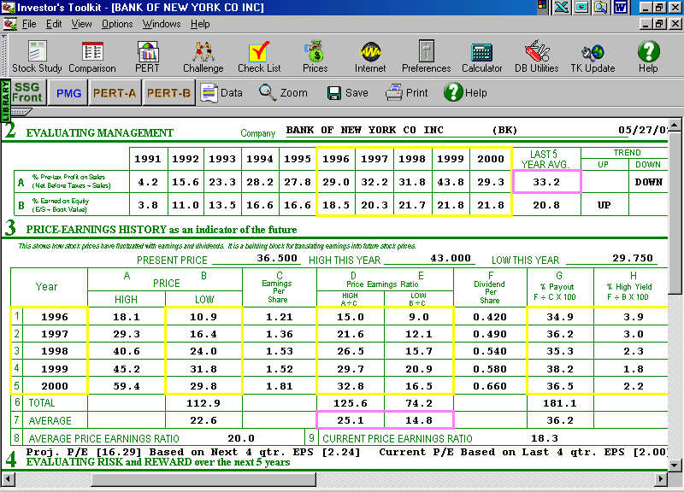
Data taken from yellow boxes >>
2B Earned on Equity is EPS / Book Value
Book Value is the par or stated value plus retained earnings plus reserves. See pg. 43.
Return on Equity page 49. (Starting and Running a Profitable Investment Club).

Price to Earnings Ratio (P/E)
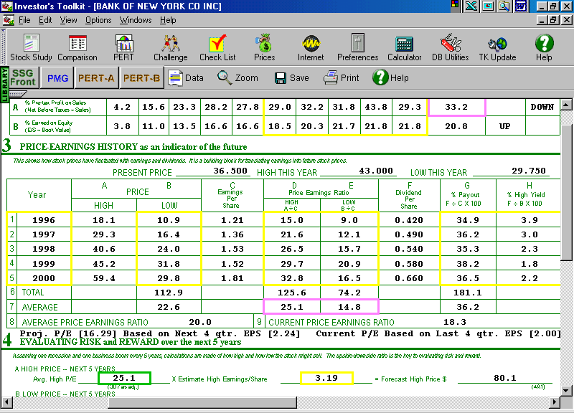
The P/E ratio tells you how much you are paying for every dollar of earnings. Also called a multiple.

Dividend Yield is the annual dividend / price x 100.
Use the last four Q’s of dividends to total annual dividend.
Percent Payout is how much they are paying out from earnings to shareholders.

P/E to Growth rate ratio (PEG) is the P/E divided by the estimated growth rate.
As a rule do not pay more than 1.5 times estimated growth rates. This means you are paying for than 150% of its estimated growth.
(PEG) is shown on the Stock Comparison Guide line 27 or 28. Set Criteria, or click ALT Z on the back of SSG for the PEG Ratio.

Relative Value is the Current P/E / signature or average P/E. (Sec. 3, line 8)
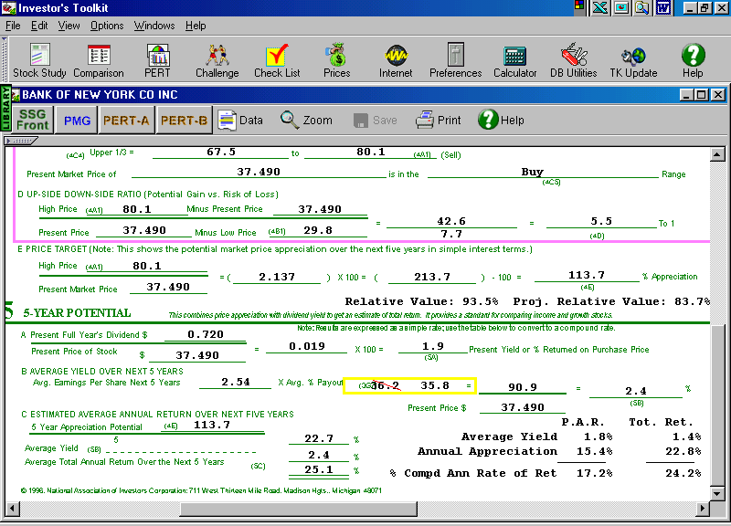
Relative Value tells how the stock is performing in relation to its historical norm

Current Ratio is Current assets / Current Liabilities (Should be at least 2/1)
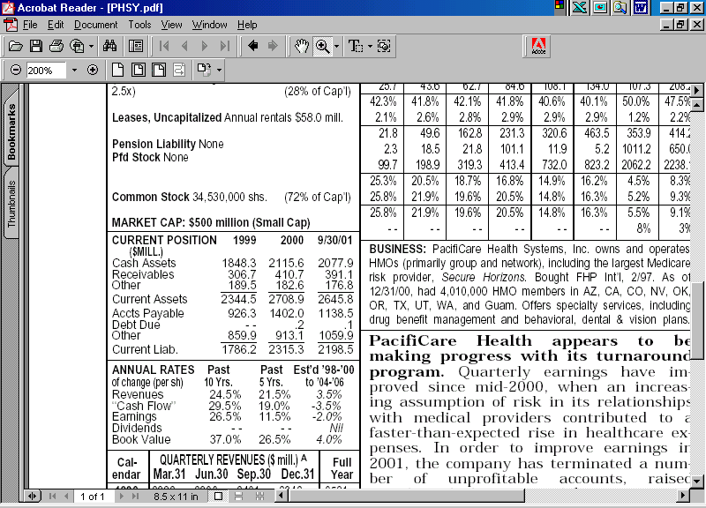
Quick Ratio is the current assets minus inventories / current liabilities. (At least 1/1).

