$kywalk Capital Investment Club

Dear Prospective Member:
Thank you for your interest in the Skywalk Capital Investment Club. This document provides an overview of the club to help you determine whether or not the Skywalk Capital Investment Club is right for you. To obtain more information regarding Skywalk Capital you can navigate to www.skywalkcapital.com which provides links to all pertinent club documents. Thank you for taking the time to review the club’s materials and feel free to contact any member of the club if you have any questions or concerns.
Mission Statement
Invest the club members’ money using a long-term approach with the goal of maximizing return and minimizing risk in order to achieve superior market performance while pursuing financial security, education, and camaraderie.

Why an Investment Club?
Over seventy years of research proves it. Investing in the stock market provides the highest return over the long run than any other investment vehicle. A limiting factor when investing in the stock market at an individual level is the lack of education and capital resources. By investing as a club you’re able to leverage the research and capital of all members within the club. This leads to better investment selections and reduces the percentage of your investment that is allocated to commissions and other fees and expenses. Along with these obvious advantages the club will also serve as a networking tool. The members of the club will represent diverse industries allowing members to gain knowledge from each other about their eclectic environments.
What does it cost?
The minimum annual contribution is $150 dollars on a pro-rated basis. Members do not have to contribute each month but must meet or exceed 150 dollars during the calendar year. Members are welcome to invest as much as they like so long as it doesn’t exceed 25% of the club’s total valuation. (The 25% rule does not apply until the club is worth at least $10,000). In addition to your investment contributions, there is also an annual $20 club fee collected upon joining the club. This will be a reoccurring fee collected during the 1st meeting of each year.
About Our Meetings
Most meetings are held on the last Thursday of each month from 6:00 p.m. to 8:00 p.m. The venue will be determined in the prior meeting. You’ll notice that we said “Most” meetings will be held during this time slot. This can be changed when holidays or other events interfere with a scheduled meeting time. The venue will more than likely reside in a bar/restaurant of some sort for the majority of the meetings. This will allow us to mix in a good balance of investment discussion along with general socializing.
About Our First Meeting
Due to the amount of content we intend to cover in the first meeting, we are planning to meet from 6pm until 9pm on the first night. The date for this first meeting has been set at May 29th. As mentioned above, while we usually meeting at bar/restaurant venues we will be meeting at someone’s house the first night to ensure we can address everyone’s questions and concerns. The meeting location is between Johnston and Des Moines in Saylor Township. The secret but disclosed address of this residence is listed below and maps are also included in the page below.
Many clubs begin by having a 3 hour introduction meeting followed by the first true investment meeting. We’ve decided to condense our introduction materials as much as possible and roll right into our first meeting for those interested. Because we are planning on making investment decisions on the first night you should bring a check book so you can cover your $20 club fees as well as your first contribution. Remember, you are only required to invest $150 a year so a contribution as low as $10 would suffice. Also, because we will be making an investment decision the first night, feel free to bring any stock recommendations. If you’re not comfortable doing this until you get more details, don’t worry, we’ll have several suggestions to get us through the first meeting. Finally, to expedite the introduction portion as much as possible we are asking all potential members to thoroughly review all documents in this welcome packet. Please come prepared with questions and concerns since there is a vast amount of information we will be attempting to work though.
First Meeting Address:
6700 NW 10th St. Des Moines, IA 50313
If you need any assistance finding the location of the first meeting, please feel free to contact one of the people below:
Chris Davis: 515-771-3886 Henry Wood: 515-974-9712 Jason Parker: 703-473-9019

Here are a couple of maps to the first meeting’s location:
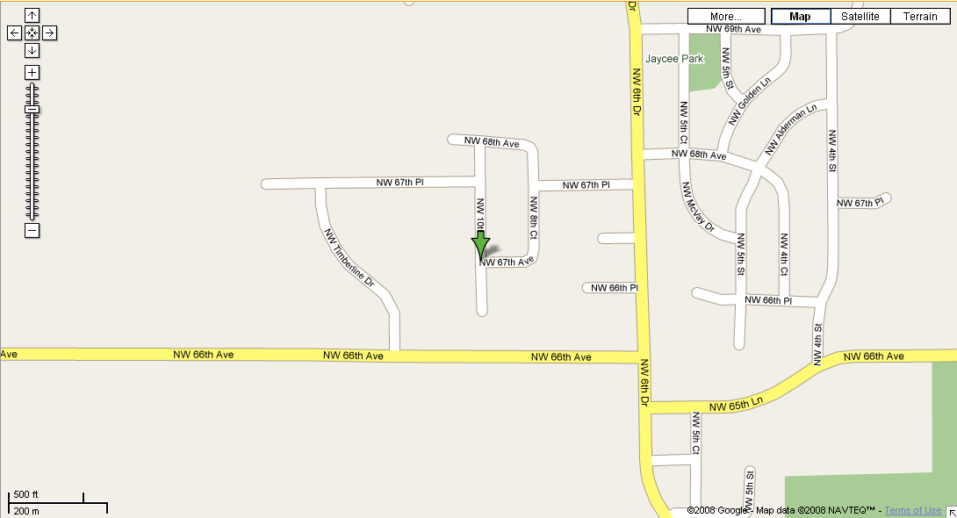

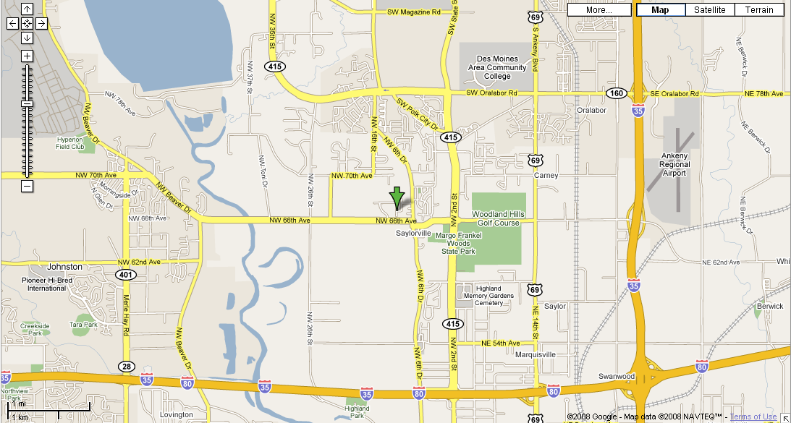

Enclosed, please find the following documents, in addition to this welcome letter:

- Partnership Agreement
- Club Bylaws
- Investment Style & Strategy
- New Member Application
- First Meeting Agenda
- Stock Selection Form
- Stock Selection Form Assistant
- Reuters Industry/Sector Classification Scheme

Many of the documents are not necessarily in final form, but were intended to be a starting point for the club that the club can modify as it deems appropriate.

Finally, for the first meeting, please be sure to:
- Read the enclosed documents and bring any questions you have
- Complete the New Member Application
- Bring your checkbook to the first meeting

Thank you and we look forward to seeing you on May 29th!

