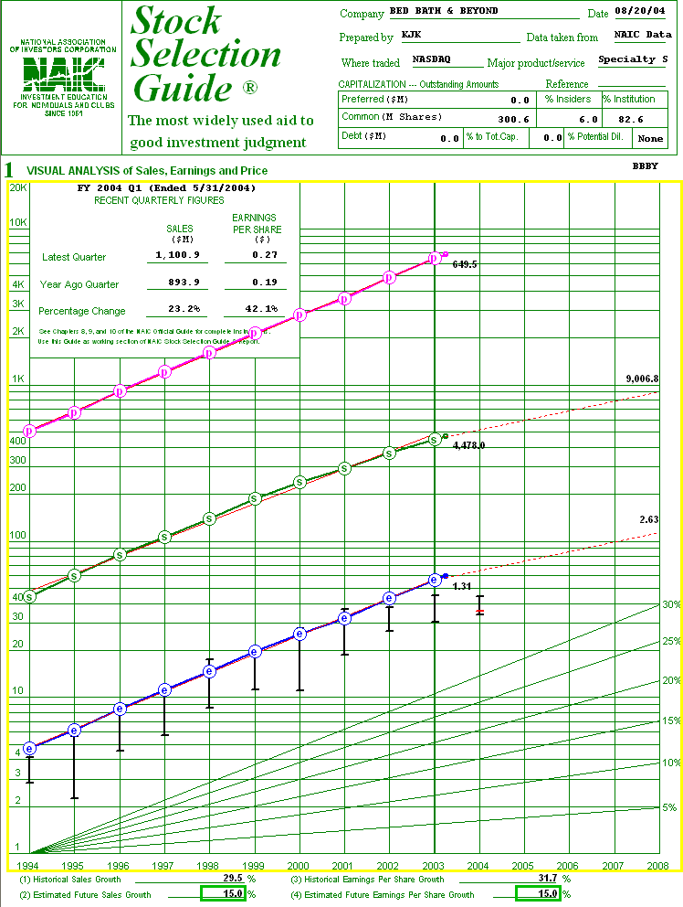
1
3

4
5
2B
2A
NOTE
1
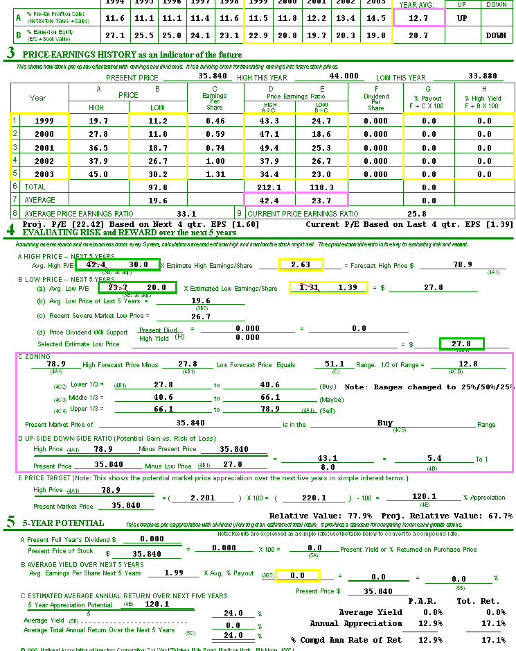
17
6

7
8
9
10
11
12A
12B
13
14
15
16
18
19A
19B
A ONE PAGE GUIDE TO THE STOCK SELECTION GUIDE

•1 Debt should not exceed 30%. Be aware that certain industries vary.
•2A Make sure data is the most recent you can get.
•2B Figures should show growth or stability. Stop the study if most recent quarter shows significant decline.
•3 Lines should be up, straight and parallel. Note EPS 5 Years from now is calculated.
STOP THE STUDY IF LINES DO NOT FIT THE MODEL!
•4 Look at historical sales growth as a guide. Do not exceed 15% as a future estimate unless you have a good reason and never exceed 20%.
•5 Look at historical EPS growth as a guide. Do not exceed sales growth.
•6 Pre-Tax Profit Margins (cents earned on the dollar) should be stable or rising when compared to last 5 year’s average.
STOP THE STUDY IF MARGINS ARE SIGNIFICANTLY BELOW LAST 5 YEAR’S AVERAGE!
•7 Look for trends in last 5 year’s High and Low PE values. Look for values that do not belong on the list and exclude them.
•8 Look at last 5 year’s average PE. Does it (or any of the PE values) make you gasp?
•9 Compare 5 year average PE to current PE. Are you gasping?
•10 Estimate High PE for next 5 years. Stay within your gasp level. Lower is more conservative.
•11 Estimate Low PE for next 5 years. Be aware of average you have set. (Add your high estimate to your low estimate and divide by 2.)
•12A Check last 4 quarters earnings.
•12B Use last 4 quarters earnings as lowest possible earnings for next 5 years.
•13 Choose option A for Low Price in next 5 years.
•14 SSG should say BUY,
•15 Up-side:Down-side Ratio should exceed 3:1.
•16 Growth should meet expectations. Goal is to double your money in 5 years which means 100% growth.
•17 Relative value should be between 70% and 110%. Do not buy when RV exceeds 110%. Be wary of stocks with RV less than 70%.
•18 If stock pays a dividend, yield is recorded here.
•19A Total return in order to double your money in 5 years needs to be 15%. TR means selling stock at your high estimated PE.
•19B Potential Average Return means selling your stock at average PE that you set for next 5 years.

THE SSG IS NOT A “MAGIC BOX”! IT TAKES JUDGMENT, STUDY AND, ABOVE ALL, PRACTICE. IT IS MUCH MORE SOPHISTICATED THAN THIS BEGINNER’S “CHEAT” IMPLIES. THE FORM IS NOT INTENDED TO EVALUATE NON-GROWTH STOCKS AND YIELDS GIBBERISH IF USED INCORRECTLY OR UNWISELY. BE FOREWARNED! TAKE THE TIME TO BECOME ADEPT AT READING AND PREPARING THE SSG. IT WILL ULTIMATELY PAY OFF FOR YOU AND YOUR CLUB!

