# The Passive Club (TPC)

Meeting Minutes for August 16, 2017

Meeting called to order at 11:08 AM by Carolyn Collins;

|  |  |  |  |
| --- | --- | --- | --- |
| **Officers** | **Name** | **Officers** | **Name** |
| *President* | Srinivas Ponugoti | *Treasurer* | Marina Gaikazian |
| *Vice-President* | Carolyn Collins | *Treasurer (bkp)* | John Janci |
| *Secretary* | Damian Stone |  |  |

**MEMBERS:**

|  |  |  |  |  |  |
| --- | --- | --- | --- | --- | --- |
| **Member Name** | **Present** | **Member Name** | **Present** | **Member Name** | **Present** |
| Alan Hull |  | John Janci |  | Morresa Meyer |  |
| Bob Mann |  | Georgeline Mitchell |  | Percy Antonio |  |
| Carolyn Collins |  | Gerry Wholihan |  | Phil York |  |
| Catherine Chall |  | Helen Sorser |  | Sherry Steinhauer |  |
| Charles Denard |  | Manu Pasari |  | Srinivas Ponugoti |  |
| Damian Stone |  | Marina Gaikazian |  | Sriram Padi |  |
| Felicia Ford |  |  |  | Sterling Black |  |
| **NOTE:** *Unchecked box means absent* | | | |  |  |

Guests:

* July’s Secretary’s Report was reviewed by Marina Gaikazian: Carolyn Collins motioned to accept, Al Hull seconded, all were in favor.
* Treasurers Report/Purchases accepted: John Janci motioned to accept, Bob Mann seconded, all were in favor.
* Portfolio Actions: John to follow up - need to determine the list/order – who will do audit
* Proposed buy for July:

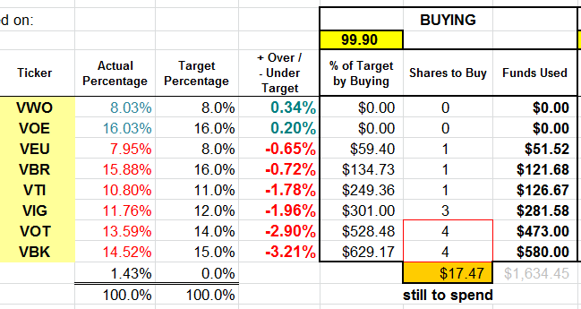

* Actual buy: VBK 5 , VOT 5 , VIG 3, VIT 1, VBR 1, VEU 1
* Old Business
  + Manu received $5,000 check
  + Need to investigate if it is possible to transfer $ from DFCU to other credit union (John to follow up)
* New Business

Is ‘Public’ folder open to non club members? Damian checked and found out that it is open to anyone and everyone. Suggested – move The Passive Club info to more secure location (content is confidential)

The meeting was adjourned at 11:30 AM.

Submitted by Marina Gaikazian