The Passive Club (TPC)
Meeting Minutes for February 15, 2017
Meeting called to order at 11:05 AM by Srinivas Ponugoti
Officers | Name | Officers | Name
President | Srinivas Ponugoti | Treasurer | Percy Antonio
Vice-President | Carolyn Collins | Treasurer (bkp) | John Janci
Secretary | Marina Gaikazian
MEMBERS:
Member Name | Present | Member Name | Present | Member Name | Present
Alan Hull | ☒ | John Janci | ☒ | Morresa Meyer | ☐
Bob Mann | ☒ | Georgeline Mitchell | ☒ | Percy Antonio | ☒
Carolyn Collins | ☒ | Gerry Wholihan | ☒ | Phil York | ☒
Catherine Chall | ☒ | Helen Sorser | ☐ | Sherry Steinhauer | ☒
Charles Denard | ☐ | Manu Pasari | ☐ | Srinivas Ponugoti | ☒
Damian Stone | ☒ | Marina Gaikazian | ☒ | Sriram Padi | ☐
Felicia Ford | ☐ |  | ☐ | Sterling Black | ☐
NOTE: Unchecked box means absent
Guests: Mike Scheuer, Tom Xu
- January Secretary’s Report accepted: Carolyn motioned to accept, Alan Hull seconded, all were in favor.
- Treasurers Report/Purchases accepted: Bob Mann motioned to accept, John Janci seconded, all were in favor.
- Portfolio Actions
  - Proposed buys for the month of February accepted: 1 BTK, 2 VBK, 3 VOE, 4 VBR; Alan Hull motioned to accept, Catherine Chall seconded, all were in favor.
  - Actual January purchases:
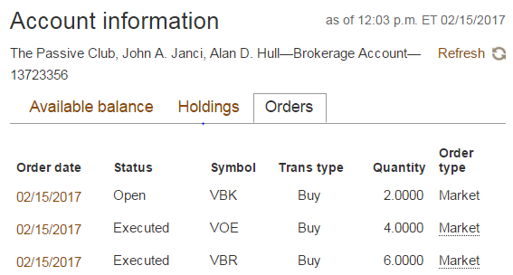

There is $9.09 left in our Vanguard account. On 2/16 Percy also transferred the contributions (total of $350.46) of John and Morresa from DFCU. Percy will make another buy with this after the transfer is complete.
2/22/17 Additional buys from John and Morressa’s February contributions. $13.29 left in Vanguard account:
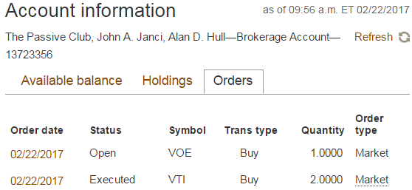
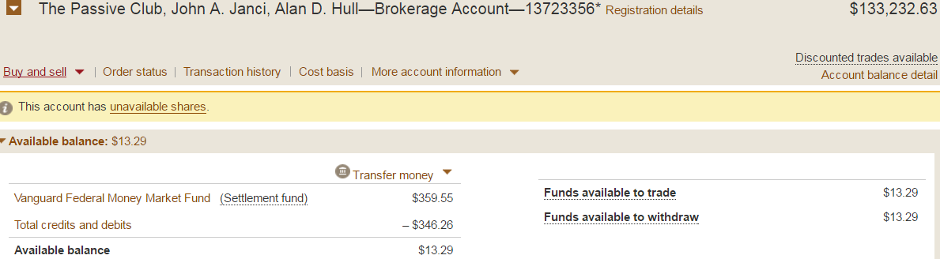
- Old Business
  - Tax forms preparation: 1) Georgeline Mitchell volunteered, 2) Phil York assigned. Tax forms are waiting for audit, audit deadline is March 1st.
- New Business
  - Percy and Carolyn are meeting on 2/16 to resolve discrepancies – must be done before audit, and audit must be completed before tax forms issued.
  - Tax forms must be mailed by March 15th.
  - John Janci will update webside bivio.com/tpc to make sure roles/names are accurate
The meeting was adjourned at 11: 28 AM.
Submitted by Marina Gaikazian

