# The Passive Club (TPC)

Meeting Minutes for June 21, 2017

Meeting called to order at 11:04 AM by Srinivas Ponugoti;

|  |  |  |  |
| --- | --- | --- | --- |
| **Officers** | **Name** | **Officers** | **Name** |
| *President* | Srinivas Ponugoti | *Treasurer* | Percy Antonio |
| *Vice-President* | Carolyn Collins | *Treasurer (bkp)* | John Janci |
| *Secretary* | Marina Gaikazian |  |  |

**MEMBERS:**

|  |  |  |  |  |  |
| --- | --- | --- | --- | --- | --- |
| **Member Name** | **Present** | **Member Name** | **Present** | **Member Name** | **Present** |
| Alan Hull |  | John Janci |  | Morresa Meyer |  |
| Bob Mann |  | Georgeline Mitchell |  | Percy Antonio |  |
| Carolyn Collins |  | Gerry Wholihan |  | Phil York |  |
| Catherine Chall |  | Helen Sorser |  | Sherry Steinhauer |  |
| Charles Denard |  | Manu Pasari |  | Srinivas Ponugoti |  |
| Damian Stone |  | Marina Gaikazian |  | Sriram Padi |  |
| Felicia Ford |  |  |  | Sterling Black |  |
| **NOTE:** *Unchecked box means absent* | | | |  |  |

Guests: Zachary Johnson, Naresh Patel

* May’s Secretary’s Report accepted: Carolyn Collins motioned to accept, Al Hull seconded, all were in favor.
* Treasurers Report/Purchases accepted: John Janci motioned to accept, Al Hull seconded, all were in favor.
* Portfolio Actions
* Proposed buy for June:

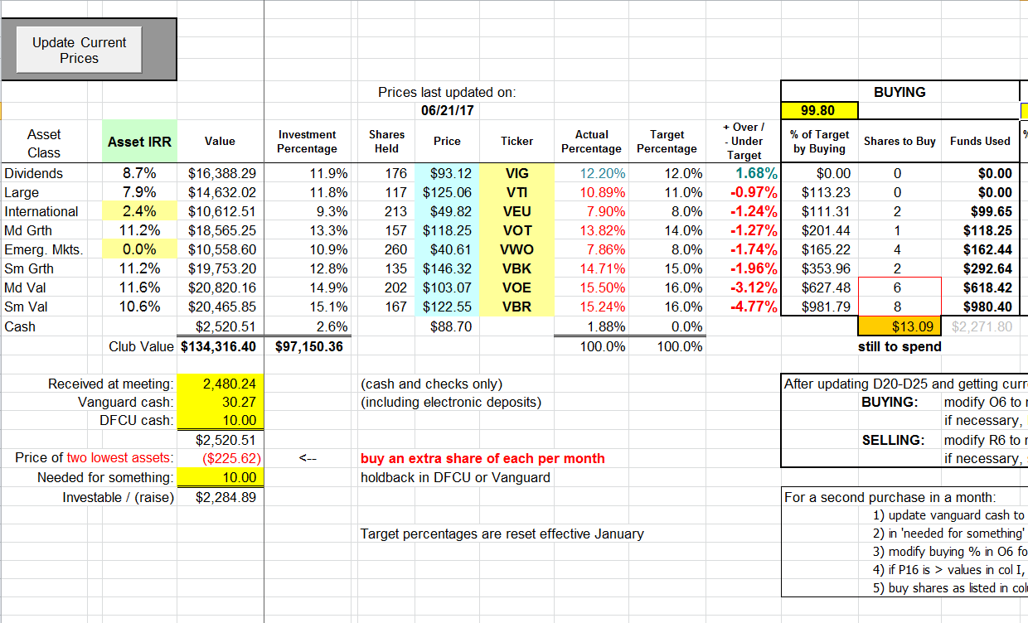

John motioned to accept and Manu seconded; all were in favor.

* + Actual buy:

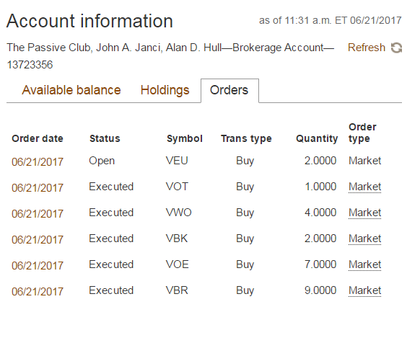

* Old Business
  + Need to investigate if it is possible to transfer $ from DFCU to other credit union - if transfer to other people’s accounts is possible and if there is DFCU charge for bill pay ? (Srinivas or John to follow up?);
  + DFCU cashier check is free
* New Business
  + Manu Pasari requested $5,000 withdraw
  + Need to review the list of the members in July to establish rotation in August

The meeting was adjourned at 11:20 AM.

Submitted by Marina Gaikazian