# The Passive Club (TPC)

Meeting Minutes for March 15, 2017

Meeting called to order at 11:05 AM by John Janci

|  |  |  |  |
| --- | --- | --- | --- |
| **Officers** | **Name** | **Officers** | **Name** |
| *President* | Srinivas Ponugoti | *Treasurer* | Percy Antonio |
| *Vice-President* | Carolyn Collins | *Treasurer (bkp)* | John Janci |
| *Secretary* | Marina Gaikazian |  |  |

**MEMBERS:**

|  |  |  |  |  |  |
| --- | --- | --- | --- | --- | --- |
| **Member Name** | **Present** | **Member Name** | **Present** | **Member Name** | **Present** |
| Alan Hull |  | John Janci |  | Morresa Meyer |  |
| Bob Mann |  | Georgeline Mitchell |  | Percy Antonio |  |
| Carolyn Collins |  | Gerry Wholihan |  | Phil York |  |
| Catherine Chall |  | Helen Sorser |  | Sherry Steinhauer |  |
| Charles Denard |  | Manu Pasari |  | Srinivas Ponugoti |  |
| Damian Stone |  | Marina Gaikazian |  | Sriram Padi |  |
| Felicia Ford |  |  |  | Sterling Black |  |
| **NOTE:** *Unchecked box means absent* | | | |  |  |

Guests: Thomas TenHoopen

* February Secretary’s Report accepted: Alan Hull motioned to accept, Georgeline Mitchell seconded, all were in favor.
* Treasurers Report/Purchases accepted: Bob Mann motioned to accept, Sherry Steinhauer seconded, all were in favor.
* Portfolio Actions
  + Proposed buys for the month of March accepted: 2 VOE, 4 VBK, 5 VBR; Alan Hull motioned to accept, John Janci seconded, all were in favor.
* Old Business
  + Tax forms have been submitted in the Bivio site. If you would like your address removed, each member can individually remove it on the Bivio site. Percy mailed in the Club’s Federal tax returns today (3/15/2017). Individuals should download their own K1 from the Bivio website for their individual tax returns.
* New Business
  + There is interest in getting together for a lunch as a club. John Janci will set something up within the next couple weeks prior to the April meeting.

The meeting was adjourned at 11:20 AM.

Submitted by Sherry Steinhauer

Actual Buys for March. There is $239.37 Percy is waiting to clear in Vanguard. Percy will buy some more stock(s) once that’s cleared.

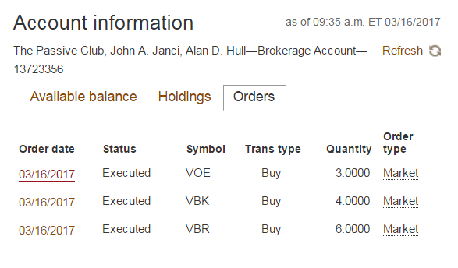

Additional buys for March

