The Passive Club (TPC)
Meeting Minutes for April 17, 2019
Meeting called to order at 11:04 AM | Meeting adjourned at 11:35 AM

Officers | Name | Officers | Name
President | Damian Stone | Vice-President | Percy Antonio
Treasurer | Gerry Wholihan | Treasurer (bkp) | Percy Antonio
Secretary | Phil York | Secretary (bkp)

Member Name | Present | Member Name | Present | Member Name | Present
Adam Englebert | ☐ | John Janci | ☒ | Phil York | ☒
Alan Hull | ☒ | Georgeline Mitchell | ☐ | Scott Ferman | ☐
Bob Mann | ☒ | Gerry Wholihan | ☒ | Sherry Steinhauer | ☐
Carolyn Collins | ☒ | Helen Sorser | ☐ | Srinivas Ponugoti | ☐
Catherine Chall | ☐ | Manu Pasari | ☐ | Sriram Padi | ☐
Charles Denard | ☐ | Marina Gaikazian | ☐ | Sterling Black | ☐
Damian Stone | ☒ | Morresa Meyer | ☐ |  | ☐
Felicia Ford | ☐ | Percy Antonio | ☒
Guests:

Previous meetings Secretary’s Report was review by Phil:
John motioned to accept the meeting minutes, Al seconded, motion passed.

Current Months Treasurer’s Report was reviewed by Gerry:
Sells Executed - $9084. Transferred to DFCU.
Deposits confirmed minus Moresa’s, which is not available yet. Scot’s deposit is > $10 now.

Portfolio Action - BUYS:
Vanguard cash = $3287.30
Al planning to drop $5000.
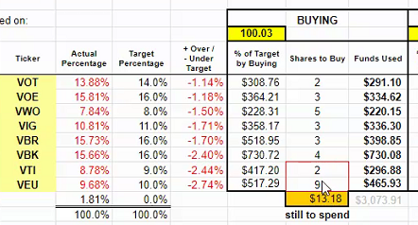
VTI – 3
VEU 10
John motion to accept, Bob seconded. Motion passed.

Old Business
John motioned to pay-off Charles and Sterling with a valuation of 4.16.2019 certified check, and send them email to confirm their home address. Damian seconded. Motion passed. (John will send the email)
Charles - $1,274.69
Sterling - $521.30

Consolidation of operations – review Bob’s email/changes. John motions to table the review to May’s meeting with emergencies only, Al seconded.
New Business
John motions to use Al’s deposit ($5K) with Gerry’s discretion, to invest the difference of Charles and Sterling’s withdrawal. Percy seconded.

Submitted by Phil York

