The Passive Club (TPC)
Meeting Minutes for June 19, 2019
Meeting called to order at 11:03 AM | Meeting adjourned at 11:13 AM

Officers | Name | Officers | Name
President | Damian Stone | Vice-President | Percy Antonio
Treasurer | Gerry Wholihan | Treasurer (bkp) | Percy Antonio
Secretary | Phil York | Secretary (bkp)

Member Name | Present | Member Name | Present | Member Name | Present
Adam Englebert | ☐ | John Janci | ☒ | Phil York | ☐
Alan Hull | ☒ | Georgeline Mitchell | ☒ | Scott Ferman | ☐
Bob Mann | ☒ | Gerry Wholihan | ☒ | Sherry Steinhauer | ☐
Carolyn Collins | ☐ | Helen Sorser | ☐ | Srinivas Ponugoti | ☐
Catherine Chall | ☐ | Manu Pasari | ☐ | Sriram Padi | ☐
Charles Denard | ☐ | Marina Gaikazian | ☐ | Sterling Black | ☐
Damian Stone | ☒ | Morresa Meyer | ☐ |  | ☐
Felicia Ford | ☐ | Percy Antonio | ☐
Guests:

Previous meetings Secretary’s Report was review by John:
Al motioned to accept the meeting minutes, Georgeline seconded, motion passed.

Current Months Treasurer’s Report was reviewed by Gerry:
Buys to Execute – $1,857.70
Al motioned to accept treasure report, Percy seconded, motion passed.

Portfolio Action - BUYS:

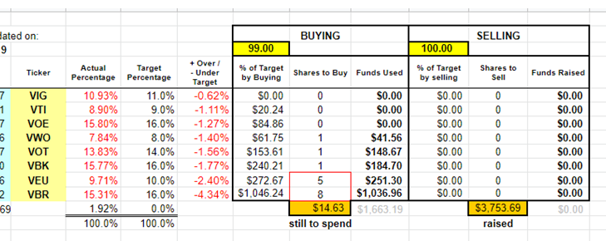

John motion to accept buys, Georgeline seconded. Motion passed.

Old Business
None
New Business
None

Submitted by John Janci

