The Passive Club (TPC)
Meeting Minutes for August 21, 2019
Meeting called to order at 11:07 AM | Meeting adjourned at 11:29 AM

Officers | Name | Officers | Name
President | Damian Stone | Vice-President | Percy Antonio
Treasurer | Gerry Wholihan | Treasurer (bkp) | Percy Antonio
Secretary | Phil York | Secretary (bkp)

Member Name | Present | Member Name | Present | Member Name | Present
Adam Englebert | ☐ | John Janci | ☒ | Phil York | ☒
Alan Hull | ☒ | Georgeline Mitchell | ☒ | Scott Ferman | ☐
Bob Mann | ☒ | Gerry Wholihan | ☒ | Sherry Steinhauer | ☐
Carolyn Collins | ☐ | Helen Sorser | ☐ | Srinivas Ponugoti | ☐
Catherine Chall | ☒ | Manu Pasari | ☐ | Sriram Padi | ☐
Charles Denard | ☐ | Marina Gaikazian | ☐ | Sterling Black | ☐
Damian Stone | ☒ | Morresa Meyer | ☒ |  | ☐
Felicia Ford | ☐ | Percy Antonio | ☒
Guests:

Previous meetings Secretary’s Report was review by Phil:
John to add June meeting minutes
July 2019 Meeting Minutes motioned to pass by John and seconded by Al.

Current Months Treasurer’s Report was reviewed by Gerry:
With $2000 going to Damian we need to sell $222.37 worth of assets to offset the contributions ($1735.78) for August. Vanguard cash = $41.85
Morresa ($30K) and Percy ($1K) are taking out partial withdrawals next month.
Remove Charles and Sterling (cashier checks – won’t know if they ever use them)

Portfolio Action - SELL:
Sell 2 VIG to raise $235.84
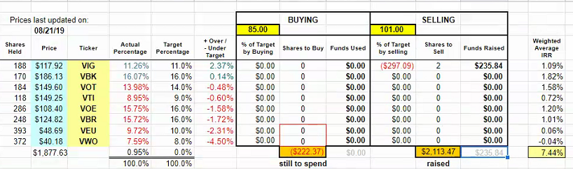
Phil motion to accept sells, John seconded. Motion passed.

Old Business
What to use at the transaction date for Charles/Sterling? The date the checks were made.
Morresa ($30K) and Percy ($1K) are taking out partial withdrawals next month.
New Business
No more declaring valuation milestones – everyone pulls out money.
New officers:
President: Percy
VP: Jerry
Treasurer: Phil
Secretary: Manu

Submitted by Phil York

