The Passive Club (TPC)
Meeting Minutes for September 18,2019 -upd on 10/17/19
Meeting called to order at 11:06 AM | Meeting adjourned at 11:28 AM

Officers | Name | Officers | Name
President | Damian Stone | Vice-President | Percy Antonio
Treasurer | Gerry Wholihan | Treasurer (bkp) | Percy Antonio
Secretary | Phil York | Secretary (bkp)

Member Name | Present | Member Name | Present | Member Name | Present
Adam Englebert | ☐ | John Janci | ☒ | Phil York | ☒
Alan Hull | ☒ | Georgeline Mitchell | ☒ | Scott Ferman | ☐
Bob Mann | ☒ | Gerry Wholihan | ☒ | Sherry Steinhauer | ☐
Carolyn Collins | ☒ | Helen Sorser | ☐ | Srinivas Ponugoti | ☐
Catherine Chall | ☐ | Manu Pasari | ☐ | Sriram Padi | ☐
Charles Denard | ☐ | Marina Gaikazian | ☐ | Sterling Black | ☐
Damian Stone | ☒ | Morresa Meyer | ☒ |  | ☐
Felicia Ford | ☐ | Percy Antonio | ☒
Guests:

Previous meetings Secretary’s Report was review by Phil:
John to add June meeting minutes (try again)
Aug 2019 Meeting Minutes Damian motioned to pass and seconded by Al – motion passed.

Current Months Treasurer’s Report was reviewed by Phil:
Damian proposed to accept the Treasurer report, Bob seconded – motion passed.

Buy/Sells:
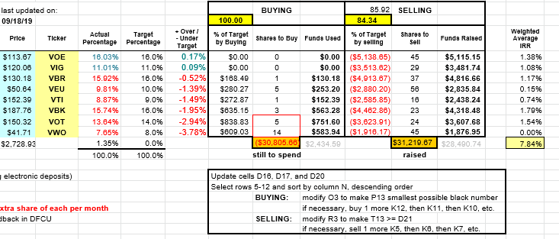
Only look at the Selling portion.
Phil proposed to sell from the above list and if we do not have enough funds, sell more of VOE.
John seconded.
Motion passed.

Old Business
New officers:
President: Percy
VP: Jerry
Treasurer: Phil
Secretary: Manu

New Business
John will give the check to Moressa
Need to give new officers access to accounts – John, pick a day and meet at the bank.

Submitted by Phil York

