The Passive Club (TPC)
Meeting Minutes for October 16,2019
Meeting called to order at 11:05 AM | Meeting adjourned at 11:28 AM

Officers | Name | Officers | Name
President | Percy Antonio | Vice-President | Gerry Wholihan
Treasurer | Phil York | Treasurer (bkp)
Secretary | Manu Pasari | Secretary (bkp)

Member Name | Present | Member Name | Present | Member Name | Present
Adam Englebert | ☐ | John Janci | ☒ | Phil York | ☒
Alan Hull | ☒ | Georgeline Mitchell | ☒ | Scott Ferman | ☐
Bob Mann | ☒ | Gerry Wholihan | ☒ | Sherry Steinhauer | ☒
Carolyn Collins | ☒ | Helen Sorser | ☐ | Srinivas Ponugoti | ☒
Catherine Chall | ☒ | Manu Pasari | ☐ | Sriram Padi | ☐
Damian Stone | ☐ | Marina Gaikazian | ☐ |  | ☐
 |  | Morresa Meyer | ☐ |  | ☐
Guests: | ☐ | Percy Antonio | ☐

Previous meetings Secretary’s Report was reviewed by Gerry:

Sept 2019 Meeting Minutes John motioned to pass and seconded by Al – motion passed. Though it was noted that Sept’s date on the meeting minutes said August. (corrected)

Note from Carolyn: June meeting minutes were there on the Bivio site Thanks John & Sept. 2019 date updated in those minutes.

Current Months Treasurer’s Report was reviewed by Phil:

John proposed to accept the Treasurer report, Bob seconded – motion passed though it was noted that
Phil wants to confirm date of Helen Sorser’s last deposit since report says last deposit was Sept.

Buy/Sells per below: Bob motioned, and Al seconded. Motion passed. Please note that per new business the percentages of 3 funds were changed and effective immediately.
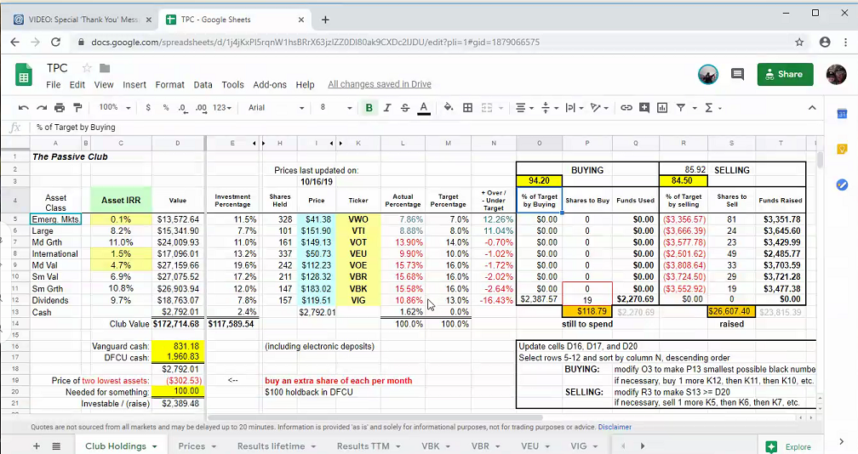

Old Business:
New officers from last month are in process to get access needed to our accounts;

All checks have been distributed from several partial withdrawals transacted last month.

New Business
Moressa needs to be compensated for purchasing the club’s Bivio subscription. Treasurer will record adjustments for all TPC members as usual in Bivio to reflect the users cost of the subscription.

Changed the percentages of our securities effective with today’s upcoming buys. VWO, VTI were reduced 1% (now 7%&8%) and VIG increased by 2% (now 13%). Bob motioned and Al seconded- motion passed

Submitted by Carolyn Collins

