The Passive Club (TPC)
Meeting Minutes for December 15, 2021
Meeting called to order at 11:02AM | Meeting adjourned at 11:34 AM

Officers | Name | Officers | Name
President | Phil York | Vice-President | Manu Pasari
Treasurer | Helen Sorser | Treasurer (bkp)
Secretary | Georgeline Mitchell | Secretary (bkp)

Member Name | Present | Member Name | Present | Member Name | Present
Adam Englebert | ☒ | John Janci | ☐ | Phil York | ☐
Alan Hull | ☒ | Georgeline Mitchell | ☒ | Scot Ferman | ☐
Bob Mann | ☒ | Gerry Wholihan | ☒ | Sherry Steinhauer | ☒
Carolyn Collins | ☐ | Helen Sorser | ☒ | Srinivas Ponugoti | ☒
Catherine Chall | ☒ | Manu Pasari | ☐ | Sriram Padi | ☐
Damian Stone | ☐ | Marina Gaikazian | ☐ | Javarri Little | ☐
Jody Tarquinto | ☒ | Morresa Meyer | ☐ | Youmin Zheng | ☐
 | ☐ | Percy Antonio | ☒ | Jeff Scott | ☒

- Georgeline reviewed meeting minutes from 11/17/2021:
Al motioned to accept
Cathy second, no one opposed
Motion passed.

- Current Months Treasurer’s Report was reviewed by Helen:
Available Cash for investment $0 - $62,757.99 need to be raised
Sherry motioned to accept
Bob second, no one opposed
Motion passed.

- Portfolio Action – Buys/Sells:

Documents location:
https://docs.google.com/spreadsheets/d/1j4jKxPI5rqnW1hsBRrX63jzIZZ0Dl80ak9CXDc2lJDU/edit?usp=sharing

December Sells:

Suggested Buys:

Ticker | 12/17/2021
VIG | 7,695.86
VOE | 5,925.57
VTI | 6,968.37
VEU | 8,009.26
VBR | 5,638.05
VOT | 12,300.41
VWO | 8,336.12
VBK | 9,445.49
 | $64,319.13

Below is the distribution:

$ 29,612.18 | Gaikazian, Marina
$ 1,509.71 | Englebert, Adam
$ 3,000.00 | Antonio, Percival
$ 15,000.00 | Steinhauer (cust. for Alyssa), Sherry
$ 15,000.00 | Steinhauer (cust. for Kayla), Sherry

- Old Business
  - Audit – submit request for volunteers (Marina and Raymond if there are no volunteers)
Define the process of authentication between DFCU and Vanguard or other options to transfer funds immediately for 2021.
- Jody Tarquinto has volunteered to do Audit
  - Withdrawal Requests:
- Sherry Steinhauer:
  - $30,000 ($15,000 from Kayla and Alyssa accounts)
  - Requesting 2 separate checks
- Adam Englebert:
  - Full withdrawal $1,542.20 (11/16/21)
- Marina Gaikazian:
  - Full withdrawal $31,044.66 (11/16/2021)
  - Wants it transferred to Vanguard Account as an asset (as much as possible) without selling
  - In Progress – John is having issues and has been able to transfer.
    - Bob suggested that we change the by-laws to say that everyone will always be cashed out by cash and not transferring it via stocks. Find the by-laws and add it to and propose and vote on it next month. Georgeline will respond to the email that we are going to cash out.
- Antonio Percy:
- Wants a partial withdrawal of $3,000 (11/17/2021 before 11am)
  - Bob Mann has been fully withdrawn from the club
  - 2022 Meeting Notice Members has been sent to Members, please forward the notice to interested parties.
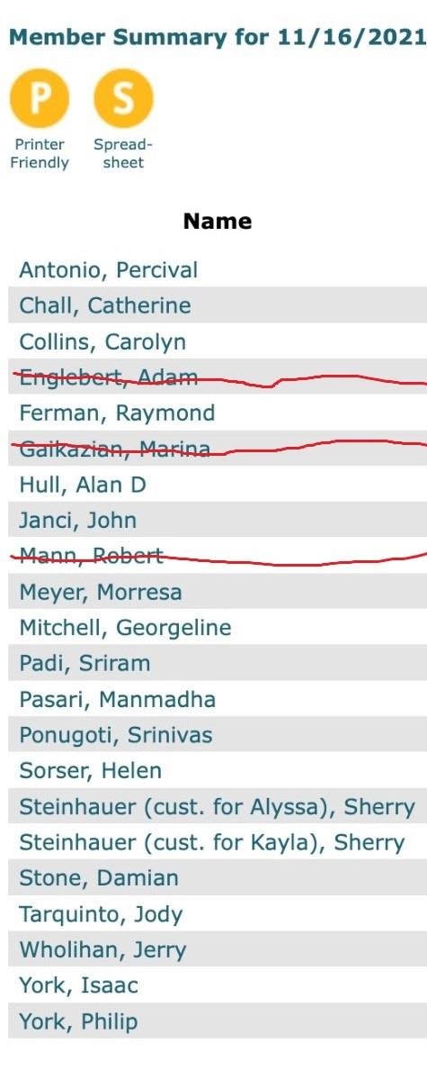
  - Why is the meeting so short – request extending it 15 minutes or 30 minutes? Maybe move it to another day – Brought up by Jody Subject to discussion next month
    - Recommend that read and dialogue (Simple Path to Wealth and Common-Sense Investing) – Brought up by Jody

- New Business

Submitted Georgeline Mitchell

