The Passive Club (TPC)
Meeting Minutes for January 1926, 2022
Meeting called to order at 11:01AM | Meeting adjourned at 11:28 AM

Officers | Name | Officers | Name
President | Phil York | Vice-President | Manu Pasari
Treasurer | Helen Sorser | Treasurer (bkp)
Secretary | Georgeline Mitchell | Secretary (bkp)

Member Name | Present | Member Name | Present | Member Name | Present
Alan Hull | ☒ | Helen Sorser | ☐ | Sriram Padi | ☐
Carolyn Collins | ☐ | Manu Pasari | ☒ | Javarri Little | ☐
Catherine Chall | ☒ | Morresa Meyer | ☐ | Youmin Zheng | ☐
Damian Stone | ☐ | Percy Antonio | ☐ | Jeff Scott | ☐
Jody Tarquinto | ☒ | Phil York | ☒ |  | ☐
John Janci | ☐ | Scot Ferman | ☐ |  | ☐
Georgeline Mitchell | ☒ | Sherry Steinhauer | ☐ |  | ☐
Gerry Wholihan | ☒ | Srinivas Ponugoti | ☐ |  | ☐

- Georgeline reviewed meeting minutes from 12/15/21:
Al motioned to accept
Manu second, no one opposed
Motion passed.

- Current Months Treasurer’s Report was reviewed by Helen:
Available Cash for investment $4,210.07
Manu motioned to accept
Jerry second, no one opposed
Motion passed.

- Portfolio Action – Buys/Sells:

Documents location:
https://docs.google.com/spreadsheets/d/1j4jKxPI5rqnW1hsBRrX63jzIZZ0Dl80ak9CXDc2lJDU/edit?usp=sharing

January Sells:

Suggested Buys:

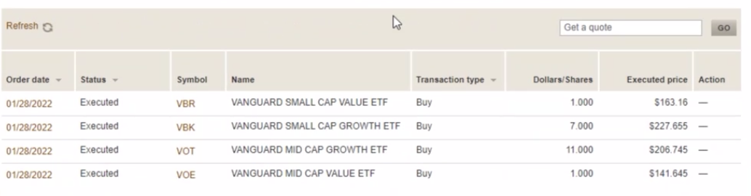

- Old Business
  - Audit – submit request for volunteers (Marina and Raymond if there are no volunteers)
Define the process of authentication between DFCU and Vanguard or other options to transfer funds immediately for 2021.
- Jody Tarquinto has volunteered to do Audit
- Question – do we have the 2 who will be doing the audit finalize? Jody and Cathy if Jerry cannot find someone else.
  - Completed all Withdrawal Requests:
- Sherry Steinhauer:
  - $30,000 ($15,000 from Kayla and Alyssa accounts)
  - Requesting 2 separate checks
- Adam Englebert:
  - Full withdrawal $1,542.20 (11/16/21)
- Marina Gaikazian:
  - Full withdrawal $31,044.66 (11/16/2021)
  - Wants it transferred to Vanguard Account as an asset (as much as possible) without selling
  - Completed – John is having issues and has been able to transfer.
    - Bob suggested that we change the by-laws to say that everyone will always be cashed out by cash and not transferring it via stocks. Find the by-laws and add it to and propose and vote on it next month. Georgeline will respond to the email that we are going to cash out. We needed doing a cash out
- Antonio Percy:
- Wants a partial withdrawal of $3,000 (11/17/2021 before 11am)

  - Why is the meeting so short – request extending it 15 minutes or 30 minutes? Maybe move it to another day – Brought up by Jody Subject to discussion next month
    - Recommend that read and dialogue (Simple Path to Wealth and Common-Sense Investing) – Brought up by Jody

- New Business

Submitted Georgeline Mitchell

