# The Passive Club (TPC)

Meeting Minutes for October 19, 2022

|  |  |
| --- | --- |
| Meeting called to order at 11:02 AM | Meeting adjourned at 11:31 AM |

|  |  |  |  |
| --- | --- | --- | --- |
| **Officers** | **Name** | **Officers** | **Name** |
| *President* | Manu Pasari | *Vice-President* |  |
| *Treasurer* | Helen Sorser | *Treasurer (bkp)* |  |
| *Secretary* | Georgeline Mitchell | *Secretary (bkp)* |  |

|  |  |  |  |  |  |
| --- | --- | --- | --- | --- | --- |
| **Member Name** | **Present** | **Member Name** | **Present** | **Member Name** | **Present** |
| Alan Hull |  | Helen Sorser |  | Sriram Padi |  |
| Carolyn Collins |  | Manu Pasari |  | Javarri Little |  |
| Catherine Chall |  | Morresa Meyer |  | Youmin Zheng |  |
| Damian Stone |  | Percy Antonio |  | Jeff Scott |  |
| Jody Tarquinto |  | Phil York |  |  |  |
| John Janci |  | Scot Ferman |  |  |  |
| Georgeline Mitchell |  | Srinivas Ponugoti |  |  |  |
| Gerry Wholihan |  |  |  |  |  |
|  | | | | | |

1. Georgeline reviewed meeting minutes from 9/21/2022:

John motioned to accept

Al second, no one opposed

Motion passed.

1. Current Months Treasurer’s Report was reviewed by Helen:

Available Cash for investment $1,722.04

Al motioned to accept

Cathy second, no one opposed

Motion passed.

1. Portfolio Action – Buys/Sells:

Documents location:

<https://docs.google.com/spreadsheets/d/1j4jKxPI5rqnW1hsBRrX63jzIZZ0Dl80ak9CXDc2lJDU/edit?usp=sharing>

October Buys:

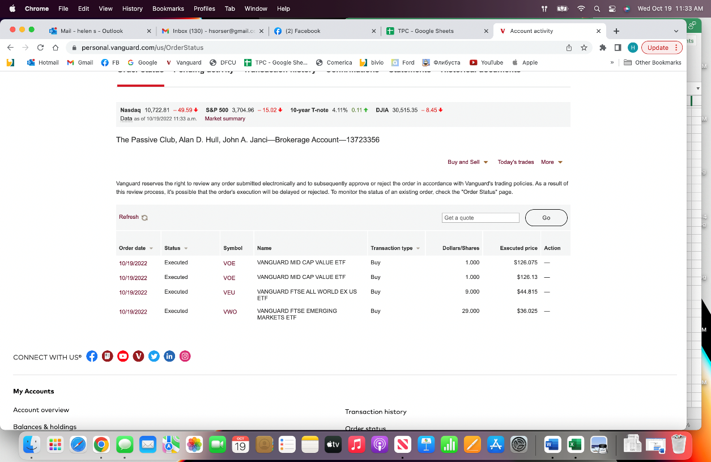

1. Old Business
   1. Audit update presented by Jody:
      1. Vote on Scott and Jody’s recommendation:
         1. Members should add phone numbers to contact information in the Bivio rooster
            1. As of 7/15/22 – We still need 17 people’s phone numbers
         2. Receipts should be uploaded to Bivio as PDF in receipt folder.
         3. Pdf statements (DFCU & Vanguard) should be uploaded to Bivio.
         4. Minutes and Treasures Report to contain more details on expenses and withdrawals.
         5. Recommend we target deposits after 1st of the month and before meeting (especially at end of year – Dec).
         6. Recommend Before leaving the club and receiving final check – to confirm deposits and withdrawal amounts! Recommend a Quarterly and or Simi Annual Audits.
   2. Jody and Manu will meet with Helen to simplify the Treasurer Report.
   3. New officer list will be shared by Manu through the TPC email
      1. New Officer list for 2022/2023 (October 2022 to October 2023)

President: ManuVice President: HelenTreasurer: Georgeline Secretary: Sri Ram

* 1. Discuss revisiting of how Bivio site is set up per Helen – “*The Bivio site where we store our club documents like meeting minutes, financial statements and information, guidelines and supporting documents needs to be revisited.  It is hard to navigate, and we have documents in multiple places, like partnership agreements, club audit documents, etc. We need to create a road map of the site, evaluate available documents, purge what is not needed and align what's needed.  For example, the partnership agreement needs to be signed every year.”*
     1. Site cleaning
     2. Creating a partnership agreement
  2. Vanguard access – discussion with John
  3. Vanguard allows to buy partial shares (per Jody) and it is a subject for discussion
     1. Validate if Bivio allows partial shares
     2. Complexity of execution (for the treasurer)
  4. Vanguard $7 discrepancy – Helen to prepare analysis. Meet with Jody and Manu
  5. Jody will talk about portfolio makeup during October meeting

1. New Business
   1. TPC Bivio Renewal of $349 for 2022 (was previously $179).
      1. The allocation to the members will be higher.
      2. Manu will pay for it this year.
      3. Do we want to keep with Bivio due to higher costs? We have been with Bivio since 2008. John will ask Bob for potential options.
   2. TPC Target Percentages reset effective October:
      1. John and Jody will put together something and will send email letting us know how we have done so far, and next month we will vote month on the potential reset.
   3. Philip York and son Isaac (who turns 18) will be withdrawing from the club in November 2022.

Submitted Georgeline Mitchell